9 July 2021

Dr Tony Richards
Head of Payments Policy Department
Reserve Bank of Australia

Via email: pysubmissions@rba.gov.au

Dear Dr Richards
Review of Retail Payments Regulation – Preliminary Conclusions
COBA appreciates the opportunity to provide a submission in response to the Reserve Bank’s Preliminary Conclusions from its Review of Retail Payments Regulation.
COBA is the industry association for Australia’s customer owned banking institutions (mutual banks, credit unions and building societies). COBA members are an important part of Australia’s payments system, providing a wide range of payment products and services to 4.5 million customers.
Collectively, our sector has $147 billion in assets. Customer owned banking institutions account for around two thirds of the total number of domestic Authorised Deposit-taking Institutions (ADIs) and deliver competition and market leading levels of customer satisfaction in the retail banking market.
COBA members provide their customers with a wide range of credit card and debit card products and, as a sector, we bring a card issuer and cardholder perspective to regulatory policy debates about payment cards.
As smaller players in a banking market dominated by the four major banks, COBA members rely on outsourcing to obtain efficiencies and economies of scale. This applies to core banking systems, data processing and other services but is particularly important in relation to access to the payments system. The key providers of payments system access for COBA members are Cuscal, Indue and ASL. These providers’ services include participation in the international card schemes (Visa and Mastercard) and eftpos, the New Payments Platform (NPP), direct entry, BPAY, ATM networks, digital applications and cheque issuance.
COBA members are typically issuer-only and generally do not compete in the merchant acquiring sector. The key decision-making factor for COBA members in the payments space is the needs of their customers as consumers.
Key points:
- COBA supports the RBA’s proposal not to extend any requirements to issue dual network debit cards (DNDCs) beyond the major banks.
- Outside of major banks, issuance of DNDCs should remain optional, based on commercial considerations of the individual issuers and the needs of their customers.
- COBA strongly opposes calls from retail sector industry bodies to make DNDC issuance mandatory for all banks.
- COBA members are concerned about any reduction in interchange fee caps, especially if it results in a net reduction of interchange revenue for smaller issuers. Revenue from interchange fees is a crucial component in funding our members’ payments offerings for their customers.
- The operating environment for smaller ADIs, including all COBA members, is challenging due to low interest rates and related margin squeeze and the growing regulatory compliance cost burden, underlining the need to reduce costs and increase non-interest income.
Dual network debit card issuance
COBA supports the RBA’s preliminary conclusion to mandate dual network debit cards (DNDC) for the major banks only.
In the consultation paper, the RBA has identified several policy options relating to DNDCs to achieve its objective of enabling and promoting least cost routing (LCR) for merchants. It noted challenges to the viability of LCR, including a “growing number of small and medium-sized card issuers choosing to issue single-network debit cards (SNDCs) instead of DNDCs”.
The policy options considered by the RBA included:
Option 1: Maintain current arrangements
Option 2: Explicit expectations of DNDC issuance for the major banks
Option 3: Regulation mandating DNDC issuance for the major banks and medium sized issuers.
The RBA’s preliminary assessment found that Option 2: Explicit expectations of DNDC issuance for the major banks is the most appropriate course of action at this point in time.
COBA supports the RBA’s intention to pursue Option 2. As the RBA notes, the costs imposed by mandating DNDCs for mid-sized and smaller issuers would be prohibitive from an operational and competition perspective and disadvantage smaller issuers who do not operate at the same scale as major banks.
“On balance…the Board is not convinced that the likely economy wide benefits from a requirement on mid-sized (and possibly also smaller) issuers under Option 3 outweigh the clear costs that would be imposed on these issuers, including on their ability to compete with the major banks.”
In COBA’s view, the RBA’s proposal in Option 2 strikes the right balance between the allowing non-major banks to issue products based their own commercial considerations and the RBA’s objective of enabling LCR.
Position of retail sector lobby groups
We note that some stakeholders are calling for issuance of DNDCs to be mandatory for all banks.
In a recent open letter, retail sector lobby groups say urgent regulation is needed, including that:
Multi Network Debit Cards (MNDCs) are mandatory as part of every bank’s social obligation to promote competition in Australia.
COBA opposes the proposal to mandate MDNCs for all banks. This would be a dramatic intervention in the market, removing choice from issuers, hitting smaller issuers hardest, harming competition in banking, and removing the incentive for debit card schemes to innovate and improve their offering to attract issuers.
Choice for issuers
A majority of COBA members offer DNDCs and may choose to continue to do so. However, members have expressed a strong desire for the issuance of DNDCs to remain a choice, based on commercial considerations of the individual issuers and the needs of their customers.
The RBA’s preliminary conclusion for Option 2, would continue to allow this choice for COBA members.
Our members consider a range of factors when deciding what payment products and services they offer to their customers. These factors include customer needs, functionality, safety and security and cost. Members work with their payments service providers, such as Cuscal, Indue and ASL, to identify and issue products that best match the needs of their organisations and customers.
Having two schemes may provide cardholders with little additional functionality despite the additional costs incurred by the issuer. It should be up to COBA members to decide whether they continue to offer this product to consumers, based on the value it offers their customer base.
If the RBA were to mandate issuance of DNDCs for all banks, this could reduce incentives for schemes to innovate and improve their offering to attract new issuers and keep existing issuers. Regulatory intervention to mandate that certain scheme be issued on all debit cards would interfere with market forces, and potentially stifle innovation in the market.
Any intervention that would require mandatory DNDC issuance by all banks would also mean that institutions would be offering a product based on factors other than their own commercial considerations and the needs of their customers.

Cost implications of DNDCs for smaller issuers
The RBA has recognised the additional costs that arise from supporting two networks given the largely overlapping functionality provided by the debit schemes. It has also acknowledged the significant challenges that these costs impose on smaller issuers, who have smaller customer bases and are less able to distribute the costs.
Generally, small issuers are subject to relatively higher regulatory costs due to the fixed cost factor and this hampers their capacity to grow and expand into new markets.
As noted above, while a majority of COBA members offer DNDCs and may choose to continue to do so, the duplication in systems and compliance costs does impose a considerable cost burden on issuers with relatively small portfolios. This applies to all COBA members, including our largest members.
Cuscal has provided COBA with the following insights about these costs.
“The key cost in supporting dual network cards are compliance and operating costs. There are also additional costs associated with physical card production incorporating two schemes, the need for two card types to be supported in digital wallets and the requirement for & fees associated with membership of two Schemes. Each of Visa, Mastercard and eftpos release two mandated major technical upgrades per year. This is in addition to other rule changes and technical updates which are distributed on a regular basis throughout the year.
These major scheme releases have increased significantly in volume and complexity, and hence cost, over the past two years. A key driver - accounting for around 60% of compliance costs - has been the requirement from eftpos for issuers to make continued changes to their product to bring it closer to the (domestic) functionality of international scheme cards.
Such mandates require changes not only with sponsors like Cuscal, but also the issuing institution’s core banking platform providers, card management vendors and other third parties required to run their card businesses.
Smaller issuers suffer a disproportionate cost per cardholder to support DNDCs, due to the need to comply with the mandates of both schemes, which requires a significant investment from the organisation. Smaller issuers have limited budgets and lack the scale in their programs to meet these costs. As scheme compliance is mandated, this has become a priority spend and an opportunity cost to other activities. The outcome of needing to cover these costs is a reduction or elimination in funding for development and innovation elsewhere and abandoning opportunities to reduce fees to cardholders. The challenge is that while mandated, compliance for eftpos is not delivering new or better product features for customers, as these are already part of the features they receive from the other international schemes.
A further cost in supporting dual network cards is the disparity in back-office processes, such as settlement and general ledger reconciliation, as well as fraud monitoring and dispute management, with each scheme having its own rules, limits and processes. This adds complexity to the base requirements of financial institutions to run these necessary processes. It also means twice the training, twice the processes and twice the oversight.”
Thresholds for mandated DNDC issuance
In considering the policy position for DNDCs, the RBA called for stakeholder feedback on a proposal to implement a regulation mandating DNDC issuance for major banks and medium sized issuers (Option 3):
“While the question of where to set the threshold would be a matter for judgement, the Board is interested in stakeholder views regarding a requirement that any authorised deposit-taking institution (ADI) accounting for more than 1 per cent of household deposits would be required to continue to issue DNDCs (Option 3).”
The 1 per cent of household deposits threshold used to determine medium-sized ADIs poses challenges for some of COBA’s larger members.
The below chart shows ADIs that hold 1 per cent or more of household deposits. It also includes three COBA members who are approaching the 1 per cent threshold.
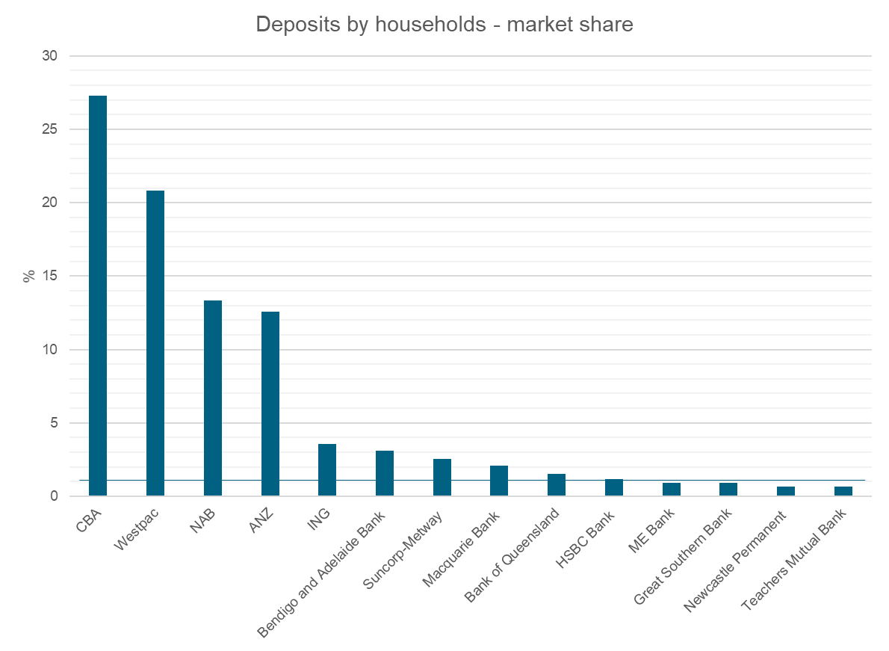
COBA is concerned that while our members are yet reach the 1 per cent threshold, it is likely that as household deposit balances grow, they could be captured within this threshold within the foreseeable future.
Once COBA members reached the1 per cent threshold they would be subject to the same fixed costs for mandatory DNDC issuance as institutions more than 20 times their size. This is unfair and should be addressed by a change in the threshold metric for determining medium-sized ADIs, should the RBA decide to pursue Option 3.
Household deposits do not accurately reflect share of debit card market
COBA notes that the metric of household deposits proposed by the RBA does not directly correlate to the market share of the card payments market. For COBA members, our market share in household deposits is proportionately higher than our market share in the card payments space.
In terms of a threshold for mandatory issuance of DNDCs, the simplest approach, and one that recognises the reality of Australia’s banking oligopoly is the approach outlined by the RBA in Option 2.
Alternatively, the threshold could be based on cards on issue. This threshold should be set at a high enough level, e.g. 1 million cards, to avoid capturing smaller ADIs.
Proposed interchange reform
COBA supports the RBA’s preliminary conclusion that it does not see a strong case for significant reforms to interchange regulations. Our members agree that the current interchange fee regime is operating effectively and should remain unchanged, providing stability for all stakeholders.
However, COBA members are concerned by the RBA’s specific proposals to reform the cents-based debit interchange caps for DNDCs and SNDCs:
“Reducing the cents-based cap, to 10 cents for DNDCs (and all prepaid cards) and 6 cents for SNDCs (Option 2), would go some way to addressing the Board’s concerns about the cost of payments for some low-value transactions, particularly at smaller merchants, without significantly changing the structure of the overall interchange framework. It would also reduce the disparity between the cost to small and large merchants for accepting similar transactions.”
There is heightened sensitivity around potential reductions in debit interchange fees in the current operating environment due to the squeeze on margins from historically low interest rates and the growing regulatory compliance cost burden.
As noted in our earlier submission to the RBA’s review, the current interchange standards which came into effect in July 2017 saw a one-third reduction in the weighted-average interchange fee benchmark for debit cards and changes to the assessment of the credit card benchmark to prevent upward drift in fees. These were further examples of RBA interventions to benefit merchants at the expense of card issuers and potentially cardholders.
Finding the right balance of fairness, competition and efficiency requires all stakeholders to bear in mind that interchange fees are a means for card issuers to recover some of the costs they sustain to provide benefits to merchants.
Revenue from interchange fees is a crucial component in funding our members’ payments offerings for their customers. As noted above, our members are issuers only and generally do not provide acquiring services.
This means that interchange revenue is particularly important to ensuring issuers can continue to support their existing payment offering for their customers – which in turn provides benefits to merchants - and to fund new and innovative payment methods in the future. A further reduction in interchange revenue will disproportionately impact issuer-only small ADIs, such as COBA members, and have flow on effects for competition in the payments space.
We note the RBA’s proposal to set a lower cents-based interchange cap for SNDC transactions than for DNDC transactions is intended to limit the possibility of schemes using interchange rates to incentivise SNDC issuance.
Rather than intervene to punish issuers of SNDCs, it would be preferable for the RBA to require schemes not to distinguish between SNDCs and DNDCs in terms of interchange rates.
This would just as effectively address the RBA’s view that it is not appropriate for schemes to provide issuers with interchange-based incentives to issue SNDCs.
Thank you for the opportunity to provide this submission. Please do not hesitate to contact Luke Lawler, Director - Policy (llawler@coba.asn.au) or Maryanna Vasilareas, Senior Policy Adviser (mvasilareas@coba.asn.au) to discuss any aspect of this submission.
Yours sincerely

Michael Lawrence
Chief Executive Officer

https://www.rba.gov.au/payments-and-infrastructure/review-of-retail-payments-regulation/consultation-paper-202105/pdf/review-of-retail-payments-regulation-consultation-paper-202105.pdf
https://www.rba.gov.au/payments-and-infrastructure/review-of-retail-payments-regulation/consultation-paper-202105/pdf/review-of-retail-payments-regulation-consultation-paper-202105.pdf
https://www.cosboa.org.au/post/open-letter-from-business-organisations-seeking-urgent-action-on-debit-payments
https://www.rba.gov.au/payments-and-infrastructure/review-of-retail-payments-regulation/consultation-paper-202105/pdf/review-of-retail-payments-regulation-consultation-paper-202105.pdf
Brief from Cuscal, produced in 2020
https://www.rba.gov.au/payments-and-infrastructure/review-of-retail-payments-regulation/consultation-paper-202105/pdf/review-of-retail-payments-regulation-consultation-paper-202105.pdf
May 2021 Monthly ADI statistics – APRA
https://www.rba.gov.au/payments-and-infrastructure/review-of-retail-payments-regulation/consultation-paper-202105/pdf/review-of-retail-payments-regulation-consultation-paper-202105.pdf

