
Russell Zimmerman
Retail Consultant
Review of Payments Regulation
About Russell Zimmerman
Since 1980, Russell Zimmerman has owned and operated the Spark's Shoes retail chain with his wife Marion. Spark's Shoes is a 90-year-old family business specialising in the fitting of children's and women’s footwear.
Russell became a Councillor of the Australian Retailers Association, New South Wales Division in 1995. He held the position of President of the NSW State Division from 2001-03. From 1997 he held the position of state delegate to the Australian Retailers Association National Council. He served as President of the Australian Retailers Association National Council from 2003-04. These positions were held in an honorary capacity.
Being involved in a small business Russell brings a closer perspective of day-to-day issues as he has been in close contact with staff and customers as well as dealt with the managerial issues of operating and financing a Small Medium Enterprise.
In 2005 Russell became the Chair the Australian Merchants Payment Forum. The Australian Merchants Payment Forum represented merchants in Australia by liaising with the Reserve Bank of Australia, card schemes and other interested parties on all card payment issues.
Due to Russell running his own retail business Russell has an overall view of all types of payment transactions and issues that confront retailers irrespective of size of the merchant from the front of store to the back-room workings.
Russell was appointed Executive Director of the ARA on 7 July 2009 and retired on the 30th of June 2020: Since retiring from the ARA Russell has set up his own consultancy “Russell Zimmerman Consulting” currently Russell is working as an Merchant Consultant for eftpos, and other retail support services.

Overview For the most part Australia has enjoyed an uninterrupted period of economic growths spanning around 3 decades, an achievement that is envied by most nations across the world.
The environment within the retail industry over the past twelve months has been difficult at best, and although there have been some winners due to COVID, there have been many merchants who have been through some very difficult times, in particular many SME merchants have had both a reduction in turnover and have seen increased costs, and an erratic supply chain in their operations during Covid. The political climate in Australia appears to be allowing small business to shoulder more and more additional costs. The review that the RBA has made on payments could allow for reduced costs for both large and small business, by making changes that will reduce the costs for all businesses.

Payments are changing rapidly, and as new types of payments evolve it is imperative that regulations are updated ensuring that retail consumer payments are secure, efficient, innovative, low cost and are robust for the next decade and beyond. Choice for merchants and consumers is critical to ensure that we retain a robust payment processing system.

Merchants’ views, along with the views of schemes, acquirers, issuers, and cardholders all must be considered. Merchants are an integral part of the payments system and make a significant investment in the payments infrastructure and are a very essential component of the payment system. Pre Covid merchants paid approximately $4.3 Billion annually in fees, however since Covid, merchants have advised that the fees they are paying have increased dramatically.
Anecdotally I believe that merchant fees have increased to $4.5 Billion annually an increase of 4.65% ($200 million PA), this is more than 4 times the CPI increase of 1.1% for the last twelve months.

Over the past 12 months I have been consulting for eftpos and working directly with merchants, the views in this submission are those of Russell Zimmerman.

Merchant Choice or Least Cost Routing

In December 2019, RBA Head of Payments Policy Tony Richards addressed the Australian Payments Summit and made a statement on Merchant Routing: “Some disputes over dual-network debit cards emerged between the debit schemes in 2012-13. However, after a series of discussions with the Bank, in August 2013, the three debit schemes made voluntary undertakings to the Bank that addressed some policy concerns. These included commitments •

- to work constructively to allow issuers to include applications from two networks on the same card and chip, where issuers wished to do this:
- not to prevent merchants from exercising choice in the networks they accept, in both the contact and contactless environments; and
- not to prevent merchants from exercising their own transaction routing priorities when there are two contactless debit applications on one card” (emphasis added).

I would refute the assertion “not to prevent merchants from exercising their own transaction routing priorities when there are two contactless debit applications on one card” the schemes may have given the undertaking, however this does not appear to have extended to the acquirers.

I am aware that on occasions merchants have requested information from their acquiring banks such as:

- The Volume - {not the dollars} of the Scheme Debit Transactions for their business over the past 12 months:
- The average transaction value for the Merchants Scheme Debit transactions
- The number of eftpos Prop 1 transaction that merchant has transacted over the past 12 months
In my experience, Acquirers are often unwilling or extremely slow to respond to the merchant with the information requested, as they realise that the merchant is reviewing their option to Merchant Choice Route.
A good case example is that of an SME merchant acquired by one of the four major banks, requested Merchant Choice Routing from their acquiring bank, however they were advised as follows:

- They were on a blended rate, and that Merchant choice Routing was not an option, and
- if they did want Merchant Choice Routing that their fees would increase “I quote “In short, the merchant will need to change to Interchange Plus pricing if they want to enable LCR. However, changing to IC+ pricing will result in a cost increase. A full fee schedule was attached, but here is the Interchange Plus pricing we can offer:
- Interchange + 0.30% Cr (currently 0.69% bundled)
- $0.21 EFTPOS debit (unchanged)
- $29.50 monthly terminal rental (currently $29.70)
- Based on the card volumes processed by the merchant in the past 12 months, the IC+ pricing will mean an annual cost increase of about $2,700.
- Can you please discuss this with the merchant and let me know if they still want to change to IC+ pricing?
Following on from the merchant request, the merchant decided to seek alternate acquiring arrangements and is in the process of changing acquirers, where they have received a reduced pricing with a saving of approximately $2,200 PA: and are moving to Merchant Choice Routing, with the alternative acquirer.
Acquirers are not keen to reduce merchant fees if a merchant moves to Merchant Choice Routing, the interchange fee that the issuing bank receives is reduced. – The example above only emphasises that all banks must offer complete transparency on fees: all acquirers should show the 3 separate fees for all schemes:
- Wholesale Interchange Fees
- Wholesale Scheme Fees
- Bank Margin - Acquiring Fees
If acquiring fees were transparent then the merchant in the example above would be able to understand that for the acquiring bank that the fees charged by eftpos for Dual Network cards would be shown as follows:
- Interchange Wholesale Fee – …………..
- Scheme Fee based on their average transaction of …………………………………….
- Acquiring Fee – ………………………………………..…
Acquiring fees are generally the area where the merchant has the bargaining ability with other acquirers.
For small business we are at a critical point in the Australian Payments industry. Australia has always enjoyed a low cost of payments fees compared to other countries, Australia has led the way in regulation over many years, the Reserve Bank must be congratulated for capping interchange fees in May 2016 and allowing surcharging by merchants these were progressive steps. In allowing surcharging merchants were able to negotiate with their acquirers and we saw the cost of acceptance in Australia reduced.

Dual Network Debit Cards (DNDCs). The Reserve Bank has released their preliminary conclusions of the Payments Systems Board (the board) which we will address. Small business has taken a battering during Covid, with many seeing a reduction in turnover:
Merchants are always seeking ways to reduce their costs, and for most merchants it is difficult, as most business costs keep increasing, (EG: rent, wages, insurance, rates and taxes to name a few) one area that merchants can make savings, is by Merchant Choice or Least Cost Routing, we know that there are around 100,000 merchants who have taken the opportunity to Merchant Choice Route, unfortunately that is a small percentage of the total merchants in Australia. Merchant Choice / Least Cost Routing should be mandated by the RBA to all acquirers, on an opt out basis for card present, card not present (online and mobile).
The example above only highlights the evidence to date that the only way that merchants will receive these savings, is if it is mandated by the Reserve Bank and that Merchants would be required to opt out. As transactions move to online and mobile - regulated routing must apply to all debit transactions.
Single Net Work Debit Cards. The RBA noted in its review of Retail Payments Regulation – Consultation Paper that a growing number of small and medium sized card issuers are now issuing single network debit cards (SNDCs) these generally have an international scheme instead of DNDCs. – as noted by the Reserve Bank this will have a significant effect on Least Cost Routing, and may long term have an impact on the viability of eftpos as a competitive scheme to the international schemes: It is noted that that the RBA has made two suggestions in response to SNDC’s:
- All major banks must continue to issue DNDCs and
- The Reserve Bank interchange standards would be amended to set a lower cents-based interchange cap for SNDC transactions
I would argue that the Reserve Bank should enforce all card issuers to issue DNDC’s and not allow any issuer (small or large) to issue SNDCs. Given that over the past twelve months it is my view that the cost of acceptance for merchants has risen by $200 Million (4.65% pa) my belief is that these costs will continue to increase if small issuers are allowed to issue SNDCs.
To quote an example of the rising costs of a small business, we reviewed the Merchant Service Fees of a SME merchant whose acquirer is one of the four major banks:
- Merchant Service Fees 2019 to 2020 - $4,761.22 - PA
- Merchant Service Fees 2020 to 2021 - $6,384.84 - PA
- Merchant Service Fee increase of $1,622.62 - PA
- Merchant Service Fee increase (as a percentage) 34.08%
- Increase in turnover for merchant 2019/2020 and 2020/2021 20.5%
Difference in fee increase 13.58% PA – We believe that the increase in the merchant service fee of 13.58% can be attributed to the merchant not routing their transactions via eftpos and therefore not receiving the lower fee costs. The bank in question has not promoted Merchant Choice Routing to the merchant, in fact the merchant is the same one we referred to that has a blended rate, and the bank would not allow MCR. – This SME business along with many other SME business would see an even greater cost to their Merchant Service Fees if SNDC’s were allowed from smaller issuers:
Card Not Present LCR I support the view that there should be an expectation that industry will follow a set of principles regarding the implantation of LCR in the device-not -present (online) environment. I disagree with the bank that it is too early for intervention, if we judge the industry on the support given to LCR/MCR – Card Present, then unfortunately I believe that similar hinderance will happen, by market participants taking restrictive approaches to the implementation of LCR on Card Not Present Transactions.

Tying Conduct: I would fully support the Bank in prohibiting schemes from engaging in “tying conduct”. Over the past 12 months it is my belief that on several occasions where I have offered MCR/LCR to a merchant that the contract has been lost due to “tying conduct” by one of the major international schemes. – I am also aware of the undertaking by Visa not to partake in Tying Conduct, which I fully support.
Buy Now & pay Later Schemes: (BNPL) Over the past few years the retail industry has seen a proliferation of BNPL schemes enter the market. Merchants are now placed in a position that they must accept BNPL schemes, when a consumer makes a purchase, they expect the merchant to accept their BNPL scheme of choice, if a merchant accepts brand A of a BNPL scheme and the consumer has brand B the sale will be lost in most cases.
BNPL schemes in particular several high-profile brands have become the brands of “must accept” by the merchant. Unfortunately, these same “high profile BNPL schemes are the schemes that appear to have the highest Merchant Service Fee, for SME Merchants the fee is generally around 5.5% to 6%.
I understand from conversations with fashion merchants that BNPL schemes often represent 12% to 15% of their sales, however it can represent up to 30% of their sales: When the Reserve Bank allowed merchants to surcharge for high-cost card payments, (EG American Express) it allowed merchants to negotiate with these schemes and we saw a major reduction in the cost of acceptance of card payments: (refer to Graph 7 below from RBA data). We would encourage the bank to review its decision on surcharging for BNPL schemes, by allowing merchants to charge their accepted costs for BNPL. It is my view that very few merchants will surcharge, however merchants will use the ability to threaten to surcharge, as they did after the RBA approved merchants to surcharge for card payments, the resulting effect will be that merchants will see a reduction in the fees from the BNPL schemes, in particular the high profile BNPL schemes:
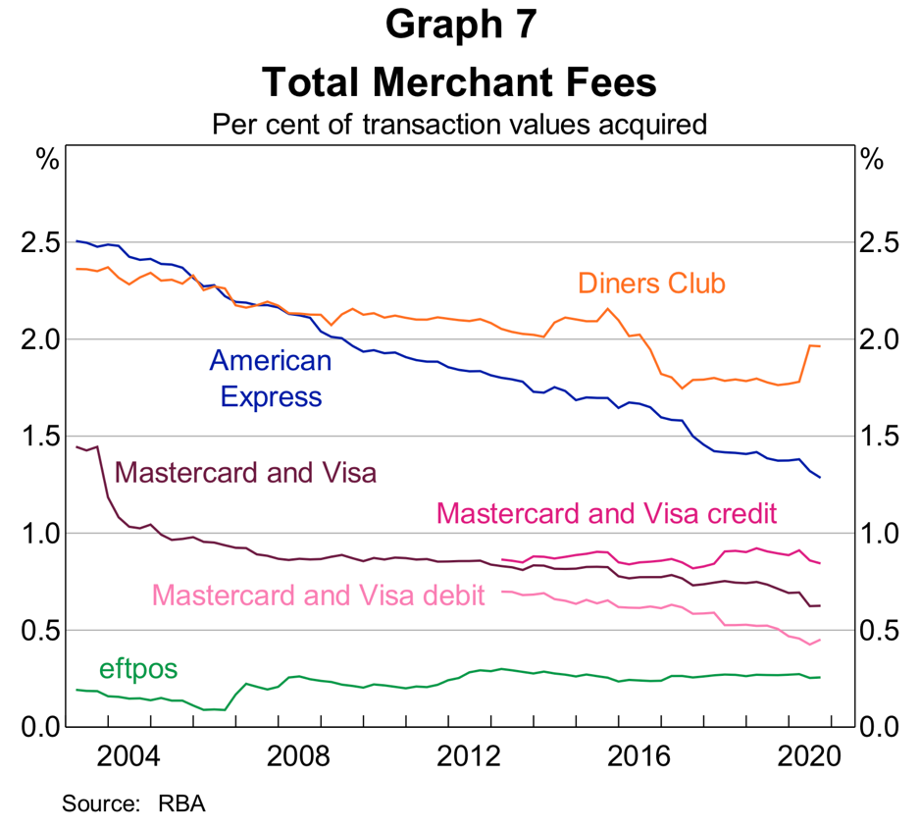

In closing I would congratulate the Reserve Bank for many of the actions taken in the past, on the regulations of payments, however if acquirers are not required to offer Merchant Choice Routing on an opt out basis, unfortunately we will see many SME merchants pay fees that are unjustifiably high, unfortunately for some of those merchants with ever increasing costs of rent, wages, insurance reduction in turnover due to Covid- 19, and other statutory costs, and the increasing costs of debit card acceptance along with more consumers wanting to purchase their goods using a Buy Now and Pay Later Scheme it will be too late, and many may simply have to close “shop” and put more employees on the unemployment scrap heap. We would encourage the Reserve Bank of Australia to reconsider some of it proposed decisions as outlined in the Review of Retail Payments regulation – Consultation Paper May 2021.
If the Reserve Bank would like to discuss this submission further, please contact Russell Zimmerman) at russell.zimmerman@sparkshoes.com.au or by mobile 0418 796 805.

Yours sincerely
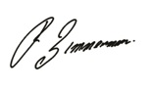
Russell Zimmerman
Russell Zimmerman Consulting
Merchant Consultant

