Dr Anthony Richards
Head of Payments Policy Department
Reserve Bank of Australia
GPO Box 3947
Sydney NSW 2001
3 February 2016

Via email: pysubmissions@rba.gov.au

Re: Submission to the RBA Review of Card Payments Regulation

Dear Dr Richards,

MasterCard welcomes the opportunity to participate in the Reserve Bank of Australia’s (‘RBA’) consultation process for its Review of Card Payments Regulation, which follows recent decisions taken by the Payments System Board (‘the Board’).

We have considered the options and recommendations from the perspective of the RBA’s mandate of controlling risk in the financial system, promoting the efficiency of the payments system and promoting competition in the market for payment services, consistent with the overall stability of the financial system. We have sought to make this response with this mandate in mind. We also note the objectives of the RBA and the Board in proposing these changes, including: to reduce the disparity in interchange between various segments of the market, to create a more level playing field in the payments system, to increase transparency for merchants and to reduce or overcome regulatory circumvention.

We also note that MasterCard and other industry participants proposed principles for an “industry solution” in early 2015 which would also have addressed these objectives, and we are pleased that several of the RBA’s recommendations have parallels with key components of the industry proposal.

The enclosed submission contains MasterCard’s response to the various proposals in the RBA’s Consultation Paper as well as our own set of recommendations, particularly on the subjects of interchange regulation and competitive neutrality.

It is important to recognise that our response is directly related to the Australian market where customer acceptance of electronic payments is high relative to other markets. Regulatory settings for Australia may not be appropriate for other international markets.

Considering the interests and perspectives of consumers, merchants, industry participants and other stakeholders in the payments system, MasterCard's guiding principles in making this submission are:
- An efficient and effective payment system;
- Protection of consumer benefits and mitigation of unnecessary cost impacts;
- Evidence-based decision making, which takes into account the real-life impacts (both intended and unintended) of previous regulation; and
- Recognition of the value electronic payments deliver to businesses, which is funded by Issuers.

In lieu of a commitment to deregulate the payments system and allow market efficiency, MasterCard’s position is that, absent an increase in the allowable weighted cap to better reflect the value delivered to merchants by interchange, we support the RBA’s proposal to retain the 0.50 per cent weighted average cap for credit interchange.

Interchange plays an important role in the payments system and provides significant value to both merchants and consumers. As evidence shows, lowering interchange would have significant unintended consequences, including consumers paying more and the stifling of payments system flexibility and competition.

We therefore believe the RBA has come to the right decision not to further lower the weighted average credit interchange below 0.50 per cent. Our concern, however, is that the RBA has not demonstrated an ongoing commitment to this decision in its Consultation Paper. Indeed, the RBA Paper states that the current review has not altered the RBA’s long-held view that there is little basis for interchange in our payments system.

Going forward, we therefore urge the RBA to reconsider this position and make a long-term commitment to its current decision on interchange, taking into account the considerable evidence of the value it provides to the payments system.

MasterCard’s enclosed submission addresses this point in greater detail as well as several other issues raised in the Consultation Paper, with particular emphasis on the following RBA recommendations:
- Ensuring flexibility in the payments system when setting interchange in order to promote efficiency and innovation. As such, a range of interchange rates for different products, payment options and industry groups is required in order to recognise the value provided to different participants in the system more accurately.
- Subjecting foreign issued MasterCard and Visa cards to Australian interchange regulation, whilst cards issued by other international networks fall outside the scope of regulation, systemically impacts some four-party networks’ regular cross-border business in Australia. It fails to reflect the value these cards provide for Australian merchants, the costs involved in processing these transactions across geographies and currencies and the different risk profiles of these cards.
- Inclusion of commercial cards in a 0.80 per cent interchange rate ceiling fails to recognise that these are different products with a different economic model when compared with consumer credit cards. This regulation would limit the ability to properly service Australian businesses and would also provide a competitive advantage to unregulated schemes such as American Express.
- Regulating American Express companion cards, which until now have been operating using interchange fee-like structures. This decision will take the strain off merchants who have been forced to wear higher acceptance costs given their prevalence, and from consumers, who have been cross-subsidising these higher cost cards. However, changes are needed to ensure there is not circumvention of the RBA’s intent with respect to these changes.
- Ongoing unequal and unfair treatment of three-party schemes and other payment systems relative to four-party regulated schemes, which continues to distort the market, adversely impact consumers, and create confusion for merchants. While designation (and intended regulation) of American Express companion cards is a positive first step, it is essential for competitive neutrality that all three-party systems, as well as digital payments aggregators such as PayPal, are regulated in the same way. There will not be true fairness for consumers, retailers and businesses while some payment systems are regulated and others are not.
- Moving away from a limit on surcharges based on the ‘reasonable cost of acceptance’ to one that will promote price signals to consumers, increase transparency on average acceptance costs for each network, and minimise the unintended consequences of excessive surcharging . Transparency of the fees paid by merchants is important for price signals to operate effectively. Therefore there is a need to ensure that all payment systems report these costs to merchants. We also welcome the ACCC’s mooted enforcement role in addressing unreasonably high surcharges.

As a participant in the Australian payments system since 1984, and having adapted to both the intended and unintended consequences of regulation, we are uniquely positioned to offer our considered recommendations in response to the RBA’s Review. Our interest is in finding ways to improve the payments system in a way that facilitates economic growth and best serves the public interest.

MasterCard looks forward to working with industry stakeholders and the RBA to develop an environment that recognises and accounts for the value that electronic transactions bring to the Australian economy as an efficient, convenient, cost-effective and safe means of transacting, and one that provides flexibility and competition, as well as facilitating a continued investment in innovation.

Yours sincerely,

Eddie Grobler
President, Australasian Division
MasterCard
About MasterCard

MasterCard is a technology company in the global payments industry that connects consumers, financial institutions, merchants, governments and businesses worldwide, enabling them to use electronic forms of payment instead of cash and cheques.
As the operator of the world’s fastest payments network, we facilitate the processing of payment transactions, including authorisation, clearing and settlement, and deliver related products and services. We make payments easier and more efficient by creating a wide range of payment solutions and services using our family of well-known brands, including MasterCard®, Maestro® and Cirrus®. We also provide value-added offerings such as loyalty and reward programmes, information services and consulting. Our network is designed to ensure safety and security for the global payments system.

MasterCard’s customers encompass a vast array of entities, including financial institutions and other entities that act as “Issuers” and “Acquirers”, as well as merchants, governments, telecommunication companies and other businesses. We do not issue cards, extend credit, determine or receive revenue from interest rates or other fees charged to cardholders by Issuers, or establish the rates charged by Acquirers in connection with merchants’ acceptance of MasterCard branded cards.

We generate revenue by charging fees to Issuers and Acquirers for providing transaction processing and other payment-related products and services, as well as by assessing these customers based primarily on the dollar volume of activity, or gross dollar volume (“GDV”), on the cards and other devices that carry our brands.

MasterCard Network – a typical transaction:

With a typical transaction involving four participants in addition to us our network supports what is often referred to as a “four-party” payments network. The following diagram depicts a typical transaction on our network, and our role in that transaction:
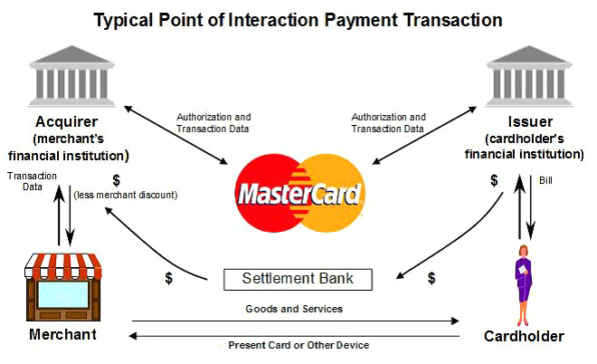

In a typical transaction, a cardholder (or an account holder who may not be using a physical card) purchases goods or services from a merchant using a card or other payment device. After the transaction is authorised by the Issuer, the Issuer pays the Acquirer an amount equal to the value of the transaction, minus interchange (described below), and then posts the transaction to the cardholder’s account. The Acquirer pays the amount of the purchase, net of a discount (referred to as the “Merchant Service Fee”, as further described below), to the merchant.

About Interchange

Interchange represents a sharing of a portion of payments system costs among the Issuers and Acquirers participating in our four-party payments system. It reflects the significant value merchants receive from accepting our products, which deliver highly valued benefits to cardholders and play a key role in balancing the costs consumers and merchants pay.

MasterCard does not earn revenue from interchange.

Generally, interchange is collected from Acquirers and paid to Issuers to reimburse the Issuers for a portion of the costs incurred by them in providing services that benefit all participants in the system, including Acquirers and merchants. In Australia, MasterCard is responsible for setting interchange, which facilitates the secure and efficient functioning of the Australian payments system. Interchange delivers major benefits to cardholders by:
- Covering the cost of fraud protection;
- Allowing cardholders to be repaid in the event of fraud;
- Paying for the interest free days on credit cards; and
- Funding investments in innovation such as ‘tap and go’ technologies.

Interchange delivers major benefits to merchants by:
- Allowing businesses to accept cards, which, among other things, increase sales;
- Guaranteeing payment and eradicating credit risk; and
- Funding innovation such as ‘tap and go’.

The interchange level can be deemed appropriate when it is set:
- Low enough for merchants to realise the economic benefits of accepting cards; and
- At a level that fairly compensates Issuers for the costs involved in issuing cards.

Interchange is set by MasterCard, taking relevant considerations into account such as the nature of the particular payment stream, the costs incurred by the recipients of interchange and the levels of cardholder usage and merchant acceptance.

Balancing the network of payments is therefore a complex process, which is best dictated by market forces. Artificial limits on interchange such as artificially lowered weighted averages or hard caps upset this balance and distort price signals to system participants.

Efficiencies of electronic payments compared with cash

Electronic payment use has grown considerably in recent years and the RBA has recognised they are “gradually replacing” paper-based methods such as cheques and cash. Electronic payments offer users benefits that cash simply cannot. They provide accuracy, efficiency and avoid operational costs associated with cash handling and security. In addition to the convenience electronic payments provide, they are clearly, the most cost effective means of transacting. The RBA recently assessed that resource costs for contactless payment technologies like ‘tap and go’ are similar to cash, even for transactions under $20.

There are also wider economic benefits of adopting electronic payment methods. Electronic payment use significantly reduces the shadow economy when compared to cash because it provides greater accuracy and transparency. This can have a considerable impact on national productivity. For example, the cost of cash to Australia’s economy between 2007 and 2011 has been estimated at 0.38 per cent of GDP.

The Value of Interchange

Electronic payments offer a wide range of benefits to all participants in the payments value chain – consumers and businesses who use our products to make payments; businesses that accept payments using our products; banks that issue and acquire MasterCard transactions; and governments. Like any valuable service with advanced technology behind it, where innovation and development is vital, it comes at a cost. Businesses pay a Merchant Service Fee (MSF) to Acquirers for acceptance and services, of which interchange is a component.

Flexible interchange rates are essential to ensure that merchants and consumers receive maximum value for electronic payments at the lowest costs. Flexible interchange rates also promote credit availability for small businesses and are a key driver for ensuring financial inclusion of unbanked consumers in many markets. Unfortunately, experience shows that when governments or regulators attempt to address cost concerns by reducing interchange, consumers and small businesses – including smaller merchants – actually suffer cost increases and reduced benefits. It is, therefore, essential that merchant concerns about interchange costs be examined and appropriately addressed. MasterCard is committed to doing this through direct engagement with merchants around the world. We believe this process will address merchant concerns while protecting consumers and merchants from the consequences of arbitrary interchange restrictions.

Australian Businesses

Business benefits in many ways as a result of interchange including reducing the significant costs associated with counting, safeguarding and transporting cash and limiting the losses that occur when cash received is lost or stolen. Merchants who accept cards also receive the most important commercial benefit: they increase sales. Studies show that consumers spend more when they use cards and merchants make more money when they accept cards. This is not surprising since shoppers using cards are not limited to cash on hand but can access their funds on deposit or credit available from their banks when they make their purchasing decisions. Interchange provides convenience, security and fraud prevention and supports the use of credit cards, which increases sales and guarantees payment for those businesses who accept MasterCard cards. For example, payment is guaranteed to the business when a good is sold but the cardholder does not pay their credit card bill.

Retailers

Retailers, in particular, have seen the value of interchange through increased speed at the point of sale, leveraging ‘tap and go’ or contactless transactions, reducing fraud, the cost of handling cash, and reducing the amount of cash held in stores (making stores safer for team members).

Consumers

Interchange delivers major benefits to consumers. Not only does it allow businesses to accept their cards, it contributes to the cost of fraud prevention and pays for the interest free days on credit cards. For example, in the event of a stolen card, MasterCard cardholders are protected from fraud or unauthorised transactions under MasterCard’s Zero Liability Policy (For more information visit http://www.mastercard.com.au/zero-liability.html)

Banks

Interchange helps card Issuers cover the eligible costs they incur, including processing and authorisation, fraud and fraud protection, and it funds new payment technologies. For example, interchange funds innovations in payment technologies like ‘tap and go’, which better facilitate transactions and improve customer service.

Society

Interchange is a core element of electronic payments, which reduce the black economy through transparency and efficiency. Research shows that electronic payments boost productivity and yield greater contribution to GDP than cash transactions. For example, under a cash payment system, a shopkeeper is able to charge a customer the full amount for a good but only declare 50 per cent of the revenue generated.

Governments

Electronic payments facilitate economic activity and provide the necessary infrastructure for citizens and businesses to interact in a financial ecosystem. Government and the public sector are major beneficiaries of interchange as they utilise many different payment options including commercial cards. For example, electronic payments have revolutionised welfare payments systems.

Response to the RBA’s Reform Options

MasterCard is pleased to provide feedback on the ‘Reform Options’ set out in the Consultation Paper. We acknowledge the key objectives which the paper aims to address, being: greater transparency of the payments system and interchange; reducing cost disparity between large and small businesses; and limiting the ability for circumvention of Payments System Regulation. These objectives are central to our response to the various options presented by the RBA. We note that MasterCard, in combination with other industry participants, proposed principles for an “industry solution” in early 2015 which would also have addressed each of these objectives, and we are pleased to observe some parallels between the RBA’s reform options and some key elements of the industry solution.

The following sections outline MasterCard’s response to three broad issues raised in the Consultation Paper:
- Interchange
- Competitive neutrality
- Surcharging

Interchange

MasterCard considers that the removal of Payments System Regulation in Australia would allow the market to set interchange optimally, and would also ensure a truly competitively neutral outcome for market participants.

Our interest in avoiding unnecessary interchange regulation extends beyond commercial objectives. Our broader focus is on growing electronic payments in a way that is sustainable, in turn providing the payments system with greater reliability, efficiency and safety than cash or any other method of payment. Interchange is key to making this happen.

MasterCard does not earn revenue from interchange. Our primary interest is setting interchange rates at levels that encourage the use of electronic payments.

The use of electronic payments also reduces the black economy and invites wider economic participation. Our interests therefore align with those of the Government.

The following sections detail MasterCard’s responses to relevant areas of interchange regulation as addressed in the RBA’s Consultation Paper. Specific recommendations are made at the end of each section.

Weighted-Average Benchmarking

Credit Interchange – Maintaining a Weighted Average of 0.50 per cent

Absent an increase in the weighted average cap to better reflect the value merchants receive from electronic payments, MasterCard supports the RBA’s recommendation to retain the current weighted average of 0.50 per cent for credit transactions. More specifically, we support maintenance of the weighted average of 0.50 per cent for consumer products, as detailed in each of our submissions to both the Federal Government’s Financial System Inquiry, and the subsequent RBA review process.

MasterCard also agrees with the RBA’s logic that it would be unwise to implement drastic changes to current interchange regulation, such as a hard cap or lower weighted average given the upcoming implementation of the New Payments Platform (NPP), ePAL hub and customer transition to mobile wallets, all of which are likely to occur over the next few years.

The NPP, in particular, is considered by many to represent a paradigm shift in the Australian payments sector, and its pending implementation and operation should not be impeded by further burdensome regulation at this critical juncture.

MasterCard requests the RBA provide the industry with a long term commitment not to further reduce interchange (for either credit, debit or prepaid, either at a weighted average or at an upper cap level). Such a commitment would provide a level of certainty for the industry, and would assist in business planning and investment decisions. We would support the RBA undertaking a detailed cost benefit study of electronic payments, in collaboration with the industry, to demonstrate the ongoing value that interchange delivers to merchants and to the broader economy. It would be valuable if that study could also consider the relative costs and benefits of cash to both merchants and to the economy, as well as comparing high resource cost payments schemes like American Express with regulated schemes such as MasterCard.

With regard to the RBA’s mandate of efficiency, the anticipated impacts of more regular interchange resets and upper caps will ensure the costs of accepting cash will exceed those of accepting interchange regulated payments schemes. There is therefore an opportunity for the RBA to partner with industry in an education campaign designed to drive down cash payments in Australia.

Our concern is that the comments made in the Review Paper in regards to possibly further lowering interchange in the future signals a fundamental disagreement on the role of interchange, and may be an indication of the RBA’s intention to reverse its current position and subsequently introduce a hard cap or lower weighted average on credit interchange in the future.

We strongly urge the RBA to hold firm in its position going forward to not lower interchange, taking into consideration the following:

Flexibility, Innovation and Productivity

Flexibility is required when setting the interchange rate, and retaining the current weighted average structure allows for greater payments system flexibility than would be possible if the average was lowered or a hard cap imposed. We strongly refute the RBA’s contention that flexibility has had adverse effects on efficiency. Flexible rates ensure merchants and consumers receive maximum value for electronic payments at the lowest possible cost. Hard caps, on the other hand, represent the blunt instrument of price setting. Flexibility in setting interchange rates enables price signals to work effectively.

Flexibility is also needed to set interchange in a way that incentivises innovation and efficiency. Issuers’ ability to implement new technology like ‘tap and go’ is partly derived from revenue generated by interchange. Banks and other Issuers have gone so far as to warn decision-makers that a reduction in interchange will reduce their ability to fund such innovations. With the flexibility that the current weighted average model provides, there is an ability to promote the introduction of new technology through targeted, lower interchange rates. It also allows MasterCard to incentivise the acceptance of more secure payment categories and grant lower industry rates where appropriate, for example zero interchange for the charity sector. There also needs to be recognition of the different servicing elements associated with commercial card programs as they provide the flexibility required to service small and large businesses and, along with the public sector – providing many solutions to meet their differing requirements.

The current interchange weighted average allows flexibility, and because of this, Australia is a leader in electronic payments, which improve productivity in the economy. Removing this flexibility in the future through adoption of a lower, hard cap, could have implications for Australia’s ability to innovate, particularly at a time when mobile payments are developing and will require significant investment by many parties in the payments ecosystem.

While we acknowledge the RBA’s goal of reducing the interchange disparity between large and small businesses, reducing flexibility by artificially limiting interchange rates will be detrimental to the overall productivity of the payments system. An inflexible interchange model does not provide an adequate return on investment for industry innovators, nor does it incentivise entry for new market players. The potential impact on productivity is such that the Senate Economics References Committee recommended in its recent report that a Productivity Commission inquiry be undertaken with a particular emphasis on interchange. In the event that a Productivity Commission inquiry into interchange does take place, MasterCard would be supportive.

Effect on Small and Medium Enterprises (SMEs)

Whilst MasterCard notes the RBA’s view that small and medium-sized merchants are unequally impacted by interchange rates, it must be equally cognisant of the benefits interchange provides to SMEs.

Interchange provides significant value to retailers and businesses that accept electronic payments including: delivering more customers, increased sales, reducing the requirement to handle cash and a payment guarantee. The latter ensures that retailers and businesses are paid by the card Issuer even if the consumer never pays for the good purchased. In fact, banks write off 2-4 per cent of credit card balances as losses – a cost which is significantly higher than the cost of MasterCard acceptance, and which would sit with retailers in the absence of interchange.

As MasterCard has argued in previous submissions to the Government and Regulators, the payments system must be carefully balanced. Experience shows that a payment network achieves its greatest efficiency and scale when the costs reflect the value that each of the participants in the payments system receives. Payments system regulation in the past, however, has distorted this balance and led to unintended consequences for end users.

The RBA has asserted that the interchange regulation implemented in 2003 resulted in lower Merchant Service Fees (MSFs) and therefore lower prices for consumers. Lower MSFs however do not, in themselves, validate the existence of interchange fee regulation. There remains a lack of evidence to support the argument that the cost savings merchants enjoyed through lower MSFs resulted in lower retail prices for consumers, as the RBA assumed they would. In 2006, the RBA acknowledged this, saying the flow in savings for merchants onto consumer prices was “difficult to measure”. The same conclusions have been drawn overseas by academics and consumer groups alike. Rather than lowering overall costs in the system, regulated interchange has shifted fixed costs away from merchants and on to other parties participating in the system, particularly consumers. Indeed, the RBA has conceded “the higher the interchange fee, therefore, the less the cardholder has to pay”.

Consumers have seen higher annual cardholder fees as a result of interchange regulation, whilst the shift in revenue away from banks has undermined their ability to provide Australians with critical services such as fraud prevention and interest-free repayment periods. The Customer-owned Banking Association (CoBA) has warned that a reduction in interchange would mean additional costs passed on to consumers through interest rates and annual fees, an issue that sparked a recent Senate Inquiry recommendation that this decision requires further consideration.

The unintended consequences of payments system regulation also extend to competition. CoBA again warned during the recent Senate Inquiry that lowering interchange would reduce several of its member banks’ capacity to issue low-rate credit cards. This is surely an outcome, however unintended, that would result in a distortion of consumer choice and a denial of cost savings, particularly given that 19 of the 20 lowest rate personal credit cards on the market are offered by CoBA institutions. This problem is further exacerbated by the fact that premium cards will also be adversely impacted by interchange regulation. Australia’s peak consumer association, CHOICE, has acknowledged that lowering interchange may make some cards more expensive.

Higher fees, coupled with surcharging and reduced loyalty benefits has meant that consumers have been most negatively affected by payments system regulation.

With excessive surcharging set to be banned and enforced by the ACCC, and the impending implementation of the New Payments Platform in 2017, MasterCard considers it appropriate that the RBA has opted not to pull multiple payments system levers at the one time. We suggest that the RBA provide an appropriate amount of time for the effects of this regulation to be seen and evaluated, notably the impact of regulation of companion cards. The need to avoid unintended consequences is only magnified by the lack of evidence to support that similar reforms to lower interchange have had any positive consumer impact.

Debit Interchange – Lowering the Weighted Average from 12 cents to 8 cents

MasterCard does not support the lowering of debit interchange. Debit is already a low cost payment option for merchants and reducing interchange from $0.12 to $0.08 fails absolutely to reflect the value delivered to merchants by debit, particularly when compared to the closest product to it – cash.

However, given the RBA’s interest in doing so, any decision must be based on data on the changes in transaction value. The RBA’s rationale that debit interchange should be lowered from a weighted average of $0.12 to a weighted average of $0.08 is not supported by changes to transaction value, as suggested by the RBA.

It is true that, since debit interchange has been regulated, average debit transactions in Australia have reduced from $60.96 in November 2006 (when debit interchange was first regulated) to $52.88, a 13 per cent reduction (in November 2015 – the most recent reported period).

Using the data, the RBA could seek to justify a lowering of weighted average debit interchange from $0.12 to $0.10, representing the same comparative reduction in rates.

However, the data does not support a lowering to $0.08, and we would respectfully request the RBA to adjust this recommendation to reflect the data.

Prepaid Interchange

Any regulation of prepaid interchange needs to ensure that a level playing field is achieved for all schemes whose customers issue prepaid products. The RBA has proposed that interchange for prepaid cards issued by MasterCard, Visa and EFTPOS be regulated. This proposal does not extend to prepaid cards issued by ‘unregulated’ schemes such as China Union Pay and American Express (both of which have prepaid cards in the Australian market). When considering the economics of prepaid cards, and the proposed upper cap, this proposal would create a major incentive for organisations to partner with unregulated schemes to issue a prepaid card which has a higher interchange rate, and is able to provide greater benefits to the cardholder. The RBA must consider regulation of all schemes who issue prepaid.

Prepaid products have the potential to improve competition in the banking sector, as they provide a mechanism for non-bank Issuers to provide services to cardholders. Local examples include Qantas and Velocity. Globally, services such as Simple Bank, Moven and others are entering the financial services sector via prepaid cards. A significant reduction in interchange could reduce the viability of these services and therefore reduce competition in the market.

Recommendation 1: Payments regulations of retail payments in Australia should be removed, to allow market forces to prevail which would allow consumers and merchants to avoid the unintended consequences of regulation, and to allow a truly competitively neutral environment to operate.
Recommendation 2 (a): Retain the weighted average for credit interchange at 0.50 per cent.
Recommendation 2 (b): Retain the weighted average for debit interchange at $0.12.

Recommendation 2 (c): In the event the Payment Systems Board rejects Recommendation 2 (b), then MasterCard strongly requests any reduction to the weighted average for debit interchange is moderated, so that the weighted average for debit interchange is set no lower than $0.10, as noted above.
Recommendation 2 (d): Ensure competitive neutrality for all Prepaid cards (including American Express and China Union Pay).
Recommendation 3: Provide a long-term commitment to the RBA’s current position of not lowering the weighted average or imposing a hard cap on interchange.

Benchmark Compliance

Whilst MasterCard supports the proposal to retain the weighted-average benchmark system, we oppose the introduction of quarterly compliance.

MasterCard acknowledges the RBA’s concerns about the ‘upwards drift’ of interchange above prescribed benchmarks. We fundamentally agree that a shorter reset cycle would be a viable means of combatting this trend. However, we contend that a reset as often as at the end of each quarter would be inappropriately burdensome on Issuers, Acquirers and merchants whose contracts with Acquirers allow for a MSF repricing event every time there are changes to interchange.

Every weighted average reset is a labour and technology intensive task, requiring allocation of appropriate resources to comply with regulation (which would be more productively spent on innovation and efficiency). Given the impact of seasonality of payments (that is, the changing payment patterns with major holidays and peak travel times) more frequent interchange resets (potentially quarterly) could prompt unintended resets due to seasonal factors rather than due to schemes’ interchange being over the cap for a period.

The three month reset proposal does not meet the RBA’s objectives of improving either competition or efficiency. It is not competitively neutral to impose these burdens on regulated schemes, whilst neglecting unregulated schemes. Additionally, it is clearly not an efficient allocation of the regulated element of the industry’s resources, which would be better directed to business development and innovation objectives.

While we support the maintenance of our current requirement to report interchange data on a quarterly basis, MasterCard believes that an annual weighted average reset (rather than every three years) will strike the appropriate balance between the upward drift of interchange and ensuring that industry participants are best placed to meet their compliance requirements.

Recommendation 4: Implement annual weighted average resets rather than quarterly compliance as set out in the Draft Standards.

Net Payments to Issuers

The RBA has proposed a system of annual reporting to certify that each scheme has not made any net payments to Issuers in any given year.

In proposing this change, the RBA’s objective is to ensure that regulatory circumvention is not available for American Express companion cards to provide additional revenue sources to Issuers over and above those which are available to the other four-party schemes. MasterCard is supportive of this objective.

However, we would propose that the appropriate certification should be made over the “life of any contract” (up to a maximum of ten years) with Issuers, such that amounts may be amortised over a period of up to ten years, and reported accordingly.

The reasons for this proposed change are as follows:
- There is a global trend for contracts to be over a longer period (up to ten years), so it follows that incentive payments should be amortised over the life of the contract;
- The commercial reality of contractual arrangements with Issuers is that incentive payments tend to be “front loaded” in the early year/s of a contract, for example to support innovation and the operational costs of migration and the implementation of new products. In those early years there often are ‘net payments’ made to Issuers. However, in the later years of the contract those net payments cease to occur and the quantum of incentive payments often markedly reduced. Importantly those contracts are always designed to ensure no net payments to Issuers over the life of the contract, regardless of the payments at the commencement of the contractual period; and
- If the current proposal (of annual certification) is to proceed, it is likely to breach the RBA’s own objective of competition. Specifically, in the proposed environment we anticipate that it would be extremely difficult for schemes to win significant business from their competitors without the ability to offer net incentive payments in the early year/s of a new contract, as these payments support switching costs incurred during the transition between schemes. This is likely to leave market shares stagnant and remove commercial levers that are currently available to market participants.

We propose that the Draft Standard be changed to reflect that that no net payments (exclusive of the regulated interchange payments) have been made to Issuers “over the life of” any contract (up to ten years) for the issuance of cards. The current standard identifies that net payments can be amortised over five years, and due to the current trend of contracts being entered into for up to ten years (both internationally and domestically), we consider that five years is too short. On that basis, we consider that there should be an amendment to Draft Standard no.1 of [ ] at clause 5.2(e)(iii) and to Draft Standard no.2 of [ ] at clause 5.2(e)(iii) to replace “5 consecutive Reporting Periods” with “10 consecutive Reporting Periods”.

Recommendation 5: Require reasonable reporting which declares that no net payments (exclusive of the regulated interchange payments) have been made to Issuers “over the life of” any contract (up to a maximum of ten years) for the issuance of cards. Such attestation could be completed on an annual basis.

Interchange Fee Ceiling

MasterCard considers that the RBA’s recommendation to supplement weighted average benchmarks with an interchange fee ceiling of 0.80 per cent is unreasonably low.
As outlined above, flexibility is needed when setting interchange in order to promote efficiency and fund innovation. As such, a range of interchange rates for different products, payment options and industry groups is required. MasterCard uses the flexibility allowed by current interchange arrangements to offer lower rates for transactions that should be incentivised in the industry’s best interests (we have previously done this for contactless transactions). This includes offering interchange rates of zero per cent on donations made to registered charities.

While we acknowledge the RBA’s (and the recent Senate Inquiry’s) views on these ‘strategic’ merchant interchange rates, a ceiling of 0.80 per cent is too low and jeopardises payments system efficiency.

If a credit interchange ceiling is to be introduced as the RBA has recommended, MasterCard considers that it would be more appropriately set at a minimum level of 1.00 per cent, with an exemption for commercial cards (as outlined below).

Recommendation 6: Any interchange ceiling rate should be set at a minimum of 1.00 per cent rather than 0.80 per cent (as proposed in the Draft Standards) with an exemption for commercial cards.

Regulation of Commercial Cards

MasterCard does not support the RBA’s recommendation to continue imposing regulation on Visa and MasterCard commercial credit cards, particularly in light of the introduction of a proposed low 0.80 per cent credit interchange ceiling. There is already an unfair advantage to three-party schemes that will be compounded by the severe reduction of interchange on these cards. Commercial payment cards are a very different product to consumer credit cards, and a one-size-fits-all regulatory approach is inappropriate. The complexity of servicing and provision of technology warrants an interchange that fairly reflects the value delivered to merchants when these cards are presented for payment while also compensating participants for their investment and risk.

Many Australian SMEs rely on their commercial cards as an important source of credit to keep business running when cash flow is insufficient to cover current expenses. These cards also simplify the process of purchasing inventory and supplies by replacing the cumbersome purchase order and cheque writing process traditionally used for these operations. While this may seem like a relatively modest benefit, it can be extremely beneficial to small merchants in that it enables them to focus on the business rather than administrative tasks. Artificial reductions in interchange have precisely the same impact on SMEs as they have on other cardholder - the costs of their cards go up when merchants who accept cards no longer pay for the benefits they receive.

Artificial interchange reductions can have an even more painful impact on SME’s - the reduction of credit availability. The flow of interchange enables Issuers to take more credit risk and extend more credit than would be possible if they were relying entirely on cardholders to compensate for that risk. When interchange is artificially reduced, Issuers may be forced to reduce risk to lower costs in an effort to offset the reduction in interchange revenue. Reduced risk means less credit availability which harms SMEs as both cardholders and acceptors of cards. Reduced credit availability means less credit extended to SMEs to run their businesses. Given the relatively sluggish lending to SMEs from other sources, reductions in credit card lending would be particularly painful. Reduced credit availability also means that the cardholders who purchase from SMEs will have less credit available to spend in their shops.

Defining a Commercial Card

A “Commercial Card” is a commercial payment system (commercial cards and/or virtual cards and associated software tools) which is very different to an individual consumer using their credit or debit card. Commercial programs address three distinct segments with different needs: small and medium enterprises, large businesses and public sector entities.

Commercial Cards are issued to businesses (an Australian Business Number and BAS statement are required) rather than individuals, and a number of accounts and cards may be provided to each business. The account is typically settled in its entirety by the entity at the end of the billing cycle – with very few instances of revolve (and therefore, interest being paid to banks). Those businesses who use commercial payment systems are provided with, and utilise, more services and data than consumers. This may include the tools needed to control, track and manage outgoing payments; protect suppliers; analyse spending patterns; better manage cash flows; and understand payment costs. In short, greater value is provided to the cardholder of commercial products. In addition to the Issuer and Acquirer, there are many more participants in the commercial payment system model including the card/account holder, the program administrator, and enhanced data providers (e.g. travel management company). There are also expense management and financial systems which increase service complexity and support costs and support the need for higher interchange.

Impact of the Proposed 0.80 per cent Interchange Ceiling

In the Consultation Paper, the RBA expressed scepticism that higher interchange payments were required to support commercial card programs and argued that a 0.80 per cent ceiling would bring about a “meaningful reduction” in commercial card costs.

We submit that the proposed low ceiling will go far beyond the RBA’s intended outcome and impact the payments system negatively in a number of ways. We ask the RBA to consider the following:

Impact on Competition

MasterCard calls on the RBA to examine the proposal for regulation of commercial payment systems through the lens of its competition mandate. It is essential that there is equal regulation of commercial cards between four-party and three-party schemes. Under the RBA’s proposed changes, however, three-party schemes such as American Express - which already has the lion’s share of the commercial payment system market - would be exempt from this regulation.

The economics of four-party commercial cards (where Issuers and Acquirers are not the same) mean that these schemes would be disproportionately affected by the low 0.80 per cent ceiling relative to three-party schemes, who with higher interchange rates (and merchant control) already offer considerably higher rebates to businesses.

The disparity between three and four party commercial card schemes will be amplified as any rebates that can currently be offered by regulated scheme Issuers will be further reduced or eliminated, making their cards less attractive to business. American Express is likely to grow even further in the sector, as it did with companion cards, due to their ability to provide low fees and higher rebates. The cost of acceptance of unregulated commercial cards would remain high, and these costs will be borne disproportionately by small businesses, as large corporations are offered strategic rates by American Express to drive broad acceptance.

Therefore, in our view, the effect of the RBA’s proposal will be to provide American Express with such a significant competitive advantage as to make four-party commercial cards obsolete, an outcome that is clearly inconsistent with its competition mandate.

The proposed regulation will, in addition, curtail competition by discouraging new market entrants given that interchange is the primary revenue received from commercial card programs, and income generated from interest is minimal.

Also, this proposal does not represent an efficient allocation of resources, considering the most attractive outcome for commercial card users (businesses) is likely to be the very scheme which has amongst the highest costs of acceptance for merchants.

Impact on Australian Businesses and Government

The current interchange rates are not high (in global or regional terms), and represent a low but fair value based on the complexity of the relationships within the commercial program market. A reduced interchange ceiling of 0.80 per cent will not be adequate to support existing commercial payment system programs and the benefits they provide. There may also be a negative effect on the public sector.

Reduction of interchange would slow investment and focus. It may even result in withdrawal by participants, which may mean business to business and business to government engagement could be severely slowed, and the benefits to efficiency and economic productivity reversed.

MasterCard strongly urges the RBA to take these potential outcomes, as well as their wider economic implications, into consideration when making a final decision on interchange regulation of commercial cards.

MasterCard’s Recommendations on Commercial Card Regulation

There is international precedent for commercial cards to be excluded from interchange regulation. In Europe, commercial cards are exempt from regulation in recognition that they have a different model than consumer cards.

If all schemes providing a commercial card are not able to be exempt from the regulation (including MasterCard and Visa), we propose that all commercial card products are regulated in the same way – that is, four and three party schemes (including American Express).

While our preferred option is for commercial payment systems to be exempt from regulation, the issues outlined in the consultation paper could be addressed simply by setting out criteria for the issuance of commercial cards and by allowing a higher cap (of 1.20 per cent) whilst continuing to calculate them within the weighted average.

Recommendation 7 (a): If American Express proprietary (including American Express commercial cards) continues to exist outside of interchange regulation, then to ensure competitive neutrality and consistency, four-party commercial cards should also exist outside of interchange regulation.
Recommendation 7 (b): If commercial cards are not exempt from regulation, that all commercial cards are regulated in the same way – including both three and four party schemes.
Recommendation 7 (c): Alternatively, if MasterCard and Visa commercial cards continue to be subjected to regulation for credit and debit interchange regulation, that an upper cap no lower than 1.20 per cent be applied which is restricted to commercial participants.

Foreign-issued Cards

MasterCard opposes the RBA’s recommendation to subject foreign-issued cards to domestic interchange regulation.

The issue of regulation of foreign issued, Australian acquired cards has not previously been raised in consultation either during the RBA’s Review of Card Payments, or during the Government’s Financial System Inquiry. Its inclusion at this point in the process has been a surprise to the industry, and seems inconsistent with the Bank’s usual consultation and decision-making processes.

MasterCard acknowledges the RBA’s motivation to recommend this regulation, given possible circumvention of the payments system, either via overseas issuance or more specifically the overuse of virtual cards by overseas Issuers. This is an issue that can be addressed; however an alternate, more targeted approach would be more appropriate. One such solution would require the use of virtual cards by any Australian business to only be provided by Issuers with a business in Australia, as opposed to being issued to any Australian business directly from an Issuer outside of Australia. For the sake of clarity, this would require foreign Issuers to issue virtual cards out of Australia, and therefore be subject to the same local interchange regulation.

The proposal to incorporate foreign-issued cards into the interchange cap does not recognise the immense value that they provide to Australian merchants via overseas consumers spending in Australia, either online or when travelling. The credit risk associated with foreign-issued cards is greater than that associated with domestic cards, and associated costs are borne by foreign Issuers for their consumers who are using the cards. The processing costs for an overseas transaction are higher than a domestic transaction due to the greater degree of complexity, risk and security protections, as well as the various currency differences which need balancing. As a result of this regulation, we believe the decline rates may increase for cardholders from overseas using their foreign issued cards in Australia, with a potential increase in the proportion of transactions declined of around five percentage points.

In order to participate in an international business community, it is also necessary to ensure that there is adequate protection for unsecured credit. Subjecting foreign-issued cards to Australian interchange rates will jeopardise the ability of financial institutions to provide cardholder services and may discourage foreign spending in Australia, having a major impact on the Australian tourism industry. This increased credit risk must be reflected in a capacity to allow higher interchange rates for foreign issue cards.

In addition, regulating only Visa and MasterCard and not regulating other schemes such as American Express, China Union Pay, Diners’ Club and JCB serves to further increase both the regulatory disparity and the existing cost differential for merchants.

For example, the number of Chinese visitors to Australia for the 12 months ending 30 November 2015 exceeded 1 million people, and is our largest source of tourism as a nation. Most of those tourists will be holding a China Union Pay card, which would completely avoid this proposed regulation. This is entirely inconsistent with the RBA’s objective of competition.

Considering the global implications that regulation of (some) foreign issued cards will have, we urge the RBA not to include them in regulation. Implementation of this recommendation would set a global precedent which would cost Australians more to use their cards.

Recommendation 8: Exclude foreign issued cards from Australian interchange regulation to ensure competitive neutrality with other ‘unregulated schemes’.

Competitive Neutrality

MasterCard believes some of the recommended options will exacerbate the uneven application of Payments System Regulation in Australia. Within the RBA’s proposals, certain schemes and products will remain ‘unregulated’, including:
- Prepaid Cards: In addition to its credit card business in Australia, American Express (proprietary) also has a prepaid business, which is not proposed to be regulated at present.
- Foreign Issued Cards: The current proposal for regulation of inbound interchange does not apply to all foreign issued cards, allowing some schemes to remain unregulated, which will have a greater impact on Australian businesses. Further, foreign-issued and domestically-acquired American Express proprietary cards are not proposed to be regulated, which would drive different consumer experiences and higher merchant costs for these cards than for other regulated schemes.
- Commercial Cards: The current proposal for the regulation of commercial cards does not apply to all schemes. There is greater incentive for Australian businesses to apply for a commercial card issued by an unregulated scheme, namely American Express.

MasterCard urges the RBA to address these issues to ensure that there is competitive neutrality throughout all regulations in the Payments System, whether they are three or four party models.

American Express Companion Card Regulation

MasterCard supports the RBA’s proposal to regulate American Express companion cards.
Until now, inequitable application of regulation across similar services in the payments system has negatively distorted economic outcomes. Through its companion card system, American Express has been allowed to operate an unregulated four-party scheme, which provides higher interchange-like fees to its Issuers, thus expanding the use of such cards and putting pressure on merchants to wear the higher costs of their acceptance.We are pleased the RBA has decided to correct this.

However, as indicated in our discussions with the RBA, MasterCard considers that the proposed Gazettal does not adequately guard against industry circumvention, which could negate the RBA’s objectives. For example, whilst banks and other organisations may not issue American Express cards, they could still promote and distribute them on behalf of American Express, in an unregulated manner. We consider that this loophole must be addressed by the RBA as a priority.

Anti-Circumvention of Companion Card Regulation

The current designation of American Express companion cards in Australia only applies to American Express cards which are issued by others. Based on the European experience, we consider that any promotion, marketing, agency or licencing arrangements and/or distribution of American Express cards should also be captured to prevent circumvention of the regulation. Also, any regulation should capture payments not only to Issuers, but also to any agents and intermediaries.

This approach would ensure that each of the following models are captured by regulation:
- Licensee model (Global Network Services - “GNS”): three-party schemes grant an issuing license to a bank to directly issue their customers with the scheme’s cards.
- Agency model: three-party scheme issues the cards and recruits the banks as agents to promote and distribute American Express cards to their own customer base. The bank receives, from the three-party scheme, an incentive similar to interchange.
- Referral model: the three-party scheme remains the Issuer, and it has a direct relationship with the cardholder. The partner (usually a bank) refers / provides three-party scheme access to its customers and, in return, receives a compensation similar to interchange.
- Co-brand model: American Express issues the cards and partners with a merchant who acts as agent to distribute card and provides American Express with privileged access to its customer base. The co-brand partner is compensated through a lower merchant service charge and through additional incentives (e.g. acquisition of airline frequent flyer points).

In all of the examples above, the three-party scheme (e.g. American Express) effectively operates as a four-party scheme model since they use an unaffiliated institution (the fourth party) to assist in the distribution of unregulated cards to the institution’s (bank or merchant) customer base.

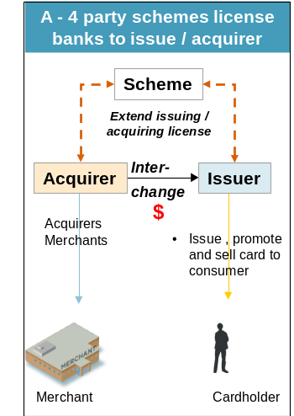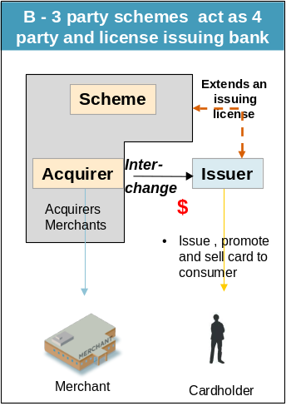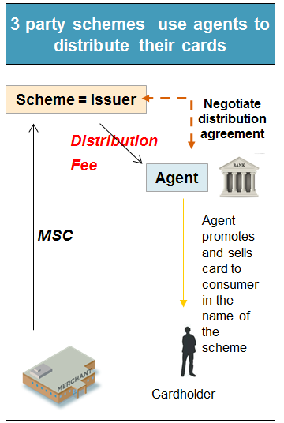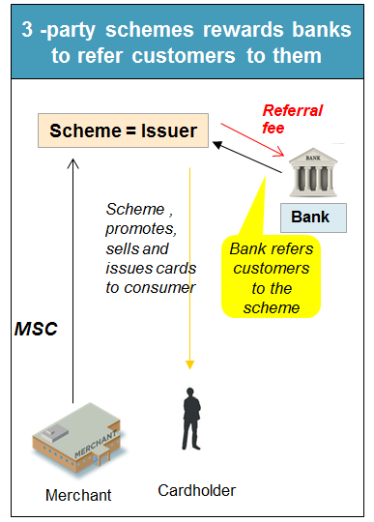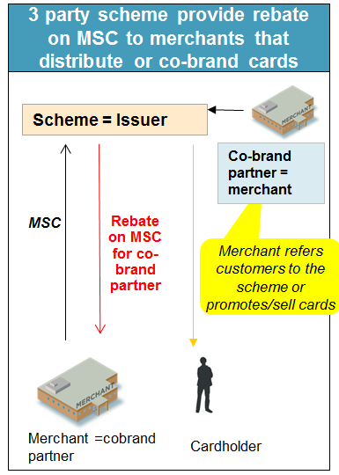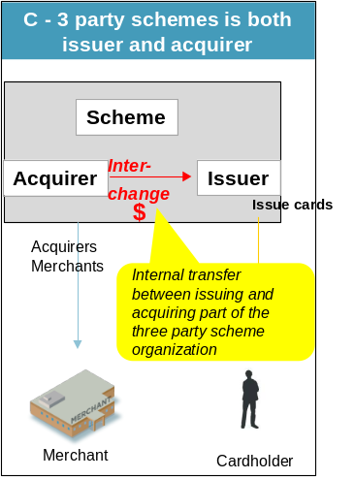

There have been instances in Europe where this circumvention has eventuated. A three-party scheme operating with a “licensee” or “agent” who issues/distributes the card receives funds from the scheme when the card is issued and/or every time the card is used. For example, a French bank issues/distributes American Express cards to consumers, and every time that American Express card is used by the cardholder that bank receives funds from American Express. Those funds may not be called interchange (they may be called “Issuer rates”, or “incentives”) but, economically, they are clearly interchange. And it should be obvious that if that bank only receives a regulated 0.30 per cent on MasterCard transactions, whereas it could continue to receive 1.70 per cent on every American Express transaction, the incentives are likely to drive less MasterCard and more American Express transactions.

Further, we believe that any incentives paid by a three-party system (including those having the attributes of a four-party system in the ways we describe above) should also be regulated so as to create a level playing field. At the moment for example there is no limit on payments that may be made by American Express to banks to incentivise those banks to develop the American Express brand by promoting its cards. Four-party systems on the other hand may incentivise banks only by an amount capped at the level of fees earned from those banks under the approach taken in Draft Standard No. 1.

The RBA may like to consider the following regulatory changes:
- Amending Designation No. 1 of 2015 pursuant to the “Designation under the Payment Systems (Regulation) Act 1998”, as follows:

In this designation, “American Express Companion Card” is any credit card bearing the name “American Express” and/or any logo, services mark, trade mark, trade name, tag line or other proprietary designation owned by the American Express Company that is issued, distributed, promoted, referred or issued as a co-brand proposition with a third party by an entity other than American Express Australia Limited or a related body corporate of American Express Australia Limited.
- Amending the proposed Draft Standard No. 1 of [ ] titled The Setting of Interchange Fees in the Designated Credit Card Schemes and Net Payments to Issuers, which is annexed to the RBA’s Review of Card Payments Regulation Consultation Paper dated December 2015 to extend it to American Express Companion Cards that are distributed other than via the standard issuing model.

Recommendation 9: Subject American Express companion credit cards to the proposed regulation set out in the Draft Standards with appropriate removal of the regulatory loopholes which remain at present.

Transparency for Merchants

It is also not clear what impacts the RBA’s proposal will have on merchants, in circumstances where some, but not all, American Express payments will be regulated. For example, it is unclear whether a merchant will be able to differentiate between a regulated American Express companion card and an unregulated American Express proprietary card, either at the point of sale or on their regular payments statements. Additionally, it is not clear whether a merchant would have the option of accepting American Express companion cards but rejecting (or charging an additional surcharge for) unregulated American Express proprietary cards.

Further, there is no imperative for the costs of American Express companion cards to be reduced for businesses, as there is no competition in acquiring for American Express.

Therefore we ask the RBA regulate all participants equally. In the absence of that we request the RBA provide clarity on these points for all market participants.

Recommendation 10: Merchants are provided transparent information regarding the costs of American Express companion cards and proprietary cards including the differences in their acceptance costs for American Express companion cards versus proprietary cards.

American Express Proprietary Cards

MasterCard does not support the RBA’s decision not to regulate three-party schemes such as American Express proprietary cards.

The RBA has justified its decision to leave American Express unregulated by arguing the combination of the voluntary undertaking on surcharging, the recommended formal regulation of American Express companion cards and the Government’s ban on excessive surcharging will result in equivalent treatment relative to other schemes.

MasterCard contends that the proposed measures do not sufficiently address the issue of competitive neutrality between American Express and regulated payment schemes. Unregulated schemes such as American Express proprietary cards remain far more expensive to accept than most credit cards. Merchant Service Fees for American Express remain more than double those applied by MasterCard and Visa. This is a direct result of the unevenness of the regulatory regime.
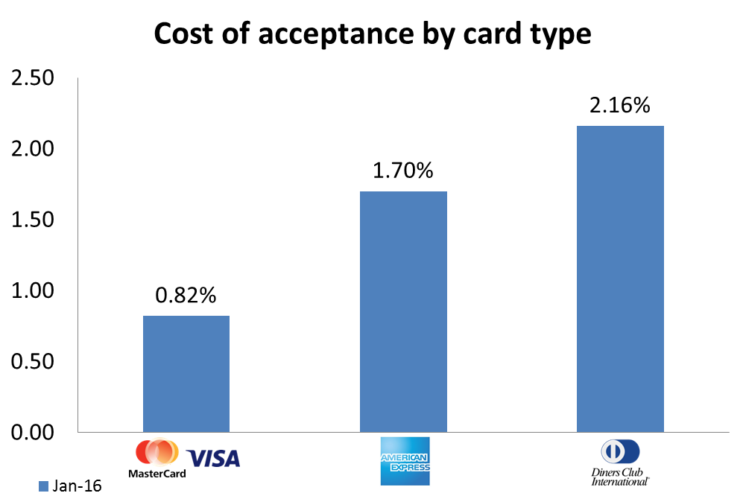

MasterCard asserts there is a complex web of interchange-like fees that are applied in proprietary three-party payment schemes. These fees functionally serve the same purpose and cover the same (or essentially the same) costs as interchange, but are not subject to regulation because they fall outside the RBA’s definition.

For example, the recent announcement that ApplePay will only be available to Australian consumers who use proprietary American Express cards goes to the very heart of this challenge and shows the unintended consequences of regulation in Australia. The result is that the card with the highest cost of acceptance for retailers and businesses (according to the RBA) is able to incentivise consumers and benefit from the work of MasterCard and Visa, who along with our acquiring customers, invested in the contactless infrastructure necessary for the unregulated proprietary American Express business to grow.

There will not be true fairness for consumers, retailers and businesses while some payment schemes are regulated and others are not.

Model for Regulation of Three-Party Schemes

It is important that the legislation guarantees a level playing field between four and three party schemes, and that in particular the “implicit interchange fee” in pure three-party schemes be captured.

For the regulation of three-party schemes, imposing accounting separation is essential in order to monitor internal transfer within three party schemes. We recommend that the RBA follow this model:

- Review the definition of interchange to regulate implicit interchange fees and consider potential discounts to merchants, and require:
  - The keeping of separate accounts for the activities associated with acquiring cards and the activities associated with issuing cards in the same manner, as would be the case if these activities were carried out by legally independent companies, and make transparent their internal transfer prices; and
  - That any net transfer received by the activities associated with issuing cards be treated as implicit interchange fee.
- Make transparent implicit interchange fees within three-party schemes by imposing accounting separation within the three-party schemes.
- Require the issuing business unit of three-party schemes to establish contracts with partners involved in the distribution/ promotion of their cards.
- Avoid that discount on MSF to merchants is linked to existence / performance of co-brand portfolios, i.e.:
  - Not allow rebates on Merchant Service Fees or other incentives to merchants involved in the distribution/ sales of cards and/or to existence / performance of card co-branded between three-party scheme and the merchant.

In addition to regulating the issuing of three-party systems, we also recommend, in the interest of increased competition, that the acquiring of three-party systems also be opened up to limit the current monopoly in acquiring for three-party schemes such as American Express.

Regulating Acquiring for Three-Party Payments

In contrast to four-party scheme transactions, there is no competition, at present, on acquiring three-party scheme transactions. Increased competition, together with the fact that the interchange that Acquirers would have to pay back to three-party scheme Issuers would be subject to an interchange fee cap, would reduce fees paid by merchants and would provide greater market transparency.

In Europe, the regulation requires three-party schemes to grant licenses on objective, non-discriminatory and proportionate grounds. This would allow independent Acquirers to get license from three-party schemes and then compete with three-party schemes in providing merchants acquiring services in relation to three-party scheme transactions.

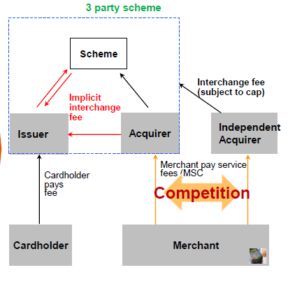

Recommendation 11 (a): Three-party schemes be regulated by splitting of Issuing and Acquiring segments of three-party schemes.
Recommendation 11 (b): Increase competition in Acquiring of three-party schemes.

Other Payment Schemes

Once again, regulating some, but not all, payment schemes will drive outcomes contrary to the RBA’s own objectives in relation to competition.

A level playing field means equal application of regulation for all participants in the payments system. This includes new and developing market entrants including new four-party schemes. Technological developments have encouraged new entrants who charge a fee for every transaction they handle. As a result, schemes such as PayPal and China Union Pay compete directly against existing, regulated networks.

It is also important that the scope of the proposed Regulation be expanded to digital wallets (as opposed to being limited to cards). In particular, the incentives that PayPal provides to an institution (e.g. a bank) that issues a PayPal wallet to its customers should be treated as interchange, and therefore subject to the proposed caps. In most cases, digital wallets operate as the merchant within the four-party scheme, and will therefore be provided by their Acquirer with more transparency. Digital wallets should be required to disclose this information to merchants that are paid through their services (the “sub-merchant”). More generally, digital wallets should be required to disclose to the sub-merchant the level of the fees that they pay to third parties for the funding of the wallet. For example, PayPal would have to disclose to a sub-merchant, with whom it has negotiated an MSF of 3 per cent of the transaction value, that it incurred funding costs of e.g. 0.5 per cent if the wallet is funded by a MasterCard card, and 1.4 per cent if the wallet is funded by a Visa credit card, etc.

Recommendation 12: To ensure a level playing field, regulation should be implemented for American Express proprietary cards, China Union Pay PayPal, Digital Wallets and other payment corporations.

Surcharging

MasterCard supports the Government’s action to ban surcharging beyond the ‘reasonable’ cost of acceptance and welcomes the RBA’s recommendation to support this with appropriate regulation.

The practice of surcharging is a side-effect of payments system regulation and has become prolific in Australia, costing Australians an estimated $1.6 billion per year. The RBA did not anticipate that surcharging would become so widespread, as the amount surcharged was intended to be limited to the “reasonable” cost of card acceptance. Instead, there has been a strong tendency for merchants to ‘blend’ surcharges or engage in other revenue-seeking behaviour under the guise of surcharging.

This has been compounded by the absence of a body and mechanism to police excessive surcharging and so we welcome the Government’s decision to now intervene and prevent anti-consumer behaviour. It is therefore appropriate that the ACCC has been tasked with the enforcement of these new regulations.

It is essential that all payment systems are treated equally under this regulation so, to increase transparency to merchants, all Acquirers (either three or four party) should be required to display the cost of each payment system (including American Express, Diners, and China Union Pay).

In addition, where there are products that are subject to different regulatory requirements, the cost of acceptance for these products should be separated (as they would be for Visa and MasterCard). An example of this is the acceptance cost difference between American Express companion cards and American Express proprietary cards. This will ensure that merchants have full transparency of the costs of different products resulting in consistency in treatment between schemes.

MasterCard recommends that blended surcharging between schemes of differing costs should not be allowed between regulated schemes and unregulated schemes, to avoid masking the higher costs of unregulated schemes. We support the objective that surcharging can send price signals for different networks and methods of payment, and so, where there is a cost differential (as there generally is between regulated and unregulated cards) this should be highlighted by the different surcharges applied.

The RBA may also consider providing merchants with information on the cost of cash so that there is full transparency across all methods of payment.

With Australian consumers in mind, MasterCard is pleased to see this recommendation and we urge the Government and regulators to continue putting consumers first when proposing these and future changes to the payments system.

Recommendation 13 (a): Ban excessive surcharging in line with the Government’s amendments to the Competition and Consumer Act 2010 as proposed in the Draft Standards, and that the ACCC should report regularly on its excessive surcharging enforcement activities.
Recommendation 13 (b): Blended surcharging between schemes of differing costs should not be allowed between regulated schemes and unregulated schemes, to reflect the higher costs of unregulated schemes.

Implementation and timelines

Given the complexity of the required changes and the number of participants in the system which will need to collaborate to make those changes, we urge implementation no earlier than 12 months and no later than 18 months from the finalisation of the package of changes. This will provide the industry with appropriate time to implement changes and ensure the continued stability of the payments system.

Conclusion and Recommendations

MasterCard welcomes the opportunity to participate further in the RBA’s consultation process. The issues addressed and recommendations set out in the Consultation Paper impact all Australians in some way and we are committed to growing electronic payments in a manner that services all market participants.

Electronic payments are a critical function in the Australian economy and regulatory decisions must not undermine the provision of essential services such as safe access to credit and security, or investments in innovation. Interchange is vital in providing such services and must not be forcibly lowered or we once again run the risk of considerable, negative unintended consequences.

While there are adjustments that we believe are required in the Draft Standards – particularly around foreign issued and commercial cards, as well as the proposed interchange ceiling – MasterCard supports the broader RBA decision not to uproot the interchange system through the imposition of a hard cap or lower weighted average.

Finally, we commend the Government’s decision on surcharging as well as the RBA’s move towards a more even regulatory playing field through the regulation of American Express companion cards.

Summary of Recommendations

Recommendation 1: Payments regulations of retail payments in Australia should be removed, to allow market forces to prevail which would allow consumers and merchants to avoid the unintended consequences of regulation, and to allow a truly competitively neutral environment to operate.

Recommendation 2 (a): Retain the weighted average for credit interchange at 0.50 per cent.

Recommendation 2 (b): Retain the weighted average for debit interchange at $0.12.

Recommendation 2 (c): In the event the Payment Systems Board rejects Recommendation 2 (b), then MasterCard strongly requests any reduction to the weighted average for debit interchange is moderated, so that the weighted average for debit interchange is set no lower than $0.10 as noted above.

Recommendation 2 (d): Ensure competitive neutrality for all prepaid cards (including American Express and China Union Pay).

Recommendation 3: Provide a long-term commitment to the RBA’s current position of not lowering the weighted average or imposing a hard cap on interchange.

Recommendation 4: Implement annual weighted average resets rather than quarterly compliance as set out in the Draft Standards.

Recommendation 5: Require reasonable reporting which declares that no net payments (exclusive of the regulated interchange payments) have been made to Issuers “over the life of” any contract (up to a maximum of ten years) for the issuance of cards. Such attestation could be completed on an annual basis.

Recommendation 6: Any interchange ceiling rate should be set at a minimum of 1.00 per cent, rather than 0.80 per cent (as proposed in the Draft Standards), with an exemption for commercial cards.

Recommendation 7 (a): If American Express proprietary (including American Express commercial cards) continues to exist outside of interchange regulation, then to ensure competitive neutrality and consistency, four-party commercial cards should also exist outside of interchange regulation.

Recommendation 7 (b): If commercial cards are not exempt from regulation, that all commercial cards are regulated in the same way – including both three and four party schemes.

Recommendation 7 (c): Alternatively, if MasterCard and Visa commercial cards continue to be subjected to regulation for credit and debit interchange regulation, that an upper cap no lower than 1.20 per cent be applied which is restricted to commercial participants.

Recommendation 8: Exclude foreign-issued cards from Australian interchange regulation to ensure competitive neutrality with other ‘unregulated schemes’.

Recommendation 9: Subject American Express companion credit cards to the proposed regulation set out in the Draft Standards, with appropriate removal of the regulatory loopholes which remain at present.

Recommendation 10: Merchants are provided transparent information regarding the costs of American Express companion cards and proprietary cards, including the differences in their acceptance costs for American Express companion cards versus proprietary cards.

Recommendation 11 (a): Three-party schemes be regulated by splitting of Issuing and Acquiring segments of 3 party schemes.

Recommendation 11 (b): Increase competition in Acquiring of Three-Party schemes.

Recommendation 12: To ensure a level playing field, regulation should be implemented for American Express proprietary cards, China Union Pay, PayPal, Digital Wallets and other payment corporations.

Recommendation 13 (a): Ban excessive surcharging in line with the Government’s amendments to the Competition and Consumer Act 2010 as proposed in the Draft Standards, and that the ACCC should report regularly on its excessive surcharging enforcement activities.

Recommendation 13 (b): Blended surcharging between schemes of differing costs should not be allowed between regulated schemes and unregulated schemes, to reflect the higher costs of unregulated schemes.

Bibliography
- Canstar database, 6 August 2015.
- Chan, I., Chong, S., and Mitchell, S., ‘The Personal Credit Card Market in Australia: Pricing over the Past Decade’, Reserve Bank of Australia Bulletin, March 2012
- CHOICE, submission to the Senate Inquiry on Matters Related to Credit Card Interest Rates, August, 2015 p. 28
- Cornell, A. (2015), “The RBA must put a Price on Innovation”; ANZ BlueNotes, 4 May 2015.
- Customer Owned Banking Association, submission to RBA, 30th April 2015, p. 4, viewed online at: <http://www.rba.gov.au/payments-system/reforms/submissions/review-of-card-payments-regulation/coba.pdf>
- Customer Owned Banking Association, Proof Committee Hansard, 3 September 2015
- Europe Economics (2013), ‘The Economic Impact of Interchange Fee Regulation in the UK’ p.1
- Freed, J. ‘Annual Chinese Visitor Numbers Exceed 1 Million for First Time’ in the Sydney Morning Herald, January 13, 2016, viewed at: http://www.smh.com.au/business/the-economy/annual-chinese-visitor-numbers-exceed-1-million-for-first-time-20160111-gm3shn.html
- Joint statement by consumer bodies expressing concerns about the European Commission’s proposal to regulate interchange on card transactions. Viewed online at: <http://www.parliament.uk/documents/commons-committees/european-scrutiny/Consumer-bodies.pdf>
- MasterCard Press Release, Galaxy Research 2015 ‘Aussies Slugged with $1.6 Billion in Credit Card Surcharges’ , viewed online at: http://newsroom.mastercard.com/asia-pacific/press-releases/aussies-slugged-1-6-billion-credit-card-surcharges/
- Payments System Board (2015), ‘Review of Card Payments Regulation Consultation Paper’
- Reserve Bank of Australia (2004), ‘Merchant Service Fees for Credit Cards’, Reserve Bank of Australia Bulletin, July
- Reserve Bank of Australia (2006) ‘Payments System Board Annual Report 2006’
- Reserve Bank of Australia, ‘Statistical Table: Average Merchant Fees for Debit, Credit and Charge Cards – C3’, 12 January 2016
- Reserve Bank of Australia Payments Data, ‘Debit Card Statistics – C5’, 12 January 2016
- Reserve Bank of Australia, Submission to the Senate Inquiry on Matters Related to Credit Card Interest Rates, August 2015, p.12
- Rodgers, D.: “Credit Losses at Australian Banks: 1980-2013”; Reserve Bank of Australia Research Discussion Paper, May 2015. pp 21.
- Senate Economics References Committee (2015), ‘Interest rates and informed choice in the Australian credit card market’, p. 97
- Stillman, R., Bishop, W., Malcolm, K., Hildebrandt, N., ‘Regulatory Intervention in the Payment Card Industry by the Reserve Bank of Australia’; CRA International, April 2008
- Zywicki, T. J.: “The Economics of Payment Card Interchange Fees and the Limits of Regulation”; International Centre for Law & Economics, June 2010. pp 11.

According to the RBA, credit card sales at large merchants are on average about three times as large as cash transactions. Chris Stewart, Iris Chan, Crystal Ossolinski, David Halperin and Paul Ryan, “The Evolution of Payment Costs in Australia, RBA Research Discussion Paper, 2014-14, Table B2, p. 60
Reserve Bank of Australia, ‘Review of Card Payments Regulation Issues Paper, March 2015’ in Reserve Bank of Australia website, p. 14
Stewart, C., Chan, I., Ossolinski, C., Halperin, D., Ryan, P. (2014) ‘The Evolution of Payment Costs in Australia’ Research Discussion Paper, Reserve Bank of Australia, p. 24
A.T. Kearney (2013) ‘The Shadow Economy in Europe’ p.3, viewed online at: https://www.atkearney.com/documents/10192/1743816/The+Shadow+Economy+in+Europe+2013.pdf
Denecker, O., Istace, F., Niederkorn, M. (2013) ‘Forging a Path to Payments Digitization’, in McKinsey on Payments, March 2013, no.16, p.5
Cornell, A. (2015), ‘The RBA must put a Price on Innovation’, ANZ BlueNotes
Senate Economics References Committee (2015), ‘Interest rates and informed choice in the Australian credit card market’, p. 97
Chan, I., Chong, S., and Mitchell, S., ‘The Personal Credit Card Market in Australia: Pricing over the Past Decade’, Reserve Bank of Australia Bulletin, March 2012, p. 60 www.rba.gov.au/publications/rdp/2014/pdf/rdp2014-14.pdf
Zywicki, T. J.: “The Economics of Payment Card Interchange Fees and the Limits of Regulation”; International Center for Law & Economics, June 2010. p 11 http://www.laweconcenter.org/images/articles/zywicki_interchange.pdf
Rodgers, D.: “Credit Losses at Australian Banks: 1980-2013”; Reserve Bank of Australia Research Discussion Paper, May 2015. p.21 http://www.rba.gov.au/publications/rdp/2015/pdf/rdp2015-06.pdf
Reserve Bank of Australia (2004), ‘Merchant Service Fees for Credit Cards’, Reserve Bank of Australia Bulletin, July
Reserve Bank of Australia (2006) ‘Payments System Board Annual Report 2006’
Joint statement by consumer bodies expressing concerns about the European Commission’s proposal to regulate interchange on card transactions. Viewed online at: <http://www.parliament.uk/documents/commons-committees/european-scrutiny/Consumer-bodies.pdf> and Europe Economics (2013), ‘The Economic Impact of Interchange Fee Regulation in the UK’ p.1
Reserve Bank of Australia, Submission to the Senate Inquiry on Matters Related to Credit Card Interest Rates, August 2015, p.12
Stillman, R., Bishop, W., Malcolm, K., Hildebrandt, N., ‘Regulatory Intervention in the Payment Card Industry by the Reserve Bank of Australia’; CRA International, April 2008
Customer Owned Banking Association, submission to RBA, 30th April 2015, p. 4 http://www.rba.gov.au/payments-system/reforms/submissions/review-of-card-payments-regulation/coba.pdf
Customer Owned Banking Association, Proof Committee Hansard, 3 September 2015, p. 25
Canstar database, 6 August 2015.
Reserve Bank of Australia Payments Data, Debit Card Statistics (C5), 12 January 2016; http://www.rba.gov.au/payments-and-infrastructure/resources/statistics/payments-data.html
The mathematics would better support a decrease from 12 cents to 10.4 cents
Freed, J. ‘Annual Chinese Visitor Numbers Exceed 1 Million for First Time’ in the Sydney Morning Herald, January 13, 2016, viewed at: <http://www.smh.com.au/business/the-economy/annual-chinese-visitor-numbers-exceed-1-million-for-first-time-20160111-gm3shn.html>
Reserve Bank of Australia, ‘Statistical Table: Average Merchant Fees for Debit, Credit and Charge Cards – C3’, 12 January, 2016
Cornell, A. (2015), ‘The RBA must put a Price on Innovation’ ANZ BlueNotes, 4 May 2015.
MasterCard Press Release, Galaxy Research 2015 ‘Aussies Slugged with $1.6 Billion in Credit Card Surcharges’ , viewed online at: <http://newsroom.mastercard.com/asia-pacific/press-releases/aussies-slugged-1-6-billion-credit-card-surcharges/>

