A Submission to the Reserve Bank of Australia’s Consultation to the Bank’s Standards for Credit Card Payments

Sinclair Davidson and Jason Potts

Summary
Having introduced inappropriate regulation in the early 2000s, the RBA has exposed Australian credit card users to excessive surcharging and profiteering. The RBA now proposes to introduce yet another round of regulation to overcome the earlier unintended consequences of its own actions. The fact is that the RBA still does not understand the role of interchange fees in a two-sided market, still relies on monopoly explanations for efficiency enhancing activity, and will further regulate and complicate the economy for no net benefit to the community.
There is a simple solution.
Allow credit card schemes to regulate themselves. The easiest and cheapest option would be to deregulate the payments system allowing credit card schemes to reintroduce a no surcharge rule.

On 3 December 2015 the Reserve Bank of Australia (RBA) called for formal written submissions into its draft surcharging and interchange standards. The RBA describes its framework for credit card surcharging as follows:
- Card schemes will not be permitted to make rules that prevent merchants from recovering part or all of the costs of accepting card payments.
- However, card acceptance costs will be defined more narrowly than in the Bank's current guidance note, as the merchant service fee and other fees paid to the merchant's bank (or other payment service provider).
- Statements provided by banks to merchants will be required to contain easy-to-understand information on the average cost of acceptance for each payment method, which will constitute the maximum permissible surcharge if the merchant chooses to surcharge.
- These statements will express acceptance costs in percentage terms, except where a merchant's cost of acceptance for a particular payment method is fixed across all transaction values. This should ensure that merchants – including in the airline industry – who wish to surcharge will typically do so in percentage terms rather than as a fixed dollar amount.
In this submission we address these points. Our argument is that the RBA has misunderstood the economics of interchange fees, and that its regulation of interchange fees has been entirely misguided. As such the RBA has created conditions whereby merchants have been able to profiteer from consumer payment choices. Rather than add an additional layer of complex and difficult-to-administer regulation the RBA should simply allow card schemes to reintroduce no surcharge rules. There is no public interest in having government regulators or government agencies regulate private business costs.
Merchants Incur Many Costs
The RBA predicates its regulation on the following observation:
Merchants incur costs when they process a payment from a customer and different payment methods can have very different costs.
…
When merchants have the right to apply a surcharge to more expensive payment methods they are able to provide price signals that encourage consumers to use payment methods that are less expensive.
This observation is trite. Merchants incur a multitude of costs when engaging in a transaction with consumers. Those merchants that are able to charge a price in excess of their costs earn a profit and those merchants that cannot charge a price in excess of their costs experience losses. Payment choice is just one of the many costs incurred when doing business. The RBA has never provided any explanation as to why consumers should consider merchant costs when making purchasing decisions. In particular there is no explanation why the payment system cost is more important than, say, labour costs, or rental costs, or some or other overhead cost. Consumers make purchasing decisions based on their subjective valuation and preferences.
The Economics of Interchange Fees
Interchange fees are fees that banks charge each other as a result of their respective clients entering into a credit card transaction. Credit card transactions are usually described as being “two-sided markets”. Credit card companies have to simultaneously meet the needs of two sets of end-users; consumers who employ credit cards as a payment mechanism, and merchants who accept credit cards as a payments mechanism. Interchange fees act as a mechanism to balance the competing interests of both consumers and merchants.
Rochet and Tirole (2003) provide an excellent exposition of interchange fees and the relationship created in a two-sided credit card market.

Figure 1: Rochet and Tirole depiction of an interchange fee
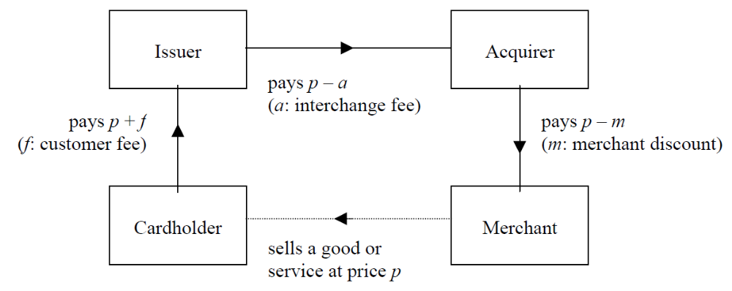
Source: Rochet and Tirole (2003: 74)
This depiction shows the net cash flows in the various relationships. The consumer (cardholder) buys goods and services from the merchant. The consumer then pays the price (p) and a net fee to his financial institution (Issuer). The consumer’s financial institution then pays the price (p) less the interchange fee (a) to the merchant’s financial institution (Acquirer) who then pays the merchant the price (p) less their own net fee.
If both financial institutions are to remain profitable then m > a. The merchant pays the interchange fee, i.e. the interchange fee is a cost of doing business that the merchant has to bear, when dealing with a consumer who chooses to pay by credit card. By contrast, the merchant does not have to bear that additional cost when dealing with a consumer who chooses to pay by cash. In theory this means that the profitability of the two types of transaction will be different – the merchant will earn a lower profit when accepting a credit card than they would when accepting cash. The implication then is that in order to earn a given level of profit merchants will increase their prices for all consumers. Despite this reasoning relying on some very strict ceteris paribus assumptions, the RBA has taken to describing that profit differential as a subsidy from cash consumers to credit card consumers. In this the RBA is following Stephen King.
And under a no-surcharge rule, these fees get hidden in the retail price and paid by all consumers. So under a no-surcharge rule, customers who pay by direct debit, cash or some other non-credit means, also pay for your reward points. Credit card users may like to force other consumers to pay for their reward points. But I doubt that such a hidden cross subsidy passes too many people’s concept of fairness.
Unfortunately Professor King produces no evidence to support the view that a No-Surcharge rule results in higher prices, as opposed to lower merchant profitability. If the RBA has ever been able to show that eliminating the No-Surcharge rule resulted in lower consumer prices that evidence is not in the public domain. In fact the RBA has admitted, “It is impossible – given the imprecision in any econometric model of consumer price inflation – to measure exactly how these reductions in merchant service fees have flowed through into prices for consumers.” We note that since January 2003, when the No-Surcharge Rule was eliminated, that the Consumer Price Index has increased from 78.6 in the March quarter of that year to 108 in the September quarter of 2015.
In any event Professor King’s more recent comments on the No-Surcharge Rule appear inconsistent with his previous work in collaboration with Professor Joshua Gans:
In the absence of a no surcharge rule, cooperative setting of interchange fees cannot have any anticompetitive effect.
Even in the presence of a no surcharge rule, the setting of interchange fees only creates competitive concerns if there is inadequate retail level competition.
Given that neither Professor King nor the RBA have produced any evidence to support the notion of “inadequate retail level competition” in Australia, it seems very unlikely that a no surcharge rule creates any competitive concerns. It is not immediately clear that there is any competition policy rationale for regulating either interchange fees or eliminating the No-Surcharge Rule.
If we accept there is an efficiency explanation for the emergence of the interchange fee (see Davidson and Potts 2015a), and note the fact that merchants, in the absence of regulation, tend to pay the interchange fee, then it is clear that merchants benefit more from credit card paying consumers than the foregone profits that a static analysis would suggest. In order for merchants to benefit from increased purchases from credit card consumers and for credit card companies to earn a profit by issuing credit cards, the increased profitability must be shared by credit card paying consumers. This is done by the merchant paying the interchange fee that in turn is used to provide reward benefits to credit card consumers. On this dynamic logic it is just as likely that credit card consumers expand the size and scope of the market and actually reduce prices that cash consumers pay. In this instance credit card consumers are subsidising cash consumers.
That relationship is guaranteed when the merchant is unable to explicitly price discriminate between consumers on the basis of payment method. A no surcharge rule protects the integrity of the two-sided market, and prevents free-riding on the part of (some) merchants. Those retail associations that have campaigned against interchange fees and/or no surcharge rules have been promoting free-riding with all the economic costs associated with that phenomenon.
If individual merchants did associate credit card payments with overall lower profitability there is nothing to stop them from:
- Refusing to accept credit card payments; or,
- Offering credit card consumers a discount for paying in cash.
Viewing the interchange fee relationship through an efficiency lens rather than a monopoly power lens leads to the conclusion that interchange fees are a mechanism to facilitate greater trade and commerce and the no surcharge rule exists to prevent free-riding.
An Accounting Cost is not an Economic Cost
The RBA proposes that the (average) accounting cost of accepting a credit card as payment be the maximum surcharge that a merchant can levy if choosing to surcharge. This proposal in no way overcomes the free-rider problem, it simply deflects criticism from the merchant and onto their bank. The underlying logic of this proposal is that the consumer should bear the cost of making a payment to the merchant and not the merchant. Yet it is not clear why a government agency should determine the incidence of costs in a private transaction – that incidence itself could and should be up for negotiation by the parties to the transaction. In any event, the RBA proposes that an accounting cost be employed as the surcharge amount; but it is well-known that accounting costs are crude proxies for economic costs.
Cost-Based Pricing
Prior to the “marginal revolution” in the early 1870s economists believed that prices were determined by input costs. The most famous variation of this view is the so-called labour theory of value. This approach to pricing is intuitively simple and easy to explain, yet it is not good business practice. Consumers do not value goods and services based upon their input prices, but rather on the subjective value those goods and services provide to the consumer. The RBA proposal mandates that businesses follow poor practice rather than enter into voluntary transactions with credit card providers and credit card consumers.
Economic costs are incurred by individuals when making a decision. They are subjective and very often unobservable. Objective and observable costs can only ever be the explicit after-the-fact costs that accountants can record. But a merchant making a sale does not compete on accounting costs, merchants compete on opportunity and economic costs. The decision to accept a credit card payment, for example, may facilitate the entire transaction. The opportunity cost of accepting or not accepting the credit card may not be the accounting cost of the credit card transaction, but rather losing the entire transaction. In this instance the wise merchant may choice to lower the surcharge, or indeed waive the surcharge. In this instance it becomes yet another margin of competition. An accounting treatment, however, may well see a diminishing of competition. At the very least it may reduce merchant demand for more efficient and cheaper payment technologies.
A further complication is that the cost of accepting a credit card will be consumer, firm, and context specific. Employing average accounting costs will mask the context specific situations consequently still exposing consumers to the hazards of excessive surcharging. The RBA will have to closely monitor and effectively second-guess the surcharging rates of nearly every merchant that chooses to surcharge. For example the cost of accepting a credit card payment from a highly credit-worthy individual who makes a purchase from a large firm must be very low to the banking system. By contrast that some transaction made by a less credit-worthy individual would be more expensive. So too if the credit-worthy individual made the same transaction at a small firm (or even a rural firm). It is simply not clear that allowing merchants to impose an average accounting cost as a surcharge will overcome any of these difficulties or provide any of the price signals that the RBA anticipates.
Just Another FuelWatch Scheme?
What the RBA proposes is very much like the discredited 2008 FuelWatch scheme proposed by the former Labor government. The proposal was that petrol retailers would be able to fix petrol prices for a 24 hour period to provide certainty to petrol consumers. What the RBA proposes is:
If merchants wish to surcharge for a particular payment method, they will use the information from their payments provider to determine the maximum permissible surcharge for each system. Merchants will be able to use the information on their average payment cost over a financial year to set their surcharge for the following year.
The RBA proposes that merchants fix their prices for a year based on lagged accounting costs. It is not at all clear how this will provide consumers with transparent price signals – especially if consumers are unable to inspect merchants’ annual bank statements.
The RBA Should Not Regulate Payments Systems
The RBA justifies its regulation of payment systems on anti-monopoly grounds:
Where merchants feel unable to decline particular cards (because consumers expect to be able to pay by that card and may take their business elsewhere if they cannot), the incentive is for card schemes to raise interchange rates.
This statement is entirely inconsistent with commercial reality. As any American Express card-holder knows merchants do not “feel unable to decline particular cards”. The decision to accept credit card payments is a commercial decision that merchants make – there is no justification for the RBA to second-guess those commercial decisions. In any event, the RBA statement is contradicted by the evidence reported in the 2000 joint RBA-ACCC analysis of Debit and Credit Card Schemes in Australia:
Interchange fees for MasterCard and Visa were last changed in the early 1990s. Australian members of each of the two schemes commissioned a review of the respective fees in the mid 1990s but no changes to fees resulted. Interchange fees for Bankcard have not changed since 1974.
As we have argued before (Davidson and Potts 2015b) the RBA is poorly placed to regulate the payments system. The economics of industry regulation, including the payments system, is a very different branch of economic theory and practice from monetary economics (the RBA’s primary specialisation). It is entirely based in microeconomic theory (not macroeconomic theory) and is focused on market behaviour under different degrees of competition and often incorporates transaction cost economics, models of technological and entrepreneurial competition, and models of strategy. Regulation of the payments system rules, including the bank interchange fee, is an issue of industrial organization, and competition policy. This is not the RBAs natural domain of competence.
Vague Benefits, Unknown Consequences
The RBA is remarkably vague when describing the benefits of its new policy setting:
The proposed reforms announced by the Government and the Reserve Bank will mean that consumers may still pay surcharges on some payment cards, but where they do, surcharges will be no more than the amount the merchant pays its bank or payments provider to accept that type of card.
Consumers are still paying a surcharge.
The proposed changes are likely to result in some reductions in the generosity of rewards programs on premium and companion cards and in the size of rebates paid on commercial cards. It is also possible that there may be some adjustment in annual fees on these cards.
While still paying a surcharge, consumers will also receive fewer reward points while incurring higher bank fees.
Banks and payments providers will have to ensure that the regular statements that they provide to merchants contain information on the average cost of each debit and credit card system. Merchants will also receive an annual statement at the end of each financial year that outlines the average cost of each payment method over the previous year.
The regulatory compliance burden for merchants and financial institutions will increase.
Hence, there should be little, if any, effect on interchange revenues of the smaller institutions, so little need for change to their business models.
The proposed policy will not benefit smaller financial institutions.
Small and medium-sized merchants … should see a material reduction in merchant service fees from the Bank's proposed reforms. This should improve their competitiveness relative to larger merchants who benefit from low interchange rates on all their card transactions.
It is unclear why these merchants – who seemingly are unable to surcharge now – will be able to surcharge after the proposed policy introduction. If larger merchants are being forced to effectively lower their prices (by lowering their surcharge) how does this make smaller merchants more competitive?

About the Authors
Sinclair Davidson is Professor of Institutional Economics in the School of Economics, Finance and Marketing at RMIT University, and a Senior Fellow at the Institute of Public Affairs. He is a regular contributor to public debate. His opinion pieces have been published in The Age, The Australian, Australian Financial Review, Sydney Morning Herald, and Wall Street Journal Asia. Sinclair has published in academic journals such as the European Journal of Political Economy, Journal of Economic Behavior and Organization, and the Cato Journal.

Jason Potts is Professor of Economics in the School of Economics, Finance and Marketing at RMIT University, an Australian Research Council Future Fellow, and also an Adjunct Fellow at the Institute of Public Affairs. He has written five books and over 70 articles on the theory of economic evolution. His work focuses on how entrepreneurship and innovation drive economic growth and development. Jason has published in academic journals such as Journal of Economic Behavior and Organisation, Journal of Institutional Economics, and Economic Affairs.

Appendix 1: Australian Interchange Fee Regulation:
A Regulation in Search of Market Failure

Sinclair Davidson and Jason Potts

Executive Summary
The Reserve Bank of Australia has been a world leader in interchange fee regulation. In this paper we suggest that this regulatory intervention has been based on wishful thinking at best and represents a failure to understand the actual working of the market economy.
In short, the Reserve Bank of Australia engaged in an extensive regulatory intervention based on poor theory, and no empirical evidence. Theory has not provided an unambiguous indication of market failure, and there is no empirical evidence to support the notion of monopoly pricing – other than a vague notion that interchange fees were “excessive”. What the Reserve Bank identified as being “externality” any fair minded observer would label “gains from trade”.
We argue that interchange fees are the outcome of an efficient bargaining process given that banks and consumers, and banks and merchants form long term relationships with each other. For as long as there is competition in the banking sector and competition in the retail sector, the interchange fee itself is subject to competitive pressure.
There is no market failure and no economic justification for government intervention. The $13 billion “saving” to merchants that the Reserve Bank identifies following its regulatory reform is simply a redistribution away from consumers (and banks) towards merchants. The Reserve Bank assumes that the saving has been passed onto consumers, but cannot provide any evidence to support that hypothesis.
It is not at all clear that consumers have benefited from interchange fee regulation. To the contrary is likely that consumers are worse off – while merchant fees have declined, so too have the benefits of using credits while the costs (including the interest rate premium over the cash) have increased.

- Introduction
Ronald Coase famously argued that “if an economist finds something – a business practice of one sort or other – that he does not understand, he looks for a monopoly explanation”. So it is with credit card interchange fees. As we will demonstrate intellectual confusion has lead to the phenomenon of interchange fees being misdiagnosed as being a monopoly problem leading to inappropriate policy intervention. Following George Stigler’s path breaking analysis of the US Security and Exchange Commission he claimed that financial regulation was “founded upon prejudice and … reforms are directed by wishfulness”. In our opinion, Australian regulation of interchange fees should be placed into the same category: reforms initiated by ignorance and anti-bank prejudice.
A 2000 joint study by the Reserve Bank and Australian Consumer and Competition Commission concluded inter alia:,
II Credit card interchange fees are significantly above levels suggested by cost-based methodologies and contribute to margins of revenues over average costs of around 39 per cent for card issuers. …
IV ‘No surcharge’ rules in credit card schemes prevent purchasers from confronting the cost of this payment instrument vis-à-vis lower cost payment instruments such as debit cards. It means that other consumers subsidise credit cardholders and financial institutions which are card scheme members. An alternative arrangement would have merchants exercising discretion to charge customers prices that are net of the cost of the payment instrument, and add a surcharge to cover that cost.
V Competition in credit card issuing and acquiring is limited by restrictions on access to credit card schemes. Excluding all institutions other than authorised deposit-takers from access to acquiring, in particular, is difficult to justify on risk grounds.
…
Interchange fees are set by card issuers and acquirers at ‘one step removed’ from the cardholders and merchants who ultimately bear these fees through transaction charges or through the general cost of goods and services. Users therefore do not have a direct influence on the pricing of card payment services but must rely on their financial institutions to represent their interests. As a consequence, the price signals and competitive responses that would be expected to put pressure on margins in card payment networks have not worked effectively. These difficulties are reinforced by restrictions on access to the card networks, both explicit and informal, and by the ‘no surcharge’ rules in credit card schemes.
The regulatory concerns then relate to excessive pricing, price fixing, abuse of market power, the creation of barriers to entry, increased consumers prices generally, and excessive use of credit cards relative to alternate payment methods. The fact that end-users do not observe the interchange fee makes it opaque, and less prone to competitive pressure. All these arguments suggest that regulatory intervention can easily correct these apparent market flaws and result in improve economic performance.
As a result of these concerns and the apparent ease at which corrective action could be undertaken Australia embarked on a program of regulatory intervention. In this paper, we argue that the regulatory concerns were over-sold and rely on a faulty understanding of the underlying economic principles. There is no case for intervention.
The remainder of the paper is set out as follows. In section 2 we explain what an interchange fee is. In section three we critique the Australian arguments for regulatory intervention and show data as to consequences of that intervention. In section 4 we provide alternative, non-monopoly but efficiency enhancing, explanations for interchange fees.
- What is an interchange fee?
Interchange fees are fees that banks charge each other as a result of their respective clients entering into a credit card transaction. Figure 1 below shows how the Reserve Bank of Australia depicts an interchange fee. The figure shows a stylised (four-party system) example of transactions involving a credit card.
The consumer (cardholder) purchases goods and services from a merchant and pays for the goods and service using a credit card. Underpinning that particular transaction is two prior transactions and a long-term relationship. The first prior transaction is between the consumer and their own financial institution whereby they acquire a credit card and pay a fee for the credit card use. As part of that transaction the consumer may or may not earn reward points as a function of the credit card usage. The second prior transaction is between the merchant and their financial institution whereby the merchant pays a fee to their financial institution in order to process credit card payments. The long-term relationship is between the two financial institutions that provide financial services to the consumer and merchant.
When the merchant sells goods and services to the consumer, the consumer authorises his financial institution to pay a sum of money to the merchant. The merchant passes the authorisation to his financial institution which then collects the money from the consumer’s financial institution and pays the merchant. Finally the consumer’s financial institution gets paid once the consumer pays off their outstanding credit card balance.

Figure 1: RBA depiction of an interchange fee
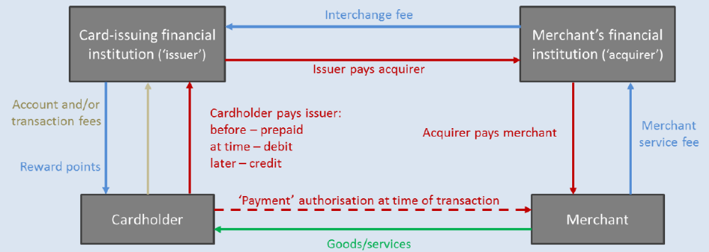
Source: RBA 2015, pg. 6
The interchange fee is a fee paid by the merchant’s bank to the consumer’s bank.
Neoclassical economists describe this type of arrangement as being a “two-sided” market. Two-sided markets consist of two sets of end-users who have their needs met simultaneously. In this case the credit card example the two sets of users include consumers who use the credit (card holders) and merchants who accept the card. The card itself is useless if either consumers will not use the card, or merchants will not accept the card in payment. Credit card companies, or associations, have a joint maximisation problem: maximising the number of consumers who will use the card and maximising the number of merchants that will accept the card. The incentives facing consumers and merchants being somewhat different Hayashi and Weiner argue that the interchange fee “an instrument that networks can use to achieve a desired balance of cardholder usage versus merchant acceptance across the two sides of the market … In other words, interchange fees are a mechanism that can be used to transfer revenues from one side of the market to the other to generate the desired level of card activity.”
There are two issues of importance.
- The direction the interchange fee flows in.
- The magnitude of the interchange fee.
In most credit card systems the interchange fee flows from the merchant side of the transaction towards the consumer side of the transaction. This implies that in some economies consumers require more of an inducement to hold and use credit cards than merchants need to accept those cards. To argue that this relationship is somehow inefficient is to argue that consumers have monopoly power over merchants. While it is true that merchants are subject to consumer sovereignty few economists, or policy makers, would argue that consumers have monopoly power over merchants, or if they did that this monopoly power should be restrained.
There is a rich academic theoretical literature that considers the magnitude of the interchange fee. In their 2006 survey paper, Hayashi and Weiner categorise the theoretical literature into one of four categories.
- Assumptions about the (credit card) networks. Are the networks themselves competitive, or monopolies?
- Assumptions about financial institutions. Are financial institutions competitive or monopolies?
- Assumptions about consumers and merchants. Do merchants have monopoly power? Do consumers have single cards or multiple cards?
- Other factors that might be important. What network rules are in place? No-surcharge rules? Honour all card rules?
Recall that the regulatory concern relating to credit card interchange fees is that the fees themselves were opaque, excessive, and encouraged excessive usage of credit cards relative to other payments mechanisms.
With a rich theoretical literature, including contributions from the 2014 economics laureate Jean Tirole, we might expect that clear unambiguous theoretical results could inform real world observations and shed light on the need, if any, for regulatory intervention. That, however, is not the case. For example, Katz (2001) reports that monopolistic networks with no-surcharge rules and reward points will result in excessive credit card use. That result appears to be consistent with the regulatory concerns. But credit card networks are not monopolistic. Studies that assume competitive networks have conflicting results. Rochet and Tirole (2002) show that if networks are competitive and consumers hold more than one card that interchange fees are not affected. But if consumers do not hold more than one card that merchants reduce acceptance of cards and interchange fees fall. In the same paper, however, they also show that even if networks are monopolistic as long as financial institutions are competitive (in issuing credit cards) that interchange fees will fall. Several other papers show similar mixed results. Interchange fees may either be higher or lower depending on the assumptions made in the analysis.
Importantly for our purposes, changing assumptions about network rules such as the no-surcharge rule or honour all cards rule has differing results. Again interchange fees could be higher or lower depends on a host of other factors or assumptions being made in the analysis.
After an extensive survey of the literature Hayashi and Weiner conclude:
What one comes away with after surveying this rich theoretical literature is an appreciation for the many factors that may affect interchange fees. Even a single factor may impact interchange fees differently, depending on other factors. Determining the actual impact of such variables is, in the end, an empirical question.
What that implies is that the theoretical results are not robust to changes in the underlying assumptions in the modelling. The 1990 economics laureate Merton Miller has claimed that there is nothing more practical than good theory. By that benchmark the theoretical analysis of interchange fees is simply not good theory as it give no practical guidance to what we might expect to observe in the real world.
In a 2003 paper Rochet and Tirole had come to the same conclusion, summarising the theoretical academic literature as follows:
On the contrary, recent academic work concurs to establishing that there is no systematic bias in the IFs selected by cooperative networks: there is no reason to think that privately optimal IFs are higher or lower than socially optimal ones. Misunderstanding the economics of the problem and imposing cost-based regulation could impose substantial distortions in the industry.
They are even more damning that Hayashi and Weiner. Rochet and Tirole claim, quite correctly as we will argue below, that the very nature of the economic problem at hand has been misunderstood.
- The Australian literature
Rochet and Tirole establish the basis for public intervention in markets as being a two-fold process:
The standard approach to public intervention in industries involves two steps:
(1) the theoretical identification of a serious market failure and the validation of its empirical relevance,
(2) the identification of the least distortionary way of addressing the market failure and a check that the remedy will not be worse than the illness.
As we have shown above, the very first step of that process has not been achieved. There is no theoretical basis for regulation of interchange fees. Rochet and Tirole are clear – the problem is a misunderstanding of the economics. In this section we highlight those misunderstandings in the Australian literature.
The Australian literature on interchange fees consists of a joint report by the RBA – ACCC, a series of papers by Joshua Gans and Stephen King, and a more recent 2015 Reserve Bank of Australia Issues paper. In this section, we mostly focus our attention on the work undertaken by the Reserve Bank.
The RBA – ACCC report provides a description of credit card networks as per figure 1. It then describes how networks provide benefits to users (both consumers and merchants) as they increase in size i.e. more consumers hold a particular card and/or more merchants accept that particular card. Rather than considering an increase in network size as an increase in the size of the market and therefore any benefits flowing from that increase as being the gains from trade, the RBA – ACCC report instead views the benefits as being an externality. This, in our opinion, constitutes a methodological error. Gains from trade constitute a benefit of the market mechanism, while externalities arise from market failure.
In this particular case the argument is that a network can generate positive externalities for users (suggesting that it should increase in size), but negative externalities for non-users (suggesting that networks can become too big). This possibility occurs if and when the merchant has monopoly power and can pass their service fees (including the interchange fee, see figure 2 below) onto consumers. At this point the interchange fee could be increased and result in greater private benefits to cardholders but higher prices to non-card holders. Given a somewhat non-standard definition of efficiency, “A payment network is said to operate efficiently if the net benefits it provides to society are being maximised”, the RBA – ACCC study is able to argue that credit card networks may be too large in Australia. Definitions of efficiency would normally suggest that an institution or process was meeting stated objectives at least possible cost. The argument here results in the proposition that increased competition to expand the network could result in increasing prices if merchants have some monopoly power.
The problem being exacerbated, the RBA – ACCC claim, by the fact that cardholders and merchants “are not involved in determining the interchange fee”. As we argue below, that statement is not strictly speaking true. It is correct to say that the interchange fee is not established in a spot market, but to argue that cardholders and merchants are not involved in overall price determination in a network is simply incorrect.
Nonetheless in the early 2000s Australia embarked on a series of regulatory interventions. The Reserve Bank of Australia announced its intention to introduce a series of reforms in August 2002. See table 1 for a time-line of reforms.
Hayashi and Weiner are blunt in their assessment of the literature and regulation in Australia: “None of the models appears to closely fir the Australian market over a large number of parameters”. In other words there is no theoretical basis to support the introduction of regulation in Australia.
Table 1: A time line of payment reforms
Date | Reform
October 200 | Joint RBA – ACCC study published
December 2001 | RBA consultation document released
August 2002 | Intention to reform announced
January 2003 | No Surcharge Rule eliminated
July 2003 | Interchange fees capped
January 2004 | Access regime modified
February 2004 | Debit card reform (Visa)
September 2004 | Debit card reform (MasterCard)
April 2006 | Debit card reforms announced
July 2006 | Debit card reforms implemented
November 2006 | Common cost-based Interchange fee Benchmark introduced
January 2007 | Honour all card rule abolished
Source: Authors, RBA 2015
Two Australian academics, Joshua Gans (now at Toronto University) and Stephen King (now at Monash University) have published a series of theoretical papers looking at interchange fees and regulatory concerns in credit card markets. It is fair to say that their views, while in favour of regulation, are nuanced. Overall their view is that the no-surcharge rule should be eliminated and as a result the interchange fee would become irrelevant. There is no need then to both eliminate the no-surcharge rule and regulate interchange fees.
The Gans and King analysis is predicated on resolving what they refer to as being “the inefficiency”. They define an efficient transaction as follows:
If a credit card transaction was efficient then it would probably be implemented if the customer and merchant as joint consumers and the issuer and acquirer as joint suppliers all negotiated over that transaction.
They refer to this description of a transaction as being Coasian bargaining after the economics laureate Ronald Coase. They are making, at least, two errors at this point. First they are characterising only spot market transactions as possibly being efficient. Second they are ignoring the efficiency gains that can come about by entering into long-term relationships. We discuss this in greater detail in the next section. For our purposes here it is important to note that the inefficiency that Gans and King analyse is an assumption based on a methodological error.
They then canvass three possible “solutions” to their “inefficiency”. The first solution involves horizontal integration – the two financial institutions merge into one (converting a four party credit card system into a three party credit card system). This is how American Express and Diner’s Club are organised. In practice, however, the costs associated with those two providers tend to be higher than those associated with four-party systems (see exhibit 1). Alternatively a no-surcharge rule could resolve the inefficiency, or the existence of interchange fees could resolve the inefficiency.
Exhibit 1: Merchant Service Fees across four-party systems and three-party systems
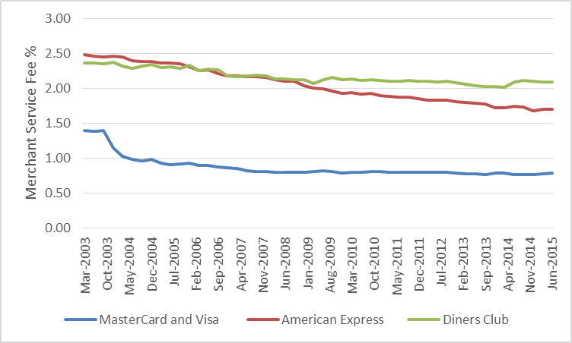
Source: RBA Statistics
Gans and King are of the opinion that in the absence of a no-surcharge rule that interchange fees are competitively neutral. The RBA – ACCC was concerned that excessively high interchange fees would distort consumer preferences towards excessive usage of credit cards relative to other payment mechanisms. A consequence of this possibility is that cash paying consumers pay too much for their goods and services and effectively “cross-subsidise” credit card paying consumers. Rather than have regulators set prices, Gans and King prefer regulators to eliminate the no-surcharge rule allowing merchants to charge differential prices (if the market will bear a price differential) depending on payment mechanism. They sum up:
In the absence of a no surcharge rule, cooperative setting of interchange fees cannot have any anticompetitive effect.
Even in the presence of a no surcharge rule, the setting of interchange fees only creates competitive concerns if there is inadequate retail level competition.
Overall Gans and King consider the no-surcharge rule and the interchange fee as substitutes and argue that eliminating the no-surcharge rule makes regulating the interchange fee redundant. Overall, they doubted that the RBA interventions would result in many benefits.
In summary, our analysis casts doubt on the benefits that will be created by the RBA’s credit card reforms. While allowing surcharging makes sense, it is not certain that the regulated approach to interchange fees adopted by the RBA will lead to lower costs of transacting.
While we believe the Gans and King analyses are methodologically flawed it is interesting to note that they argue the interchange is competitively neutral. Of course, the RBA does not agree with assessment.
The RBA 2015 issues paper seems to suggest that its regulatory interventions are been successful. It restates unproven regulatory concerns as having been fact. For example,
Competition between the schemes had, if anything, created upward – not downward – pressure on these fees. The higher the interchange fee paid to card issuers, the greater their incentive to issue the cards of a scheme and the larger the subsidies that can be paid to cardholders to encourage use of those cards. At least up to some limit, merchants appear unable to resist the high merchant service fees that result, typically finding it difficult to decline acceptance of cards given the risk of losing sales.
Whether or not competition resulted in increased interchange fees and increased merchant service fees (resulting in downward pressure on merchant profit margins) is an empirical question. If the evidence to validate that view exists, it is not in the public domain. It is true that interchange fee regulation did lead to a decline in merchant services fees, but as the RBA admits:
It is impossible – given the imprecision in any econometric model of consumer price inflation – to measure exactly how these reductions in merchant service fees have flowed through into prices for consumers.
The RBA do report, however, that the reduction in merchant service fees since the regulatory intervention has been some $13 billion. They assume that those “savings” have been passed onto consumers claiming, “it seems reasonable to assume that they have mostly flowed through to lower retail prices for consumers”. Yet the RBA provides no reason why it would not be equally reasonable to assume that the $13 billion flows mostly to the merchants’ profit margins. Indeed profit is something that is curiously missing from the entire RBA analysis.
We are told, for example, “competition in well-established payment card networks can lead to the perverse result of increasing the price of payment services to merchants (and thereby leading to higher retail prices for consumers)”. It simply never occurs to the RBA that, alternatively, increased costs to merchants could result in reduced profit margins. Much the same as the economic incidence of taxation is determined by the market, so too the economic incidence of costs is determined by the market.
It is important to note that the $13 billion is not a saving to the economy. It is simply a redistribution. If that money had been paid in interchange fees it would have been shared between consumers, in the form of reduced fees and loyalty programs, and their financial institutions. At best the RBA argument is that the $13 billion is being shared by merchants and consumers.
In addition, the RBA appears to be ignorant of standard business practices such as the “cash discount”. It writes, “the consumer typically decides which means of payment is tendered and used in a transaction”. Yet merchants and consumers often bargain over price and over payment method. The cash discount is a very common mechanism to induce consumers to switch payment method. This is an astonishing oversight for the RBA given that it assumes the alternative payment mechanism to credit cards is a cash payment.
In summary, the RBA engaged in an extensive regulatory intervention based on poor theory and no empirical evidence. Theory has not provided an unambiguous indication of market failure, and there is no empirical evidence to support the notion of monopoly pricing – other than a vague notion that interchange fees are “excessive”.
While we have other criticisms of the RBA approach – for example, we suspect the regulatory interventions were protectionist measures designed to support the local eftpos system – those arguments are beyond the current paper.
In March 2006, the Melbourne Business School hosted a Payment Systems conference discussing the interchange fee regulations in Australia. Jean-Charles Rochet (of Rochet and Tirole fame) presented at that conference and made a number of predictions:
First predicted consequences of a reduction in interchange fees:
- increase in cardholders fees,
- decrease in merchants fees,
- reduction of the profit of issuers,
- increase in the profit of acquirers.
Reduction in interchange fees likely to decrease the share of card payments (maybe after a delay). Ambiguous impact on consumer demand and consumer surplus:
- Merchants may decrease retail prices (small?)
- Transaction costs for consumers increase (less convenient to use cards)
Most important consequences of a reduction in interchange fees are medium to long term:
- Issuing is likely to become more concentrated and less efficient
- Issuers may be tempted to bypass the regulation of interchange fees (socially inefficient)
While it is not possible to test all of these predictions – it is possible to test some of them. What is particularly noteworthy, however, is that Rochet clearly identifies that profitability can and will be impacted by regulatory change, yet the RBA fails to discuss that issue. Rather the RBA focusses on consumer price changes, something that Rochet suggests will be small.
It is clear from the data that there was some impact in the credit card market following the RBA’s regulatory intervention. We show that consistent with Rochet’s predictions the advantages of using credit cards declined and the benefits associated with using credit cards declined. In Exhibit 2 we calculate the average number of transactions per credit card account using RBA data.
Exhibit 2: Transactions per card
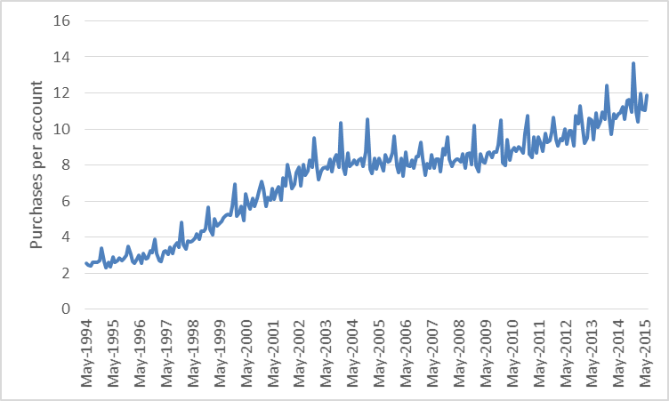
Source: RBA Statistics, Author calculations.
There is a very clear turning point in the data following the RBA’s initial regulatory interventions. The growth in credit card transactions plateaus for nearly six years. Clearly the advantages associated with using credit cards declined.
Similarly the benefits of using credit cards declined too. In Exhibit 3 we show the proportion of cards that had an interest free period. Looking at the exhibit, the result is quite stark. A sudden decline from 86.7% in December 2001 to 79.8% in January 2002 is a massive change. While those dates do not quite line up with the actual regulatory timeline set out in table 1, it does immediately follow the publication of an RBA consultation document into the Australian credit card market. If we were to assume that financial institutions and consumers correctly anticipated the RBAs intentions then it is plausible to imagine that they would modify their behaviour before the regulatory intervention.
At the same time Rochet had predicted that issuing would become more concentrated. The RBA provides market share data for credit card schemes but indicates that one of the original three schemes that it initially regulated, Bankcard, closed in January 2007. At the same the domestic payments scheme eftpos has lost market share too.
Exhibit 3: Proportion of credit card accounts with an interest free period
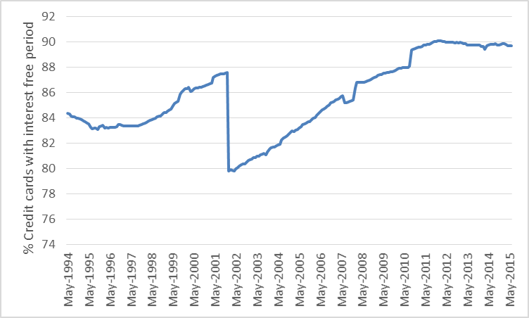
Source: RBA Statistics, Author calculations.
In Exhibit 4 we show the proportion of bank fee income from credit cards as a percentage of total bank fee income. It is clear over the period the RBA was introducing its regulations that fee income from credit cards accelerated as percentage of total bank fee income.

Exhibit 4: Credit card fee income to total fee income
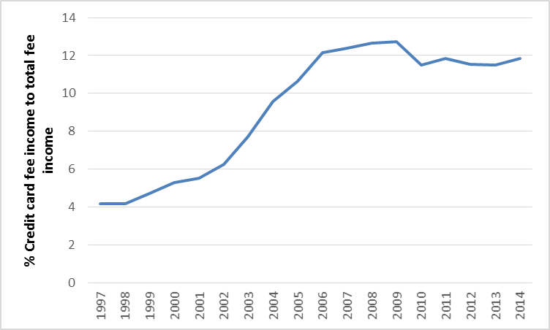
Source: RBA Statistics, Author calculations.
Finally we show the credit card (standard) rate premium over the cash rate in Exhibit 5. Between December 2000 and December 2001 there is a 95 basis point increase in the credit card interest rate premium over the cash rate. In the context of the subsequent global financial crisis and risk-rerating that has occurred over the past few years, that increase is small. Nonetheless it is clear that interest rates charged by financial institutions moved in anticipation of regulatory change.
Exhibit 5: Credit card premium over Cash Rate

Source: RBA Statistics, Author calculations.
Consistent with Rochet’s predictions, the RBA regulatory intervention has resulted in consumers paying more for their credit cards in the form of interest and increasing the fee income of banks while the benefits of the cards declined. The usage of credit cards relatively declined. All that for the $13 billion saving to merchants that the RBA identifies – yet the RBA is uncertain as to what actually happened to that money. They assume that it was passed onto consumers, but cannot know for sure. In addition, they are unable to point to any actual decreases in consumer prices following their intervention.
- Alternative perspectives
We believe that the Reserve Bank has failed to understand the problem at hand. To see the issue more clearly consider not their exposition of the interchange fee as shown in figure, but rather Rochet and Tirole’s exposition that we reproduce in figure 2.

Figure 2: Rochet and Tirole depiction of an interchange fee
Source: Rochet and Tirole (2003: 74)
This depiction shows the net cash flows in the various relationships. Again the consumer (cardholder) buys goods and services from the merchant. The consumer then pays the price (p) and a net fee to his financial institution. The consumer’s financial institution then pays the price (p) less the interchange fee (a) to the merchant’s financial institution who then pays the merchant the price (p) less their own net fee. This depiction of the issue makes very plain that if both financial institutions are to remain profitable that m > a. The merchant pays the interchange fee. Of course, this is not surprising. The interchange fee exists to rebalance the relationships within the two-sided market. In a competitive market for financial services, the interchange fee would be used to reduce the net consumer fee for credit cards. It is also unsurprising then that retail associations have led the charge against interchange fees. After all it is cost of doing business to them and reduces the profitability of their businesses. The subsequent regulation of the market is then well explained by the 1981 economics laureate George Stigler’s theory of regulatory capture.
However, the basic issue is not one of monopoly exploitation, which has thus far been the guiding regulatory impulse that Stigler criticises, but rather is one of efficient contracting in the shadow of what 2009 economics laureate Oliver Williamson (1973) called the Fundamental Transformation that occurs in consequence of transactions that require both parties to make idiosyncratic investments – transforming ex ante competition into an ex post bilateral monopoly – that can subsequently give rise to opportunism.
The credit payments system is not and cannot ever be an interlinked series of anonymous spot markets exchanging financial commodities because the information asymmetries and moral hazards inherent in these exchanges require the parties to the transactions to make idiosyncratic investments (also known as asset specificity) that bind them into a bilateral monopoly – i.e. the fundamental transformation – in which quasi-rents are only secured through mechanisms to inhibit opportunism by aligning incentives to long term relational contracting.
The interchange fee, we argue, has evolved as an efficient governance mechanism to achieve this outcome without requiring horizontal integration – i.e. collapsing the four party payments system into a three-party payments system, and the associated losses of technical and information efficiency and competition that would imply. Banks need to make transaction specific investments in acquiring information about the properties of customers and merchants, the value of which – the quasi-rent – is realised through a long term relation.
  - Argument 1: The interchange fee represents an efficient institutional mechanism, not monopoly exploitation

Alternatives to collective setting of interchange fees, varying from bilateral negotiation to government-regulated cost-based fees, all have serious drawbacks in terms of generating excessive transactions costs, failing to internalize external benefits and costs, and distorting incentives.
Chang and Evans (2000: 461)
The existence of the interchange fee at what appears to be both a fixed and high level has been criticized by competition regulators because of its seeming departure from what would be expected in a perfectly competitive market. Among competition authority regulators, this is widely taken to be prima facie evidence of collusive price fixing and monopoly exploitation.
In an institutionally frictionless world of zero transaction costs, perfect rationality, perfect information, and zero uncertainty, any such fixed fee structure collectively agreed upon by competitors that seemed to generate permanent uncontestable flows of what would appear to be (natural) monopoly rents would certainly appear to be evidence of collusive monopoly exploitation. In this version of the story, the monopoly aspect of these rents are attributed to high entry costs owing to strong network effects on payments platforms.
In consequence, banking and competition regulators around the world have sought price caps on bank interchange fees (Schmalensee 2002). In Australia, this was reduced from 0.95% to 0.55% in 2003 (Europe Economics 2014: 27-32). These regulatory imposed fee caps are allegedly justified because they restrain anti-competitive behaviour and therefore benefit consumers.
Not only is there no evidence for this supposed regulatory benefit (ATA & IAEP 2015), but we argue that the economic theory behind it is also flawed. What it neglects is the adapted efficiency of the contractual and governance structure of the economic organization of payments systems and consumer finance.
The argument we make (expanding on the work of Chang and Evans 2000) is that the interchange fee, as it has emerged and developed around the world over many decades, is an efficient governance outcome in a largely private ordering of mostly long term relational contracting between consumers, issuing banks, acquiring banks and merchants, all operating in the context of uncertainty, opportunism and asset specificity (Williamson 1985).
There are two specific aspects that we seek to highlight, both of which point to the fact that these are non-standard exchanges, and that the particular institutional and contractual features of the overall economic organization that depart from an Arrow-Debreu zero-transaction cost and complete markets model – i.e. the interchange fee – most likely reflects efficient contractual governance adaptations to these particular aspects of the exchange situation.
(1) The four-party exchange involves different types of contractual relationships, only one of which (between customer and merchant) is typically a spot-market transaction. The other three that have banks at one or more ends are typically long-term relational contracts. These involve complex contractual agreements that trade-off risks from uncertainty, opportunism, and asset specificity. The conditions of the spot market will be considerably shaped by the agreements made in the other three long run relational contract markets.
(2) The default payments model is assumed to be cash, which is assumed to be costless as a two-party-exchange between consumer and merchant. The four-party credit exchange relation is assumed to be more costly because of the additional services offered in the interbank payments and processing network that benefit both consumers (by extending finance) and merchants (by facilitating payments, screening credit-worthiness, covering credit risk). Both consumers and merchants benefit from these services and are willing to pay for these services. However, cash is also costly to both consumers and merchants (carry cost, risk, opportunity cost) and thus both will be willing to pay to use an alternative payments technology that mitigates these costs. Yet in a pure exchange spot market, merchants will only accept cash because to accept credit requires them to assume the costs of screening or of a long-term relationship that exposes them to consumer opportunism. However, by leveraging off the long-term relations established in the interbank payments networks, merchants can become indifferent at some fee margin between cash and credit transactions in the spot market, thus maximizing the overall transaction value by accepting all bids.
Our central argument then, as informed by transaction cost economics and the New Institutional theory of the firm (Williamson 2002), is that the various structures of fees that we observe in the long-term relation contracts that banks intermediate are most likely to represent an efficient bargaining outcome to arrive at stable long term relational contracts, given the various risks associated with opportunism and asset specificity, and are therefore not prima facie evidence of monopoly rent extraction.
The spot market between consumer and merchant is likely to be efficient when effective governance institutions in the long-term credit networks and payments systems emerge. These are facilitated by the inter-banking system, at the core of which is the interchange fee.
In consequence, regulatory attempts to treat these fees as if they were the result of collusive rent-extraction by seeking to constrain them within a price ceiling can risk harming an otherwise efficient system of institutional adaptation through long-run relational contracting to specific governance problems associated with uncertainty and transactions costs in the supply of consumer finance and payments systems (Balto 2000, Chang and Evans 2000).

Models of the four-party and two-party payments systems
In a simple model of economic coordination, all exchanges take place in spot markets between firms (which in this model are hierarchical organizations whose boundaries are determined by the technology of production). In such a world, payments networks and consumer finance would be modelled as a natural monopoly (because of scale economies and network effects) such that the most efficient form of economic organization would be a single monopoly firm – call it The Bank. All consumers and all merchants would be customers of The Bank. The Bank would levy a fee across consumers and merchants, but the incidence of which would ultimately fall on consumers either directly or through higher prices as a function of the substitution margin with cash. An interchange fee would simply be an internal aspect of the firm’s cost accounting. The total price The Bank charges would likely be regulated.
But under competition in retail payments networks, consumer banking and finance, and merchant banking we expect there will be multiple banks and that the boundaries of banks and financial services firms will depend upon specialization, competences and capabilities, often tied to specific assets (including reputational assets and context specific knowledge). This will be governed in large part by long term relational contracts between agents and firms, such as between customers and a bank, both consumers and merchants, and between firms within the banking and payments network. Indeed, for the most part the only spot contracts in this system of economic coordination are the exchanges of goods and services for money between consumers and merchants.
Figure 3 re-imagines the credit card network from a contractual governance perspective. Our central argument in this report is that figures 1 and 2 (above) have dominated discussion and analysis without sufficient consideration of the implications of figure 3.
Figure 3: Interchange fee in a governance framework
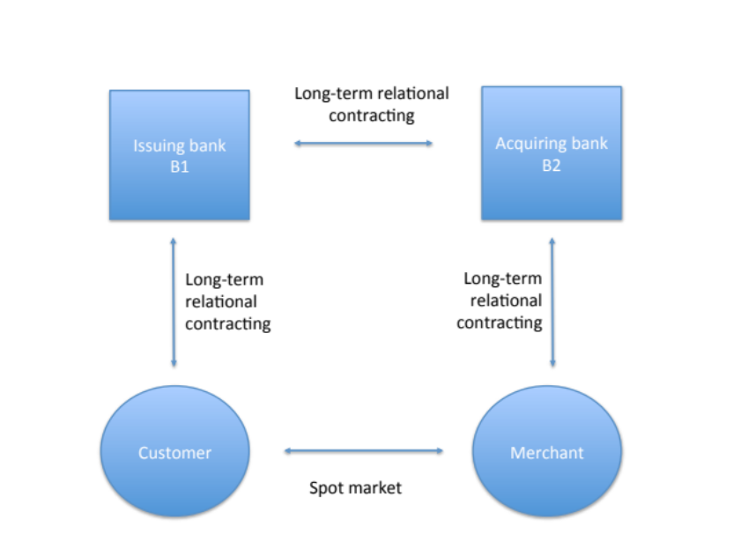
Source: Davidson & Potts 2015

Theoretical foundations: efficiency, not monopoly
The efficient organization of economic activity entails matching governance structures with these transactional attributes [uncertainty, frequency of exchange, asset specificity] in a discriminating way.
Oliver Williamson (1979: 261)
Economics laureate Oliver Williamson won his prize in large part for his classic work The Economic Institutions of Capitalism. Building on the work of Ronald Coase, Williamson developed the transaction cost-based field of New Institutional Economics, at the heart of which was a clear distinction between the monopoly branch and the efficiency branch of microeconomic analysis. As Williamson (1985: 23) explains:
The monopoly approaches ascribes departures from the classical norm to monopoly purpose. The efficiency approaches hold that departures serve economizing purpose instead.
Williamson explained how economic agents will seek to ‘organize transactions so as to economise on bounded rationality while simultaneously safeguarding them against the hazards if opportunism’ (ibid: 32). Williamson’s point is that sometimes forms of economic organization that may look like collusive or monopolistic behaviour when examined in terms of resource allocations are actually forms of economizing when analysed from the institutional perspective of transactions.
We argue that the dominant regulatory view of payments networks and interchange fees is through the lens of the monopoly view of economic organization (Carlton and Frankel 1995). This view focuses on resource flows and rents (as in figure 1), and within that seeks to identify the exercise of monopoly power. The monopoly view of bank interchange fees is based around an applied price theory approach in which barriers to entry give rise to leverage and price discrimination, resulting in rent capture. The implied correction to this outcome is to restrict the ability to exploit the rents through a legislative price ceiling – i.e. fixing a maximum interchange fee.
But this same situation looks rather different when the unit of analysis is the transaction (as in figure 3). The notion of a transaction includes both exchanges and contracts. Economic organization can occur in a spot-market (exchange) with neither future promises nor responsibility, or through long-term relational contracting, where parties make investments of which the profitability and utility depends on the other parties subsequent behaviour (Alchian and Woodward 1988: 66). Transaction cost economics predicts that where there are transaction specific assets, trading regularities will emerge that support and signal continuity intentions (Rochet and Tirole 2000), thus expanding trade from a unilateral spot-market relation to a bilateral ongoing relational contract.
From the transactions cost perspective, observed departures from the classical model may therefore reflect economizing behaviour in conducting ongoing transactions, and in the context of risk of opportunism and bilateral investment may already be ex post efficient forms of organization of economic activity. In consequence, if these adapted institutions and contracts are efficient forms of economic organization, then regulatory intervention will harm efficiency. Consider why this might be so.
Long term contracting and spot markets in credit and payments systems
Figure 3 indicates that of the four types of transactions relations between consumers (C), issuing banks (B1), acquiring banks (B2), and merchants (M), three of those relations (C-B1; B1-B2; B2-M) will usually be governed by long-term relational contracting, and with only C-M being a spot market transaction. Why is this?
First, why are they not all spot contracts? Specifically, why are C-B1 and B2-M typically long-run relational contracts rather than spot contracts?
One, they are engaged in multiple repeated transactions, and minimizing transactions costs associated with processing scale economies are achieved through bundling transactions through a single supplier. This incentivizes B1 to form a long-term contract with C.
Two, there is asymmetric information about creditworthiness of C that accumulates through repeated transactions, and which then enables a cumulatively better offer to be made to C as their true risk is cumulatively revealed, which then incentivizes C (if their ‘true type’ is low risk) to form a long-term contract with B1. This moral hazard problem of constraining C to good behaviour is enforced with threat of expulsion from the contract by B1, which would then take them back to a higher rate with a new issuing bank that had not accumulated information about the credit properties of C.
This in turn works as an effective screening mechanism by B1 on C, because only a high quality C will accept the conditions of a long-term contract, which will be valuable to C and profitable to B1, only if C can be effectively constrained from opportunistic behaviour.
Three, the same arguments apply between B2 and M, where B2 accumulates information about the transaction volume of M and their propensity to accept fraudulent sales (which require chargebacks). This information is a specialized asset that is profitable to B2 (and B1) if they can constrain opportunism by M (and C). The long-term relational contract, and the credible threat of expulsion from that contract, is an efficient governance mechanism to organize economic coordination in the context of the threat of opportunism and information asymmetry.
Four, incomplete relational contracts enable many specific contingencies to be dealt with by negotiation between the parties under the threat of exit, with the ensuing costs that imposes. These are a private ordering that may have final recourse to courts, but will often be most efficiently handled through direct bargaining under credible commitments and threats through the various hostages (threat of default versus threat to harm credit score) that each side has offered the other (Williamson 1983).
Five, long-term contracts may arise because of differential risk preferences between consumers, merchants and banks, which banks being systematically risk neutral and consumers and merchants being risk adverse.
Second, why is B1-B2 a relational contract, rather than either a spot exchange or horizontally integrated within a single firm (see Williamson 1985: ch6)?
A single bank – integrating B1 and B2 within a single firm – might be technologically efficient, but would be informationally inefficient, would be exposed to greater risk of shirking behaviour because of information impactedness and costly monitoring, and would be exposed to opportunism in internal pricing transfers. Because retail consumers and merchants are highly heterogeneous and geographically distributed, specialized skills and investments are required in assessing quality (i.e. true type) and in delivering services. Banks will therefore tend to specialise under competition in order to economise on information. Long-run relational contracts then reconnect this into a payments network under high-powered incentives. In general this can be observed in the relative market success of open payments networks over closed payments networks.
Long-term relation contracting is efficient because banks take different sides of many transactions, giving rise to threat of exploitation through non-cooperative play. However, opportunism is disciplined only by threat of retaliation. Furthermore, repeated transactions enable learning and synchronising of processes and transaction routines in order to generate an efficient payments system, all without loss of high-powered incentives if the transactions were integrated into a single firm.
  - Argument 2: Equilibrium in choice of payments: cash versus credit cards
An important point follows from these considerations of the payments system in terms of transaction costs and the institutions that develop to efficiently govern these. In essence, these will be some margin of equivalence between alternative governance institutions, which we represent in figure 4 below with the credit card payments network on the left and the cash transfer nexus on the right.

Figure 4: Payment Networks and Cash Transfer
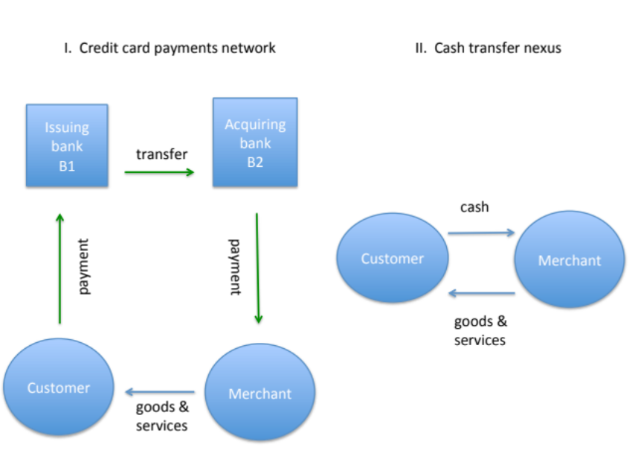
Source: Davidson & Potts 2015
First, the added complexity and physical and organizational resources involved in the card payments network, which are approximated by the flow of fees that consumers and merchants pay to the banks, will in equilibrium be competitively disciplined by the threat of exit to the cash transfer nexus (on the right in Figure 4 above). What is crucial to understand is that the cash transfer nexus is not the default setting of free, against which to compare the costs and fees of the card payments network. There are significant costs associated with the use of cash, for both customer and merchant, and both will be willing to pay some margin to avoid those costs. For the consumer, the costs are the carry costs and risks of using cash. For the merchant, these are the same costs in processing cash, but also in the reducing in sales due to financing constraints by the consumer. The merchant will be willing to pay some margin to enable the consumer to access credit.
Second, the merchant is not indifferent between cash and credit because of asymmetric information and adverse selection. For the customer, in their relation with Bank1 and Merchant, the equivalence between cash and credit depends on the benefit of liquidity plus the carrying cost of liquidity (cost of carrying cash, cost of credit cards). In equilibrium, the cost of carrying and using cash will equal the maximum credit fee charge. However, this assumes that the customer is of a type: ‘creditworthy and solvent’, and that this is known to the merchant and the bank. Yet there is no reason to suppose the merchant knows this, or can acquire this information at low cost.
An equivalent argument occurs on the merchant side of the equation. In a long-term relationship between Customer and Merchant there would emerge an equivalence between cash and credit, plus the transaction cost that would be self-enforcing in long run equilibrium of a repeated game only if the exchange relation was at least a one-sided monopoly. But in a competitive spot market the logic is different because the consumer choosing credit over cash is not just facing a transaction cost decision but also signalling information about their ‘true type’ as a credit risk [i.e. good or bad]. A consumer choosing credit in the C-M transaction risks signalling that they expect not to pay (that they are a bad type), which drives an adverse selection/moral hazard spiral that will drive credit out of the spot market, leaving only cash. This will result in a lower equilibrium level of transactions because good credit use in the spot market (i.e. ‘good’ customers, for whom the cash carrying cost greater than the credit fee cost) suffers a ‘lemons’ problem (Akerlof 1971). B1, however, has a long term relation with C, and thus can effectively underwrite that use of credit in the spot market.
5. Summary and Analytic Conclusions
Interchange fees are not a problem of monopoly exploitation, but rather an efficient solution to an unavoidable bilateral monopoly that arises because banks need to form long term relations with customers and merchants – what are in effect irreversible investments that pay off only if the relationship continues – and which are therefore vulnerable to opportunism.
We make two specific theoretical claims that explain why regulatory intervention to cap the interchange fee will harm consumer welfare. Both claims hinge on recognizing that the governance structure of the card payments system is composed of long run relational contracts, the threat of exit from which disciplines short run opportunism in the system.
First, the interchange fee equilibrates the issuing (B1) and acquiring (B2) sides of payment cards systems. A fee setting association of banks is not evidence of collusive monopoly, but of minimizing transactions costs across the network in achieving economic coordination between all transacting parties. Constraints placed on internal bargaining and side-payments – i.e. an interchange fee ceiling – cause less efficient outcomes, resulting in higher fees to consumers and an unnecessary loss of social welfare.
A further implication is that interchange fees also enable an efficient network governance structure based around relational contracting that avoids horizontal integration between issuing and acquiring banks, maintaining incentive intensity and minimizing administrative monitoring burden arising from information impactedness.
Second, the relevant theoretical comparison between the four-party card payments system and the simple two-party cash nexus exchange must recognize that cash is also costly to consumer and merchant and that both parties will be willing to pay some margin to use a superior payments technology. This can be seen clearly when we consider why merchants do not usually offer credit payments to customers – or are risk averse in doing so – but banks can be risk neutral in this offering, namely because they are in a long term relational contract with the customer, and can effectively punish opportunism. Both consumers and merchants are willing to pay to avoid cash transactions by agreeing to enter long term contacting relations with banks.
Bibliography
Alchian A. and S. Woodward. 1988. The firm is dead; long live the firm: a review of Oliver Williamson’s The Economic Institutions of Capitalism. Journal of Economic Literature, 26: 65-79.
Balto, D. 2000. The Problem of Interchange Fees: Costs Without Benefits? European Competition Law Review, 21, pp. 215-224.
Baxter, W. 1983. Bank Interchange of Transactional Paper: Legal and Economic Perspectives’ Journal of Law and Economics 26(3): 541-588
Carlton, D. and A. Frankel. 1995. The Antitrust Economics of Credit Card Networks. Antitrust Law Journal, 63: 643-668.
Chang, H. and D. Evans. 2000. The Competitive Effects of the Collective Setting of Interchange Fees by Payment Card Systems. Antitrust Bulletin, 45: 641-77.
Coase, R. 1937. The Nature of the Firm. Economica, 4: 386-405.
Coase, R. 1960. The problem of social cost. Journal of Law and Economics, 3: 1 – 44.
Coase, R. 1972. Industrial Organization: A proposal for research. In R. Coase. 1988. The firm, the market and the law. University of Chicago Press.
Europe Economics 2014. The economic impact of interchange fee regulation. London, UK.
Gans, J. and S. King. 2001. The role of interchange fees in credit card associations: Competitive analysis and regulatory issues. Australian Business Law Review, 29 (2): 94 – 122.
Gans, J. and S. King. 2002. Regulating Credit Cards in Australia: A Submission to the Reserve Bank of Australia. Available from http://www.rba.gov.au/payments-system/reforms/cc-schemes/consult-doc-responses/core-120302.pdf
Gans, J. and S. King. 2003a. The neutrality of interchange fees in payment systems. Topics in economic analysis & policy. 3(1): online.
Gans, J. and S. King. 2003b. Approaches to regulating interchange fees in payment systems. Review of Network Economics, 2(2): 125 – 145.
Gans, J. and S. King. 2003c. A theoretical analysis of credit card reform in Australia. The Economic Record. 79(247): 462 – 472.
Hayashi, F. and S. Weiner. 2006. Interchange fees in Australia, the UK, and the United States: Matching theory and practice. Economic Review. 91(3): 75 – 112.
Katz, M. 2001. Reform of credit cards schemes in Australia. RBA Commissioned Paper. http://www.rba.gov.au/payments-system/reforms/cc-schemes/ii-commissioned-report/
Klein, B., R. Crawford, and A. Alchian. 1978. Vertical Integration, Appropriable Rents and the Competitive Contracting Process. Journal of Law and Economics XXI (1978), 297-326.
Reserve Bank of Australia and Australian Competition and Consumer Commission. 2000. Debit and Credit card schemes In Australia: A study on interchange fees and access. October 2000.
Reserve Bank of Australia. 2015. Review of card payments regulation: Issues paper. March 2015.
Rochet, J. 2006. The Consequences of Reducing Interchange Fees. Presentation to 2006 Payments System Conference, March 2006, Available at http://web.archive.org/web/20060613224511/http://www.mbs.edu/payments_system/
Rochet, J. and J. Tirole. 2000. Cooperation Among Competitors: The Economics of Payment Card Associations, mimeo, University of Toulouse.
Rochet, J. and J. Tirole. 2003. An economic analysis of the determination of interchange fees in payment card systems. Review of Network Economics. 2(2): 69 – 79.
Schmalensee, R. 2002. Payments systems and interchange fees. Journal of Industrial Economics
Stigler, G. 1964. Public regulation of the securities market. Journal of Business, 37(2): 117-142.
Williamson, O. 1973. Markets and hierarchies: some elementary considerations. American Economic Review, 63(2): 316-25.
Williamson, O. 1975. Markets and Hierarchies: Analysis and Antitrust Implications, New York: Free Press.
Williamson, O. 1979 Transaction cost economics: the governance of contractual relations. Journal of Law and Economics, 22(2): 233-61.
Williamson. O. 1983. Credible commitments: Using hostages to support exchange. American Economic Review, 73(4): 519-40.
Williamson, O. 1985. The Economic Institutions of Capitalism, New York: Free Press.
Williamson, O. 1996. The Mechanisms of Governance, New York, Oxford University Press.
Williamson, O. 2002. The theory of the firm as governance structure: from choice to contract. Journal of Economic Perspectives, 16(3): 171-95.

Appendix 2: Who Should Regulate the Bank Interchange Fee?:
The RBA or the ACCC?

Sinclair Davidson and Jason Potts

It’s run like a secret society. No one can explain why this [regulating payments, setting interchange fees] is a function retained by the RBA. The Payment Systems Board is the least transparent, most secretive and poorly understood government body that is responsible for every transaction that takes place in this country.
– Senator Sam Dastyari, Chair, Reference Committee on ‘Matters relating to credit card interest rates’ (Sept 2, 2015)

Summary
Since 1959 the Reserve Bank of Australia has occupied dual statutory functions in: (1) the central bank role of the setting and conduct of monetary policy, including ancillary roles of banknote provision and banking services to the Federal government; and (2) the regulation of the payments system. The case for RBA regulatory control of the payments system (including the bank interchange fee) was always based on its relation to the first function – its ability to promote stability and control risk in the financial system through a secondary role of promoting efficiency and competition in the payments system.
Yet there has never been a strong case for these two distinct functions – monetary policy, and regulating the payments system – to be contained within the same agency. It is a holdover from a more protectionist era. Indeed, economic theory suggests these are distinct functions should be separated because they draw upon distinct theory, specialization, and experience: the monetary policy function drawing on monetary economics and macroeconomics, and the payments function drawing on theory of competition and industrial organization.
Once we recognize that the ACCC, as a specialised competition regulator, is the appropriate agency to regulate the payments system and interchange fees, the issue then arises as to why the government would be engaged in fixing a market price. We suggest that the interchange fee does not so much need to be regulated as demystified, and that the RBA has systematically failed in this task.
This tension is seen in the consumer welfare losses and distortions to industrial organization caused by the RBA fee-capping regulation of the bank interchange fee in 2003 (IAEP/ATA 2015). It is also seen in the politically motivated demands that the RBA ‘do something’ about supposed hidden bank and card fees, when microeconomic theory suggests there is no problem here to solve.
We argue that the regulatory function over the payments system should be removed from the RBA and placed with a transparent specialist agency with capabilities and experience in regulating competition and industrial organization.

1 The Nature and Role of the Reserve Bank of Australia
The Reserve Bank of Australia (RBA) is Australia’s ‘independent’ central bank. The primary function of any central bank is the conduct of monetary policy. In Australia monetary policy has since 1993 been conducted under an independent charter requiring inflation targeting and pursuit of macro-financial stability, using the tools the RBA has at its disposal, including setting the reserve cash rate, and the conduct of open market operations using its financial reserves. This role also includes issuance and management of banknotes, which are the legal tender required for payment of Australian taxes. A parallel role, occupied since it separated from the Commonwealth Bank in 1960, is to function as the Australian government’s bank.
Two Boards
The Reserve Bank consists of two Boards: the Reserve Bank Board, which covers monetary policy, and the Payments System Board (authorized by Division 2, Part IIIA of the Act) which covers policy relating to the operation of the payments system.
Since the 1997 Wallis Report, the regulation of the Australian financial system is no longer based on status but is based on function. This resulted in the creation of new agencies. The Payments System board of the RBA was given responsibility for decisions that concern the payments system by the Payments System Regulation Act (1998). The Australian Prudential Regulatory Authority (APRA) (established by the Australian Prudential Regulatory Authority Act 1998) was created to take over a role previously exercised by the RBA of prudential supervision. And the Australian Securities and Investment Commission (ASIC) (formerly Australian Securities Commission) was given powers to regulate appropriate standards of market conduct by financial institutions, including the Electronic Funds Transfer Code of Conduct.
The RBA’s own description of its role in the payments system is as such:
A safe, competitive and efficient payments system is essential to support the day-to-day business of the Australian economy. The Payments System Board of the Reserve Bank has a mandate to contribute to promoting efficiency and competition in the payments system, and the overall stability of the financial system. The Bank oversees the payments system as a whole, which encompasses a wide variety of individual payment instruments – ranging from cheques and payment cards to high-value corporate payments – and the usually unseen arrangements that ensure the smooth transfer of funds from accounts at one financial institution to another. The Bank also has a formal regulatory role to ensure that the infrastructure supporting the clearing and settlement of transactions in financial markets is operated in a way that promotes financial stability. In addition, the Bank has an important operational role in the payments system through its ownership and management of the Reserve Bank Information and Transfer System (RITS), Australia’s real-time gross settlement system.
(Source: http://www.rba.gov.au/payments-system/)
The efficient function of the payments system – in effect a mutual clearinghouse requiring interoperability – requires many different financial firms to work together, creating hazards of collusion. The Payments System Regulation Act (1998) allows the Australian Competition and Consumer Commission (ACCC) to override the Trade Practices Act (1974) that would otherwise make such cooperative agreements between competitors illegal. Since 2001, the Reserve Bank has been granted the power to regulate the payments system.
The Payments System (Regulation) Act 1998 gives the Payments Board the power to address clearing and settlement issues, including the determination of standards, of the payments system. It is important to note here that, as a practical matter, the clearing system was owned by Australia’s licensed banks, and the main issue for financial competition in payments was access to that system. The banks themselves argued that exclusion of non-bank financial intermediaries along with other exclusions from this system were justified on grounds of financial stability (echoing, obviously, the RBA statutory mandate). But it is also plainly true that this same behaviour clearly benefited the participants in the payments system by excluding competition. This regulatory issue, therefore, is manifestly one of competition policy.
Basic Economics of RBA scope and function
The RBA therefore has a legitimate role in the expert conduct of monetary policy in order to ensure monetary stability in Australia’s official currency (the AUD), as associated with low, stable inflation. Monetary stability is a near perfect public good that can be expertly and efficiently supplied by a monopoly provider – the RBA.
While we do acknowledge that a free banking system (Hayek 1976, 1978, White 1999) also provides monetary stability through competitively issued currencies, and thus without the need for a central bank, this is not the line of our argument. By most accounts, the RBA has successfully furnished broad monetary stability over the term of its independent operation targeting inflation (1993 – present). In both theory and practice, there is a widely understood need for this role to be conducted autonomously and secretively.
But the economic reasoning contained in this argument does not extend to the payments system, which is not a public good, but rather is a suite of technologies and organizations, i.e. an industry. The payments system refers to a vast network of operations, agreements, rules and technologies that enable payments to be transacted between all parties in the Australian economy. Like the Internet, it is not a single system but a network of networks. It is also important to note that it is not a public network, but an interlinked web of private systems: it is an open private network. It is useful to think of the payments system as a network infrastructure that has cumulatively emerged from entrepreneurial actions, as the economy has grown and developed, in order to facilitate the transaction needs of a market economy. The payments system was not created by the RBA, and a payments system would exist without the supervisory oversight of the RBA.
From a regulatory perspective, the payments system is not a public good but rather is a technology, a network, a market, an institution, and an industry. This should be approached as a separate issue of industrial organization. Yet this is not what currently exists or what happens. The RBA has taken on exclusive responsibility to regulate the payments system, and furthermore does so under the same operational cover of secrecy and independence as the conduct of monetary policy, where such secrecy and independence are essential to ensure policy effectiveness (Kydland and Prescott 1977). But no such argument can be made for regulating what is, in effect, competition policy. Instead, there is the risk of unaccountable policy mistakes, what Djankov et al (2003) associate with the social costs of government intervention (or the “costs of dictatorship” in their terminology).
2. Is there a case for the RBA having regulatory authority over the Payments System in general and the interchange fee in particular?
On the face of it is might seem entirely natural that the RBA, as the nation’s statutory central bank, should regulate the payments system that interlinks all of the transactions in the economy, and that pass through all providers of payments services, which are largely composed of competing commercial banks and providers of financial services. The RBA has regulatory power over what would otherwise be private negotiations over contracts between competing firms in pursuit of mutual gains from trade – such as credit card interchange fees between acquiring and issuing banks – because this falls within its payments system remit.
But that logic does not make a case for the RBA in particular, just for any specialized agency. Rather, the reason for RBA involvement in regulation of the payments system in general, and of specific issues such as credit card interchange fees in particular, is because the RBA has historically been concerned about the cost of the operation of the price system. This is a macro-institutional concern, derived from the long 20th century battle between market capitalism (the price system) and communism (the command system). Monetary and price stability coupled with efficient operation of a payments system is essential to the flourishing of a market exchange system.
But there is no inherent reason, other than the payment of taxes, why this needs to be based entirely on a derivative of a cash payments system using official government money. Once it is appreciated that money is a technology, the institutional form of a financial technology (Menger 1892), and that payments is a market service, and that the issuing and operation of credit is a value adding market service, it becomes clear that public welfare in a market economy is best served not simply by minimizing the cost of the operation of the price system, but by maximizing the benefits of the price system.
Cost minimization is easy enough to achieve by prescribing a simple capped offering, but that has the (unintended?) consequence of constraining the commercial development and market offering of superior or varied credit and payments services (including for example, no fees cards, or those offering extensive rewards programs). A price cap on financial services works in exactly the same way a price cap does in any sector, effectively eliminating all possible market supply above that price, and therefore reducing the choice set facing consumers. By reducing the ability for suppliers to price discriminate, the market is made less efficient. Ultimately, this results in a less effective, less competitive, and less innovative market for money, credit, and payments services.
There is no strong case for the RBA to regulate the Payments System
The oversight and regulation of Australia’s payments system has been with the RBA since 1959, where it accrued more or less by default, in the absence of a specialized regulatory agency. Indeed given the underdeveloped competitive state of the banking and payments system at the time there was no perceived need for such a specialised agency. The main argument for why the regulation of the payments system still remains with the RBA, through the various inquiries and reviews of its scope and ambit, can be summarized, in essence, as ‘because it has been with the RBA since 1959’. In more technical terms the regulatory status quo has been determined by path dependency.
The payments system has evolved enormously since the 1950s, as a technology built no longer on paper ledgers or paper currency but on digital communications infrastructure and software, as complex business operations, in terms of interfaces and organizational complexity, and as a competitive market. The payments system is as different now from how it was then as, say, are the telecommunications or global logistics industries. Yet the regulatory function and organization remains unchanged.
There is no strong or explicit case for positioning the oversight and regulation of the payments system within the RBA. This can be seen in the RBA’s own public defence of its function in speeches explaining the RBAs role and function, as we will observe below.
However, there are a number of weak and often implicit cases that are regularly made. These can be approximated as follows:
- That the payments system has some connection with the monetary system – viz. payments are made in money, and because the RBA controls money, it should also control payments.
- Interchange fees are connected to credit cards and credit cards involve interest rates – monetary policy involves interest rates, ergo the RBA should regulate interchange fees. (This is a variant of 1 above).
- The payments system is a utility (run by the banks). Therefore the central bank should regulate this.
- The RBA has acquired historical experience in oversight and regulation of the payments system, and so it should continue in this role.
- The RBA should regulate the payments system because it can regulate the payments system.
It does not require a great deal of logical skill to disassemble these arguments: (1) and (2) are fallacies of composition; (3) is a truth conditional (i.e. an empirical claim); (4) is the induction problem, and (5) is the naturalist fallacy. The point is that none of these are solid economic arguments, each can be picked apart logically and empirically, and all carry a large amount of expediency.
The RBA itself acknowledges as much
In a speech in 1996 by then Deputy Governor of the RBA Graeme Thompson on ‘The Reserve Bank's Role as it Impacts on Business’, Mr Thompson concludes by noting (emphasis added):
… there is talk from time to time of narrowing the RBA's focus, so that it would have only one or two ‘core’ responsibilities. In my view such a move would be misguided. There are significant synergies in having the responsibility for both price stability and financial stability in one place. Banking supervision is integral to our financial stability role, and provides information on market and institutional conditions which is helpful to monetary policy. Meanwhile, our operational activities in securities markets, in the payments system and in conducting banking services give us some ‘hands-on’ experience in, and a better understanding of, pressures and constraints in the business world. This, in turn, contributes to the better-informed conduct of our broader policy functions.
This is an instance of both (1) – ‘it has something to do with money, so it is good practice for us’, and (5) – ‘we can do it so we should do it’. Which then supports (4) – ‘we do it now because we did it then’.
To further disassemble this argument is to acknowledge that if the RBA had an effective payments simulator, or required its executives to do apprenticeships in banks, the result would be much the same. In other words, this is not an argument about why the RBA should regulate the Payments system, but rather about the benefit the RBA itself gets from that regulatory function.
This is a common characteristic in the RBA’s explanation. It explains the benefit the RBA gets from that function – including experience, synergies, and more employees – but these are not arguments about why Australian citizens, consumers, and businesses benefit from RBA regulation.
What is striking, even, is that this persists in the face of the RBAs plain and open acknowledgement that the payments system is clearly a technology and competition driven industry. In 2015, Assistant RBA Governor Malcolm Edey said this in a speech discussing the path from the Wallis report (1997) to the recent Murray inquiry (2014) (emphasis added):
…Third, and related to the first two points, Wallis foresaw the growth of payment systems as a business, in contrast to the utility-based model that I described earlier. If commercial realities were leading to the unbundling of payments from other financial services, then it was to be expected that this business would open up to innovative and specialist providers. It also meant that existing players would need to put their own payments services on a more commercial footing. And lastly, Wallis looked at the regulatory implications of these developments. Payments systems are networks which link service providers and their customers. That means that they need to have ways of ensuring adequate coordination among network members who would normally be competitors. This in turn raises a whole suite of questions as to whether particular network arrangements are generating efficient outcomes: for example, is there appropriate access to networks for new players, are network pricing arrangements efficient and are there effective coordination mechanisms to promote network innovation? Wallis concluded that there was a need for regulatory oversight of payment systems, and the recommendations that flowed from that formed the basis for the arrangements we have today.
And the Wallis Inquiry explicitly insists…
So the RBA acknowledges that the goal of Payment system regulation is competitive efficiency. This is also explicitly what the Wallis Inquiry recommends (61-63). The purpose of the RBAs regulation of the Payments system – through the Payments System Board (PSB) – is to promote competitive efficiency in the development of the payments markets, technologies and industry. It is not for the RBA to ‘gain experience’ or ‘exploit synergies’. The Wallis Inquiry argued the case for the separation of Payments from the RBA’s core functions.
In the Wallis report summary they say this by way of recommending the creation of the PSB (p. 23-4):
Competition in the Payments System: Establishment of the Payments System Board
The task of ensuring systemic stability is closely linked with maintaining the integrity of the payments system. The central bank itself plays a pivotal role in the final settlement of payments. Accordingly, it is proposed that the RBA remain the regulatory authority in charge of the Australian payments system, but with a separate subsidiary board established to oversee this function - the Payments System Board (PSB). The PSB would have some common membership with the parent board of the RBA, including the Governor and one deputy governor. It would make its decisions independently of the main board which would concentrate on monetary policy and economic stability.
The RBA should be empowered to set standards for the payments system, adopting the role of regulator. Any provision of payments clearing services to its customers in competition with the private sector should be clearly separated from the RBA’s regulatory function and be subject to transparent reporting arrangements. The RBA should, however, retain its ownership and participation in those parts of the payments system where high level control and coordination is necessary to ensure maximum efficiency; for example, in the provision of the infrastructure for the high-value payments system.
The clearing systems should be subject to access rules which are transparent and subject to approval by the competition regulator. There should be no presumption that any one class of financial institution should have exclusive rights to issue particular payment instruments, with the exception that only DTIs should be able to issue cheques in their own name. Conditions of access to clearing streams will vary and especially high standards may be mandated as necessary. Entry to payments clearing streams should be determined by the PSB and not be controlled by industry organisations.
There should be no presumption that banks will be the only holders of ESAs. The right to hold an ESA should be determined by the RBA on the basis of clear and open guidelines, including the requirement that participants have extensive payments business with third parties.
The language Wallis employs is unmistakably describing a competition regulator, albeit a competition regulator within the RBA that would work with the ACCC. This is reinforced in the Report’s summary recommendations – most notably recommendation 61 (emphasis added).
Recommendation 61: A Payments System Board should be formed within the RBA.
The payments system should be regulated by the RBA under a Payments System Board (PSB). The PSB should have responsibility for implementing policies to improve payments system efficiency, including the adoption of the most efficient technology platforms, and enhancing the competitive framework, consistent with overall systemic stability. The PSB should also have general oversight of the clearing streams.
Why do we not have a separate Payments System regulator?
Given the RBAs own somewhat hazy arguments about why it maintains control of the payments regulation function, and the Wallis Inquiry’s recommendations toward separation in other areas, it is somewhat puzzling why the Payments System regulation still with the RBA (in the form of the PSB). Detailed analysis of this question is beyond the scope of this paper but in the next section we explain why the RBA is poorly suited for this task.
3 The Case for Regulatory Specialization, or Why the RBA is Poorly Suited to Regulate the Payments System
The RBA undertakes two tasks that on the surface appear related, because they are both about money, but are actually entirely distinct phenomena, based on different underlying economic theory, reasoning, and practical experience. The first argument for their separation is basic economics: namely, to exploit the benefits of specialization – in theory, analysis and experience. By this logic, while the operation of monetary policy is best done by the RBA, the regulation of the payments system is not. Indeed, a case can be made that precisely its lack of specialized understanding and experience in the domain of the competitive dynamics of industrial organization has led to some costly (although underreported) failures (IAEP/ATA 2015).
It is certainly not inconceivable that a single government agency can have multiple unrelated tasks based on distinct specialist functions. The Australian Defence Force, for example, both trains soldiers (a task focused about mental and physical education) and maintains materiel (a task focused about logistics and engineering). But these largely unrelated functions are gathered within a single organization for a compelling reason, namely that they are conjoint inputs in providing the service of security and defence. But this argument does not hold for RBA joint control of monetary policy and the regulation of the payments system. Regulatory control of the payments system is not a necessary co-input into achieving effective monetary policy or in the conduct of open market operations.
Monetary policy is a specialization based on the theory of both monetary economics and macroeconomics. Monetary theory of money in an exchange economy, the theory of money supply and demand, the theory of banking, credit and debt, an understanding of monetary history, and of the monetary transmission mechanism that connect monetary instruments to the macro-economy. Built around analysis of interest rates, and various indices (inflation, asset prices, aggregate demand, GDP, unemployment, industrial production, et cetera) the theory underpinning the effective conduct of monetary policy is broadly the study of emergent aggregates, mechanisms and macro-econometric models of economic systems. Both individual economists and also teams of economists or research departments specialize in this task and body of theory and practice.
Monetary economics and policy has its own scientific culture, a specialized language (and scholarly history), and is a branch of economics in the same way that quantum mechanics is a branch of physics and electrical circuits is a branch of engineering. The RBA, as with all central banks, is highly competent in monetary economics and monetary policy.
The economics of industry regulation – of any industry, including financial ones, such as the payments system – is a very different branch of economic theory and practice. First, it is entirely based in microeconomic theory (not macroeconomics) and is focused on market behaviour under different degrees of competition (from perfect competition to monopoly). This is called the theory of industrial organization, which since the 1980s has been extended to consider strategic interactions (through the application of game theory to the previous framework known as ‘structure-conduct-performance’). This is based around the study of rational firm behaviour and action in a competitive market context. This approach often incorporates transaction cost economics, imperfect competition, models of technological and entrepreneurial competition, and models of strategy.
Regulatory economics is, in essence, the study of the social control of business. It began in the welfare economics in the 1920s (associated with the work of Arthur Pigou 1938) that diagnosed market failures arising from imperfect competition, particularly negative externalities, and sought to meet these with deliberate attempts by government to intervene in market outcomes to correct these. This is the public interest theory of regulation. In this approach, the government and its regulators are assumed to be benevolent, competent and wise, and act purely in the public interest. The RBA hews strongly to this model of regulation.
Beginning in the 1960s and 1970s a new economics of regulation developed associated with the Chicago school of law and economics. (This was developed by Ronald Coase, George Stigler (1971) and Richard Posner (1974), among many others.) The private interest theory of regulation argued that the main beneficiaries of regulation is not the public, but private firms, for whom it serves to restrict competition. A further line of argument, associated with Coase (1960), sought to emphasise that private bargaining and contracts, enforced through courts, can usually more efficiently internalise those externalities (Laffont and Tirole 1993). With efficient courts, there is no rationale for regulation (Posner 1972). A third argument, associated with the public choice school, was that government failure associated with regulation (particularly rent seeking) was much worse than market failure it sought to correct. This questions the assumption that the regulator is necessarily ‘benevolent, competent and wise’.
Again, this branch of economic theory and application is a distinct and specialised part of economics – as regulatory economics and the economics of industrial organization. It also has its own culture, models, and history, and ways of seeing and understanding the world.
Monetary economists and regulatory economists are very different animals. They practice a highly specialised and difficult craft, drawing upon different theory, models and traditions, with little overlap between them. This is no less true of the applied policy domains of the conduct of monetary policy and effective regulation.
These two bodies of knowledge and experience can of course be combined in the same agency, but they must reside in different people, and different teams, with different cultures. There is little gain to be had from aggregation, and much mischief to be made from running the two together. An obvious problem with the RBA and its two separate boards is that the same person – the RBA Governor – is chair of both.
A final point to note here is that monetary policy and industrial regulation pursue very different functional objectives. The objective of monetary a policy is macro financial and price stability – as a public good. But payments system regulation is about promoting efficiency and competition, in order to drive out waste and encourage innovation. This is an economizing objective – to promote the efficient use of society’s resources. These different objectives have completely different pathways of effect, and completely different measures of success. There is no overlap in the practical prosecution of the tasks of monetary policy and industrial regulation.
Regulation of the payments system rules, including the bank interchange fee, is an issue of industrial organization and competition policy. This is not the RBAs natural domain of competence. Instead, the RBA has a comparative advantage in monetary policy. Australian financial industry would be better served if payments regulation were handed off to a more specialized agency.
4 Competition regulators should not fix market prices
The Australian Competition and Consumer Commission (ACCC) is, because of its specialization in the economics of competition and industrial organization, the appropriate government agency to regulate the payments system in general and bank interchange fees in particular.
Competition regulators are usually mostly concerned with case-by-case rulings with respect to particular policing of anti-competitive practices, such as blocking mergers and acquisitions that create substantial monopoly power, or seeking evidence of collusion toward the same effect. Competition regulators seek to identify and prosecute firm behaviour that weakens competition and therefore threatens to harm consumer interests.
It is rare that this remit extends to endeavours to impose price ceilings (or floors) on what are otherwise market-determined prices. There are of course instances of this, and which are usually associated with producer-initiated lobbying (for example seeking to rule on whether retailer discounting of house-brand milk constituted ‘predatory pricing’). There is no theoretical justification for a competition regulator to impose price floors or ceilings, or in any way determine a price that is otherwise competitively set through a process of market discovery. The role of the ACCC is to ensure an institutional environment which competition occurs in order that all relevant information, under competitive bargaining, is expressed in market prices (Hayek 1945).
The ACCC has no position (and nor has the RBA) of superior knowledge from which to advance a true and correct price that the market will not discover itself, if it is free to. Bargaining and economising in the process of competitive price discovery occur on many fronts, including not only matching of product features to segments of consumer demand, but also in finding the optimal specializations and boundaries of firms, across which payments will be made (Williamson 1985). The interchange fee is simply an instance of gains from trade made possible by separation of function between the incentives of acquiring banks and issuing banks in order to maximise the benefit of holding and accepting credit cards to both merchants and consumers (IAEP/ATA 2015).
The interchange fee, then, does not so much need to be regulated as rather demystified. The demand for interchange fee regulation has largely been created out of confusion about the nature of the fee in a competitive market, something the RBAs lack of transparency has exacerbated.
5 On the Issue of Transparency in Bank and Credit Card Fees
A final point to note relates to the issue of consumer-facing transparency in bank fees and credit card fees. The issue of ‘hidden fees’ has been widely and repeatedly raised as a problem with the private ordering of financial markets, which are thought to be subject to asymmetric information in which consumers know less about the structure of the costs of the financial services they purchase than the suppliers selling these products. The result is sometimes referred to as a “confusopoly”, implying that banks and card issuers deliberately create complex information schedules in order to make product-to-product comparisons difficult, and to raise the information costs of switching. This creates rents from imperfect competition.
The credit card interchange fee, which occurs between acquiring bank and issuing bank in a four-party payments system is a good example of a fee that is largely invisible to consumers. This seeming suspicion that merchants and banks are exploiting the hidden nature of the interchange fee to exploit consumers is a major reason for RBA endeavours to regulate and cap the interchange fee.
But the economic theory of information in competitive markets does not support this position. Consumers do not need to see all the costs that go into all of the components of a product. The only information they need is on the attributes of the product, and its total price (Hayek 1945). The price system economises on information, and provided there is competitive entry and exit, there is little to be gained from regulatory requirement to post all input and component prices.
Indeed, there may be substantial costs to this, falling on the consumer. The confusopoly literature (e.g. Kalaychi 2015) points out that this sort of disaggregation of a price into components – for example also observed in phone plans and insurance, does not actually necessarily benefit bounded rational consumers because it creates more information to process, thus raising the cost of comparison. Firms seeking regulatory disclosure are a good example of private interest masquerading as public interest
Furthermore, a credit card, as with most financial products, is a complex commodity with many dimensions of value. The RBA is in no position to observe what consumers value and why – these are subjective preferences.
A more serious issue is the transparency of the RBA’s Payments Board. This is a non-minuted society. Its decisions are completely non-transparent. This governance model is for very good reason with respect to monetary policy – namely to ensure effective independence and time consistency. But there is no basic in logic or experience to argue that this secrecy and unaccountability is appropriate for a competition regulator.
6 Summary and recommendations
The Reserve Bank of Australia has two boards: the Reserve Bank Board and the Payments System Board. Our immediate issue is not with the Reserve Bank Board. Rather, our problem is with the second part of its charter – the Payments System Board. The RBA should not be involved in regulating the payments system. They have no comparative advantage in industrial organization and competition policy regulation. The RBA should relinquish control of regulation of the payments system, and hand it to competition regulators, namely the ACCC.
Once this is done, it immediately becomes apparent however that the price-cap on the bank interchange fee, as imposed by the RBA, when translated into the space of the ACCC, is identical to legislatively fixing a market price. This is entirely without economic justification and achieves only political ends. The price-cap should be repealed, and the ACCC should then undertake to demystify, rather than regulate, this efficient value creating market exchange.

REFERENCES
Coase R (1960) ‘The problem of social cost’ Journal of Law and Economics, 3: 1 - 44.
Djankov, S., Glaeser E., La Porta, R., Lopez-de-Silanes, F., Shleifer, A., (2003) ‘The new comparative economics’ Journal of Comparative Economics. 31(4): 595–616.
Hayek FA (1945) ‘The use of knowledge in society’ American Economic Review, 35(4): 519-30.
Hayek FA (1976) Choice in Currency: A way to stop inflation. Institute of Economic Affairs: London.
Hayek FA (1978) The Denationalization of Money: The argument refined. Institute of Economic Affairs: London.
IAEP/ATA (2015) ‘Australian Interchange Fee Regulation: A Regulation in Search of Market Failure’ Sydney. https://www.taxpayers.org.au/interchangereport/
Kalayci K (2015) ‘Confusopoly: Competition and obsfucation in markets’ Experimental Economics, forthcoming.
Kydland F, Prescott E (1977) ‘Rules rather than discretion: the inconsistency of optimal plans’ Journal of Political Economy, 85(3): 473-92.
Laffont J, Tirole, J (1993) A Theory of Incentives in Procurement and Regulation. MIT Press: Cambridge, MA.
Menger C (1892) ‘On the origin of money’ Economic Journal, 2(6): 239-55.
Pigou A (1920) The Economics of Welfare. Macmillan: London.
Posner R (1972) ‘The behavior of administrative agencies’ Journal of Legal Studies, 1(2): 305-47.
Posner R (1974) ‘Theories of economic regulation’ Bell Journal of Economics and Management Science, 5: 335-58.
Stigler G (1971) ‘Theory of economic regulation’ Bell Journal of Economics and Management Science, 2: 1-21.
White L (1999) The Theory of Monetary Institutions, Part XII, “Competitive Supply of Fiat-Type Money”, Blackwell: New York.
Williamson O (1985) The Economic Institutions of Capitalism: Firms, Markets, Relational Contracting. The Free Press: New York.

http://www.rba.gov.au/media-releases/2015/mr-15-24.html
http://www.rba.gov.au/payments-and-infrastructure/resources/qa/card-payments-regulation.html
Jean-Charles Rochet and Jean Tirole, 2003, An economic analysis of the determination of interchange fees in payment card systems, Review of Network Economics, 2(2): 69 – 79.
https://theconversation.com/credit-card-surcharging-what-is-it-and-how-is-it-changing-49511
Reserve Bank of Australia. 2015. Review of card payments regulation: Issues paper. March 2015.
Joshua Gans and Stephen King, 2003, The neutrality of interchange fees in payment systems, Topics in economic analysis & policy, 3(1): online.
Sinclair Davidson and Jason Potts, 2015a, Australian Interchange Fee Regulation: A Regulation in Search of Market Failure, Appendix 1 below.
See James M Buchanan, 1975, Cost and Choice, Liberty Fund.
http://www.rba.gov.au/payments-and-infrastructure/resources/qa/card-payments-regulation.html
http://www.rba.gov.au/payments-and-infrastructure/resources/qa/card-payments-regulation.html
Reserve Bank of Australia and Australian Competition and Consumer Commission, 2000, Debit and Credit card schemes in Australia: A study on interchange fees and access, pg. 43.
Sinclair Davidson and Jason Potts, 2015b, Who Should Regulate the Bank Interchange Fee: The RBA or the ACCC? Appendix 2 below.
Coase, 1972 [1988], pg. 67.
Stigler, 1964, pg. 142.
Reserve Bank and Australian Consumer and Competition Commission, 2000, pg. 73 – 74.
Hereinafter RBA – ACCC.
What is missing from the Reserve Bank explanation is that the consumer’s bank as extended credit to the consumer while immediately paying the merchant’s bank. The risk of non-payment is borne by the consumer’s bank.
This is not always the case. In some markets the interchange fee has gone from the consumer side of the transaction to the merchant side, and in some economies the interchange fee is zero.
Hayashi and Weiner, 2006, pg. 88.
Rochet and Tirole, 2003, pg. 71.
Rochet and Tirole, 2003, pg. 70.
Gans and King, 2001, 2002, 2003a, 2003b, 2003c.
RBA – ACCC, 2000, pg. 24.
RBA – ACCC, 2000, pg. 27.
RBA – ACCC, 2000, pg. 28.
In this paper we are primarily interested in credit card interchange fees, but include other reforms for completeness.
Hayashi and Weiner, 2006, pg. 100.
Gans and King, 2001, pg. 99.
This, of course, is a (common) mischaracterisation of Coase 1960.
Gans and King 2003a.
Gans and King, 2003a, pg. 39.
Gans and King, 2003c, pg. 472.
RBA, 2015, pg. 4.
RBA, 2015, pg. 23 (emphasis added).
RBA, 2015, pg. 23.
RBA, 2015, pg. 7.
RBA, 2015, pg. 8.
Papers available at http://web.archive.org/web/20060613224511/http://www.mbs.edu/payments_system/
Emphasis original.
Number of credit and charge card purchase transactions divided by Number of credit and charge card accounts.
Number of personal credit card accounts with an interest-free period divided by Number of credit and charge card accounts.
Klein et al (1978), pgs 289 – 307.
Talk to the 1996 National Institute of Accountants New South Wales Congress, ‘Maximising Your Business Opportunities’, Sydney - 22 May 1996.
Malcolm Edey, Assistant Governor (Financial System). Speech at the Cards & Payments Conference - “Card Payments Regulation: From Wallis to Murray” (Melbourne - 21 May 2015)

