Ellis Connolly, Head of Payments Policy
Reserve Bank of Australia
GPO Box 3947
Sydney NSW 2001

Dear Mr Connolly,
Thank you for the opportunity to provide our response to the Reserve Bank of Australia’s Review of Merchant Card Payment Costs and Surcharging.
It is in every Australian’s interest to have a fair and competitive payments ecosystem.
As one of Australia’s largest Payment Service Providers, supporting some 60,000 big and small businesses across the country, ANZ Worldline Payment Solutions is well placed to assess the impact of fees and charges on merchants and consumers.
In the pages overleaf, ANZ Worldline Payment Solutions has outlined a number of recommendations that address the key focus areas of this review.
In principle, we support greater transparency and competition in Australia’s payments ecosystem.
We also support enabling a fairer, simpler and more transparent framework for transaction fees and charges for merchants and consumers.
Key to the sustainable success of any future reform to merchant card payments and surcharging will be ensuring Payment Service Providers – and all other impacted stakeholders – remain consulted at each stage of the process.
Should this (or any other) review result in material changes to the operating environment, transition arrangements will be important to allow for payment providers to embed new business processes, reporting requirements, and ways of working.
We hope to have the opportunity to talk further with you about our submission and recommendations.

Regards,
Steve Aliferis
Chief Executive Officer
ANZ Worldline Payment Solutions

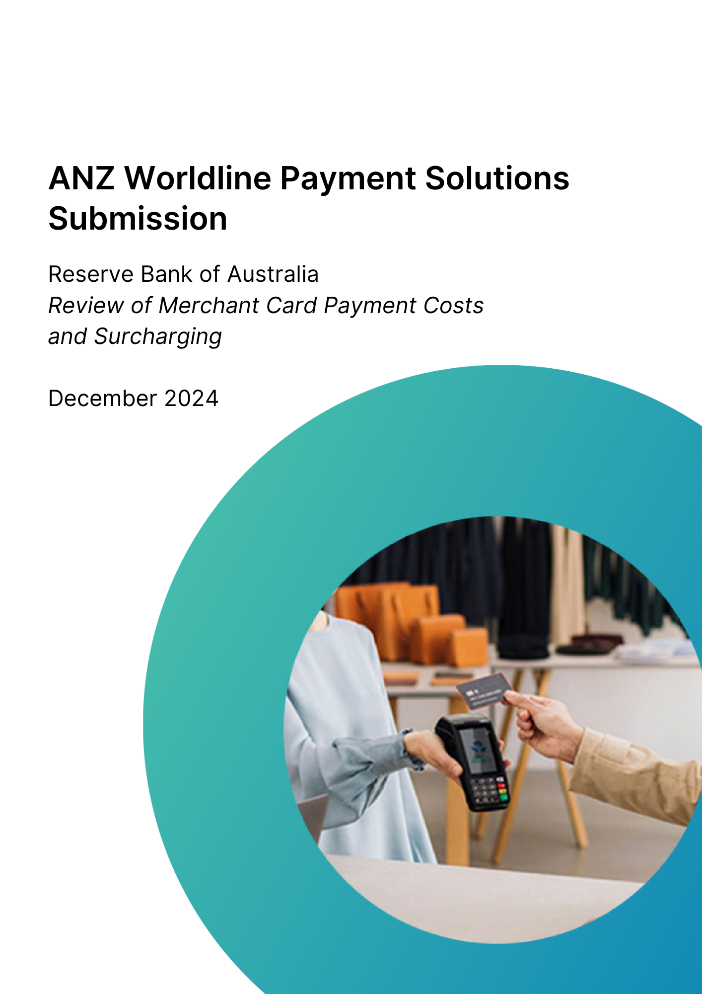

About ANZ Worldline Payment Solutions
ANZ Worldline Payment Solutions is a joint venture between global payments provider Worldline and ANZ Banking Group.
With its headquarters in Melbourne and locations in Sydney and Brisbane, ANZ Worldline Payment Solutions provides small, commercial and institutional businesses across Australia with leading technology for fast, reliable and secure point-of-sale and online payments.
It is part of Worldline [Euronext: WLN], a global leader in the payments industry and the technology partner of choice for merchants, banks and acquirers.
Worldline has 18,000 employees and is active in more than 170 countries. It provides 1.4 million customers with services including instore and online payment acceptance solutions along with commercial acquiring.

Overview and summary of recommendations
The Reserve Bank of Australia’s (RBA) Review of Merchant Card Payment Costs and Surcharging comes at an important time for the payments sector, which is under the microscope in a way it hasn't been for decades. And rightly so. Over the past few years, Australia's digital payments landscape has significantly transformed – especially in the past five years.
Global fintech companies have entered the Australian market, bringing new technology and disruptive business models to an industry previously dominated by a small number of local incumbents.
At the same time, traditional payment technology companies are branching into new areas, like financial services.
All of this change is happening against a backdrop of significant cost of living pressures that are being felt by households and businesses across the country looking to cut costs and tighten budgets.
For the payments sector to continue to support businesses and enable economic activity, it must be fair and competitive.

Our top five recommendations for consideration in this review, include:
- Interchange fees be capped and standardised for businesses of all sizes and simplified overall.
- Scheme fees be regulated (capped) and their transparency improved.
- Least Cost Routing (LCR) be offered by default for all small businesses on the proviso it does not translate to a default route to eftpos.
- Payment Service Providers be mandated to publish relevant and appropriate standardised information on their pricing and services for businesses, in line with reforms introduced in the UK.
- Surcharging be capped, not banned, across the board for debit and credit cards.

Recent research which informs our response
Across August and September 2024, ANZ Worldline Payment Solutions surveyed some 4,000 consumers and 1,000 small businesses across Australia to find out what they were most concerned about when it comes to payments.
Key insights from our research, shared over the following pages, include:
- More than half of all those surveyed worry about the security of their personal information when making payments.
- Before completing a purchase, most of those surveyed want to know the final price of something they are buying, including fees and charges.
- The overwhelming number of those surveyed want paying for things to be fast and convenient and,
- Most of those surveyed want choice in how they pay – from digital to cash, instore to online.
We would be happy to share a copy of our research with the RBA and discuss the findings relevant to this review.

Interchange fees
Getting the regulatory regime right for interchange fees is critical for a competitive and equitable payments system.
Of the 4,000 Australian consumers surveyed in our research across different demographics and life stages, debit and credit cards continue to be the most used forms of payment for many Australian households across various transactions and lifestyle categories, however cash also features regularly.
Starting a new subscription | Direct debit of deposit 39%, credit card 33%
Buying clothing | Cash 59%, debit card 56%
Buying groceries | Debit card 64%, cash 58%
Buying a big-ticket item | Debit card 51%, credit card 55%
Paying for a meal | Cash 66%, debit card 64%
Buying something more than $500 | Credit card 58%, debit card 51%
Buying something less than $500 | Debit card 51%, cash 48%
Table source: ANZ Worldline Payment Solutions commissioned survey of 4,000 consumers and 1,000 small business owners in Australia, conducted by Fiftyfive5 – part of Accenture Song, 2024.

ANZ Worldline Payment Solutions believes interchange fee regulation has contributed to a more efficient payment system. This is particularly evident when compared with other global markets – such as the US – where interchange fees are not regulated and have become a serious cost impost for businesses.
That said, ANZ Worldline Payment Solutions believes interchange fee schedules have grown in complexity, which, unchecked, has potential to stifle competition and present cost challenges to small businesses that pay higher interchange fees than large businesses.
Is there a case for lowering the level of interchange benchmarks or caps?
- Lowering the interchange fee is unlikely to make a material difference for consumers as there is no guarantee that businesses would pass on any savings to consumers.
- In principle, ANZ Worldline Payment Solutions supports an appropriate level of capped interchange fees.
Should the difference between interchange fees paid by big and small businesses be limited?
- There is a need to regulate more closely the fees paid by businesses so that small to medium businesses (SMBs) are not disadvantaged, given they lack the ‘buying power’ of larger enterprise businesses.
- Standardising fees for SMBs would create a fairer system.
Is there a case for reducing complexity and enhancing transparency?
- ANZ Worldline Payment Solutions agrees the existing interchange fee arrangement is too complex.

- For example, there are currently more than 400 different Domestic Interchange Fee categories, making it difficult for Payment Service Providers (PSPs) to determine how to deliver the cheapest interchange to businesses, especially with regards to determining routing and entering strategic interchange programs. The schemes also frequently change and restructure their interchange hierarchies.
- As a result, for acquirers, the implementation and management of interchange rates both from a billing system and reporting perspective has become increasingly onerous.
- This complexity also makes it difficult for businesses to understand interchange and the fee structures we propose.
- To address this, ANZ Worldline Payment Solutions proposes the establishment of standardised categories and dimensions to which all the Schemes need to adhere. This will allow a consistent, industry-agreed methodology for introducing new categories, across all payment brands.
- ANZ Worldline Payment Solutions supports simplifying fees and increasing transparency (expanded further below). However, there needs to be agreement across the industry and with the regulator on what constitutes ‘simple’, to avoid introducing additional complexity leading to unintended cost across the ecosystem.

Interchange fees: ANZ Worldline Payment Solutions recommendations
- Standardisation of the interchange fees paid by SMBs to ensure they are not disadvantaged by their lack of ‘buying power’ compared to big businesses.
- Establish a set number of interchange fee categories consistent across payment brands and with clear definitions on what is included and charged. And a consistent, industry-agreed methodology for introducing new categories, across all payment brands.

Scheme fees
ANZ Worldline Payment Solutions agrees scheme fees have risen over time putting upward pressure on card payment costs for merchants.
Furthermore, the current duopoly in international scheme providers, lack of consistency in scheme fees between the two dominant card networks, and the lack of regulation restricting the level of scheme fees, creates an opaque environment for merchants and consumers alike.
Is there a case for further transparency, greater simplicity and increased competitiveness of scheme fees?
- Scheme fees are complex and hard to understand, and pricing is opaque. Schemes have also increased the complexity and number of fees since interchange fees were capped.
- Scheme fee should be more aligned to transactions and, like interchange, Schemes need to be restricted on what fees can be introduced. This will allow the acquirer to transparently pass through the interchange and scheme fee to the merchants or communicate the nature of these fees in pricing conversations.
- In Australia, same-day-settlement to merchants is commonplace, however, schemes are not currently transferring funds to PSPs on the same day card transactions take place. This causes PSPs to carry additional costs (such as bridging finance) to enable same day settlement with merchants.

Scheme fees: ANZ Worldline Payment Solutions recommendations
- Scheme fees need to be regulated (capped) and transparency of scheme fees needs to be improved.
- Scheme providers should be mandated to set fee structures in AUD.
- Scheme providers should be mandated to transfer funds to PSPs on the same day transactions take place.
- Scheme providers should be mandated to publish the total value of scheme fees collected, along with the volume and value of transactions processed through each network.

Least Cost Routing
ANZ Worldline Payment Solutions provides businesses with a variety of payment solutions that support their business needs. The ability to route to the lowest-cost payment network for a particular transaction is important for many businesses.
ANZ Worldline Payment Solutions offers Multi-Network Card Routing (MNCR) as standard to all new SMB customers on our ANZ Worldline Payments Solution payment platform.
We’re in the process of enabling MNCR for thousands of small to medium sized businesses that have been recently migrated to our new payment platform. We are targeting the middle of 2025 for the majority of our small to medium sized businesses to be enabled.
How does ANZ Worldline assess the functioning and effectiveness of LCR? Is further regulation needed?
- ANZ Worldline Payment Solutions supports default Least Cost Routing (LCR) for small businesses. To ensure the intended benefits (for businesses and consumers) of LCR are realised, ANZ Worldline Payment Solutions calls for certainty from the RBA that default LCR will always route to the least cost option, irrespective of the payment network.
- Based on the above, ANZ Worldline Payment Solutions also calls for an industry-wide process for PSPs which accommodates the ‘grandfathering’ of existing customer arrangements, within an agreed timeframe.

Least Cost Routing: ANZ Worldline Payment Solutions recommendations
- LCR should be offered by default for all small businesses on the proviso it does not translate to a default route to eftpos.

This requires scheme fee transparency and the publication of scheme fees, which would also be beneficial for the broader application of LCR.

Transparency and publication of fees
Fees matter. We know it’s an important topic for consumers and businesses alike. Our research shows, that of the 4,000 consumers we surveyed, many look for assurances around what the final end-cost of a payment will be - including associated payment fees.
But we also know fees are misunderstood by many in the general population.
ANZ Worldline Payment Solutions supports greater awareness and education around merchant service fees to ensure businesses – big and small – are better equipped to make decisions about payment processing fees.
Greater transparency of fees, costs and market share – benefits and drawbacks?
- ANZ Worldline Payment Solutions agrees in principle that there is a significant need for community education and greater transparency around the cost of providing merchant services.
- ANZ Worldline Payment Solutions supports in principle the notion that PSPs be required to publish standardised relevant and appropriate information - that does not compromise confidential commercial arrangements - on pricing and services for merchants, similar to reforms introduced in the UK.
- ANZ Worldline Payment Solutions does not object to mandating the publication of transaction volumes across the industry.

Transparency and publication of fees: ANZ Worldline Payment Solutions recommendations
- PSPs should be mandated to publish relevant and appropriate standardised information on their pricing and services for merchants, in line with reforms introduced in the UK.

Surcharging
Surcharging has been in the media and political spotlight recently. Our research shows that when it comes to surcharges, there is a significant disconnect between what small businesses believe consumers think and what consumers actually think.
More than 50 per cent of consumers say they will refrain from making a purchase if there is a surcharge. This differs from the views of many small businesses, with just 19 per cent believing consumers will refrain from making a purchase if there is a surcharge.
And while consumers typically understand that small businesses charge a surcharge to cover transaction fees, a large portion of consumers feel that surcharging is about improving business profitability, rather than simply covering costs.
Importantly, as a PSP, ANZ Worldline Payment Solutions does not commercially benefit from merchants who surcharge and decisions to surcharge are at the discretion of every merchant.
As a key player in the payments ecosystem, ANZ Worldline Payment Solutions believes the RBA’s current regulatory approach to surcharging – which allows merchants to surcharge consumers for the reasonable cost of accepting card payments – has been somewhat successful in promoting the efficiency of the payments system by encouraging consumers to use lower cost payment methods.
While banning surcharging may appear to present immediate cost relief for consumers, the cost of payment processing remains for small businesses.
If surcharging is banned, but scheme fees remain unchanged there may be no material saving for consumers as businesses find other ways to pass on the cost.
Material savings for consumers will only come through capping fees across the board.
Promoting competition between service providers and policing of surcharging – what regulatory change should be considered?
- ANZ Worldline Payment Solutions considers the Australian market to be one of the most competitive in global terms for PSPs – this leads to relatively small operating margins. Currently, the onus is on businesses to implement surcharging within the existing rules.
- There is opportunity for greater regulatory oversight and potentially, enforcement to prevent accidental misuse of surcharging or deliberate gouging (if/where it exists).
- A pricing regime that seeks to cap surcharging across the board - which includes cost of acceptance and a percentage of the transaction price - would better address payment processing cost issues facing businesses.
- Should surcharging be banned, it should be done so across the board for all (debit and credit) card types to ensure simplicity and reduce complexity. If a decision is made to ban only for debit, it should apply to all schemes that offer debit.

Surcharging: ANZ Worldline Payment Solutions recommendations
- Don’t ban surcharging, cap it. ANZ Worldline Payment Solutions recommends a pricing regime that seeks to cap surcharging across the board for debit and credit cards - which includes cost of acceptance and a percentage of the transaction price.

Other considerations
Are there any other considerations not currently tabled by the RBA?
- We need to fairly balance the needs, costs and benefits of a two-sided (consumers and businesses) payments ecosystem, rather than having one side - the business - enduring higher fees to fund consumer benefit.
- The review must seek reforms that balance:
  - the right approach without tipping the balance too far one way or the other and,
  - what is needed to sustain a viable and innovation-friendly payments industry while making it fair and equitable for all stakeholders.
- The payments ecosystem is already complicated, and striking the appropriate balance between transparency and complexity is difficult.
- Any efforts to put downward pressure on debit card charges cannot come with further complexity and/or overly-onerous and potentially costly compliance.
- If any moves to cap fees goes too far, it has the potential to push scheme providers out of the domestic market, thereby threatening local investment and innovation.
- If Australian card holders are unable to benefit from the same advancements as international cardholders when buying products and services from businesses outside of Australia, there may be unintended consequences.

Further inquiries:

John Collins
Chief Product Officer
ANZ Worldline Payment Solutions
john.collins@worldline.com

ANZ Worldline Payment Solutions means Worldline Australia Pty Ltd ACN 645 073 034 (“Worldline”), a provider of merchant solutions. Worldline is not an authorised deposit taking institution (ADI) and entry into any agreement with Worldline is neither a deposit nor liability of Australia and New Zealand Banking Group Limited ACN 005 357 522 (“ANZ”) or any of its related bodies corporate (together “ANZ Group”). Neither ANZ nor any other member of the ANZ Group stands behind or guarantees Worldline.

ANZ Worldline Payment Solutions commissioned survey of 4,000 consumers and 1,000 small business owners in Australia, conducted by Fiftyfive5 – part of Accenture Song, 2024.
ANZ Worldline Payment Solutions commissioned survey of 4,000 consumers and 1,000 small business owners in Australia, conducted by Fiftyfive5 – part of Accenture Song, 2024.
ANZ Worldline Payment Solutions commissioned survey of 4,000 consumers and 1,000 small business owners in Australia, conducted by Fiftyfive5 – part of Accenture Song, 2024.
ANZ Worldline Payment Solutions commissioned survey of 4,000 consumers and 1,000 small business owners, conducted by Fiftyfive5 – part of Accenture Song, 2024.
As above.
As above.

