Submission to the Review of Retail Payments Regulation Consultation Paper May 2021

9 July 2021
Public

The Commonwealth Bank of Australia (CBA) appreciates the opportunity to respond to the Reserve Bank of Australia (RBA) Consultation Paper on the Review of Retail Payments Regulation dated May 2021.

CBA acknowledges the importance of the issues addressed in the Consultation Paper and we provide our responses to the RBA’s preliminary conclusions and proposals in this submission. However we are concerned that the Consultation Paper does not address a number of key emerging challenges to the payment system. During this time of rapid technological change and the transition to an increasingly digitised economy, the RBA needs to take a forward looking view to ensure that risks to the payment system continue to be managed effectively.

CBA’S RESPONSE TO THE PRELIMINARY CONCLUSIONS

Dual-network debit cards (DNDC) and Least-Cost Routing (LCR)

Dual Network Debit Cards (DNDC)
CBA currently issues, and remains committed to continue issuing dual-network debit cards. We are supportive of the provision of DNDC in all form factors and in offering our customers the same experience for digital transactions as for point of sale.

LCR at point of sale
CBA has been offering LCR to merchant customers since 2019. CBA acknowledges the concerns in the Issues Paper that ‘the take-up of LCR among merchants remains relatively low, and the functionality provided by many acquirers is still somewhat limited’. Since July, we have contacted 83,000 of our merchant customers to raise awareness of LCR, offering to help them determine what setting would be best for them. We also updated our LCR page on the CBA website, and promoted educational videos direct to customers on the website, social media and via our Alliance Partners. CBA intends to further enhance our LCR offering to increase the benefits for small businesses.

LCR online
CBA is supportive of extending LCR into the online environment in principle, and agrees with the RBA that the online ecosystem is significantly more complex than point of sale.

In a digital environment customers value convenient and frictionless payment methods, and seamless secure payment experience is critical to merchants’ ability to convert sales in an online environment. At present there are still major gaps in functionality between the international debit schemes and eftpos. Significant technological build and system changes will be required on the part of a number of participants in the payments ecosystem to deliver the full suite of online payments for eftpos and to enable LCR, with significant uncertainty on the best approach to address a number of challenges. A coordinated industry approach to develop a set of guiding principles to address these issues and facilitate an efficient enablement of LCR in an online environment, is best managed by AusPayNet, through its Issuer and Acquirer’s Forum.

Interchange Fees
The RBA asserts that ‘there is no strong justification for significant interchange fee payments in mature card systems.’ The card payment system is currently rapidly evolving and adapting in response to technology and changing payment behaviours. Growth in digital wallets and e-commerce platforms are forcing the international card schemes to develop new value propositions and commensurate security and performance initiatives. Investment funded by interchange continues to remain relevant in this dynamic environment to ensure Australians benefit from new technologies that the international card schemes are rolling out in other countries.
As the RBA acknowledges, interchange allows the international card schemes to ‘… incentivise certain issuer and acquirer behaviours that benefit the entire network (for example, the adoption of new security features such as tokenisation)’. The RBA should explore more tailored and targeted options to encourage the use of interchange ‘…for the purpose of incentivising innovation or other actions that improve the payments system’ as alternative to a blanket reduction that would limit Australian access to world standard technology offered by the international card schemes.
Interchange is critical to the ability of the major banks to continue to fund and maintain the increasingly burdened underlying payments infrastructure that is relied on by merchants, BNPL and digital wallet providers. With growing reliance by merchants on card based payments, it is critical that the security and stability of the networks and infrastructure is maintained and enhanced in the future.
The RBA suggests that ‘overall issuer revenue will not necessarily be impacted’ – whilst this might be true at an industry level, that is not correct at any individual issuer level, given the differing mix of transactions across different issuers. CBA has modelled the impact of such a change on its portfolio, and it is substantial. This will reduce the level of funding available for issuers to ensure investment to adhere to scheme mandates, align with new technology, prevent continued sophisticated fraud attacks, all while maintaining and improving system resiliency of a critical component of the Australian economy. In CBA’s view a sustainable level of interchange will be essential to support the safe and secure transition to a digital economy.
CBA has the largest SNDC base of eftpos only debit cards. We have long supported eftpos by continuing to issue these proprietary cards and we are concerned with the proposal to reduce the interchange cap for SNDC to 6 cents. Reducing the cap for eftpos only debit cards will have the consequence of further straining the overall business case for issuers to maintain an eftpos only SNDC alongside a DNDC, leading to a migration of eftpos only debit cards to DNDC and further erosion of eftpos volumes.

Scheme Fees
CBA supports the disclosure of fees and rules, and the provision of quarterly data by card schemes to the RBA. Fee transparency is critical to the RBA’s ability to monitor costs in the payment system and manage efficiency. It is therefore an appropriate use of the RBA’s powers under s26 of the PSRA to request and audit data provided by the schemes.
In CBA’s view, the routine collection of annual data of scheme fee payments from large issuers and acquirers would create an unnecessary compliance burden. Duplicated provision of data by issuers and acquirers to ‘act as a cross-check on the data reported by the schemes’ as proposed by the RBA would only be justified in the event that the RBA detects irregularities in data or after conducting an audit of the schemes.

Surcharging
Consistent application of regulation is important to maintain clear price signals and minimise the cross subsidisation of more costly payment types. Surcharging rules and disclosure of fees are required across payment types to allow consumers and merchants to make better informed decisions based on the cost of the various payment choices, and encourage payment providers to keep the cost of transactions as low as possible.

Additionally, inconsistent application of rules to newer entities reduces the incentive to innovate and compete on the basis of convenience, efficiency and lower costs. CBA rejects the view that no-surcharge rules are needed to ‘…. promote innovation and competition by helping an emerging payment service provider develop its network – for example, by making the service initially free or inexpensive for consumers.’ Fintechs and digital platforms have successfully demonstrated that it is possible to capture market share from incumbents by offering seamless experiences and value added services.

For the reasons above, CBA believes that the growth and share of consumer payments should not be a determining factor in the RBA’s assessment of policy in relation to no-surcharge rules. Further, our understanding of the size and growth of the BNPL sector is much more significant than the RBA’s assessment in the Conclusions Paper.

BNPL has now become an unavoidable offering for merchants wishing to maintain current sales levels, and impacting the incomes of small business operators and the general level of consumer prices. It is critical therefore, that the RBA act now to ensure that the ongoing growth in the adoption of BNPL is sustainably based on the sector’s ability to add value to merchants and consumers.

Digital Wallets
Similar to BNPL, CBA’s understanding of the size and rate of growth of digital wallet use is much more significant than the RBA’s assessment of this market.
In CBA’s view, digital wallet use is growing rapidly. Between March 2020 and March 2021, the number of monthly digital wallet transactions increased 90 per cent, with the number of transactions rising from 36 million to 68 million. Over the same period, the total dollar value of digital wallet transactions more than doubled, with the value of monthly transactions rising to $2.1 billion, up from $1 billion. Based on the current trends it is likely that digital wallets will be the most popular contactless way to pay by the end of the 2021. Refer Figure 1 below.
Figure 1: CBA Digital Wallet Usage
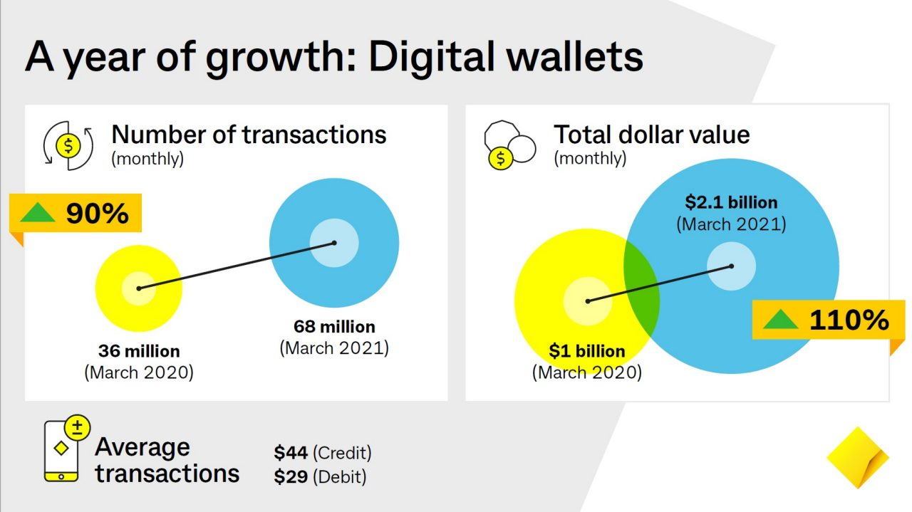
The Consultation Paper notes the challenges with competition in this market and the responses by regulators in other jurisdictions, however considers digital wallet transactions still only account ‘….for a small share of overall card payments’. CBA data above and the Parliamentary Joint Committee inquiry into Mobile Wallet Payments indicates that digital wallet use in Australia is an immediate concern. We strongly urge the RBA to work closely with the ACCC on competition issues in digital wallets and, in line with the RBA’s mandate, consider any implications for the cost, safety and security of the payments system associated with digital wallet payments.

Other Issues
RBA Monitoring of New Payment Trends
Monitoring and understanding the impacts of emerging payment types is critical to the RBA’s mandate. The RBA must ensure that sufficient information is available to monitor payment activities so that emerging risks to the payment system can be identified and addressed appropriately. To keep pace with the speed of change in payment trends with new technologies, the RBA may need to adapt the frequency and granularity of its monitoring of consumer payment behaviours. As described above, the RBA’s assessment of payment trends in the Consultation Paper appears to understate the uptake of digital wallet and BNPL services compared to CBA’s own commercial data and experience.

As the RBA notes in the Issues Paper, ‘there is limited data available with which to assess the effect of competition on BNPL merchant fees’. The RBA may benefit from working with the industry, through AusPayNet to enable data collection that provides the RBA and Industry with more accurate and timely information to enable forward looking monitoring. To provide a comprehensive picture, monitoring should include BNPL and Digital Wallets as well as the impacts on the payment system from other payments innovation such as open banking and action initiation.
Competition in Acquiring.
CBA believes competition in the merchant acquiring space is very strong. The number of merchant acquiring service providers has continued to increase through the entry of large overseas platforms and emergence of local new players, such that merchants have no shortage of choice and have access to detailed information to assist them to ‘shop around’ if they choose.
The extension of CDR to acquiring should be considered in the context of the broader CDR regime and not as a standalone initiative. The RBA will be familiar with the extensive set of current and future priorities for CDR as articulated by the government, including not least of all, payment and other action initiation. Any additions to the regime should be assessed against other priorities and objectives and sequenced accordingly, with sufficient consideration given to the significant effort required to implement such an initiative.
Collection of Merchant Level Data
CBA supports the collection of merchant level data and the RBA’s intention to publish this information along with merchant education. We would suggest that AusPayNet be engaged to coordinate and define the exact information required and materials needed to educate merchants on acquiring pricing.
Net Compensation Draft Standards 1, 2 and 3.
CBA is supportive of the amendments to the Draft Standards for Debit, Credit and Merchant Pricing.

RBA General Questions
Is the proposed approach appropriate? Does it meet the public interest? Are there factors that have not been properly addressed or considered, either in the general approach or the specific drafting?
As the payments system progressively becomes more diverse with a range of new entrants and payment methods, a holistic approach to managing the payments system will become more and more important to maintain the productivity and competitiveness of the Australian economy. The regulatory measures proposed in this Consultation Paper, while important, are disproportionately focussed on fine-tuning regulations which affect only parts of the payments system. To manage risks to the payments system in a digital economy the RBA needs to monitor the overall impacts on efficiency of the payments system as a whole, rather than singling out costs associated with specific payment methods. Payments regulation should ensure end-to-end operational and financial resilience across the entire payment chain. Regulation targeted exclusively at particular payment types, such as interchange regulation, only encourages new entrants to innovate and operate outside of the regulatory framework. It is critical that regulatory and policy levers encourage innovation that makes payments cheaper, faster and more convenient.

The RBA will need to adapt supervisory and regulatory approaches to the challenges created by newer entrants to the payments system. As the RBA has recognised, transparency is an important mechanism for improving efficiency and promoting competition in the payments system. This is more challenging with newer payment providers that tend to blur payments processing costs with other fees/services. Consistent with CBA’s submission to Treasury’s review of the Australian Payments System, the complex challenges arising from changing payments landscape will require a co-ordinated approach between the RBA and other regulators such as APRA, ASIC and ACCC to solve areas where market distortion is occurring and causing possible consumer harm.

What impact will the proposed policy changes have on your regulatory compliance costs? (Please provide dollar estimates.) Are there alternatives that would achieve the policy objectives at lower cost?
We will provide this in the spreadsheet as requested. However, CBA emphasises that the technical complexity involved to extend LCR online demands a cost effective, industry led and practical approach.
How much time should be allowed between any final decisions being made on the interchange standards and the effective date of any new or revised standards? What factors are relevant to the length of this implementation period?
CBA believes a 6 month implementation period is appropriate for implementation of any interchange standards and the revised Standards 1, 2 & 3. Given the RBA currently proposes final determination at the November PSB meeting, we would suggest an effective date of 1 July 2022.
CBA’s Recommendations
- The extension of LCR to online payments should be industry led to ensure that the consumer and merchant experience is not adversely impacted. eftpos’ capability will be critical to the ability of acquirers to deliver LCR in the online environment.

- Interchange should be maintained at a level and in a form that will facilitate ongoing maintenance, upgrading and innovation of the underlying card payments infrastructure to ensure that Australians continue to benefit from world class payment services.

- Meaningful disclosure and monitoring of the costs associated with payments should apply consistently to both existing and newer payment types to prevent regulatory arbitrage, improve cost efficiency and promote competition in the payment system.

- RBA monitoring of current and emerging payment trends should provide timely and accurate information to enable regulatory and policy responses that keep pace with technological change. Information sharing and co-ordination of regulatory responses with other financial regulators is needed to ensure coherent policy that produce the best outcomes for Australian consumers and the economy.

- Measures to improve fee transparency should entail minimal compliance burden or duplication and be delivered via co-ordinated industry collection where possible.

We look forward to discussing these recommendations with the RBA in more detail.

(https://www.pwc.com/us/en/advisory-services/publications/consumer-intelligence-series/pwc-consumer-intelligence-series-customer-experience.pdf)

